**Enrollment System for Department of Computer Studies – Cavite State University – Bacoor Campus**

Abelon, Rosemarie A.

Adao, Jennylle Fate C.

Caliwan, Neil Yvan S.

Dimailig, Jessica H.

Gripon, Anne Aubrey P.

Tan, Gerlyn R.

Virtudez, Donna Pauline F.

January 2025

**Table Of Contents**

1. Summary 2–3

2. Introduction 4–6

3.  Major Contributions or Roles of Team Members 6–9

4. System Analysis 9–19

5. System Design 20–53

6. Implementation 53–71

7. Testing 71–98

8. Maintenance 97–99

9. Conclusion 99

10. Appendices 100–103

# 

# 1. Summary

The Enrollment System for the Department of Computer Studies—Cavite State University—Bacoor Campus is an upgraded digital platform that simplifies the enrollment process for students. It replaces the traditional manual methods of course registration and record-keeping with a more efficient, user-friendly system. The goal is to make the enrollment process faster, easier, and more accurate for students, faculty, and staff, ensuring a smoother experience for everyone involved.

**1.1 Purpose**

* This documentation helps users understand the features and functions of the online enrollment system designed specifically to improve the in-person enrolling process for students studying Computer Science and Information Technology at Cavite State University Bacoor Campus.
  1. **Key Features**
* **For Returning Students:** Students can register and login to manage their enrollment process, submit needed requirements, explore the course catalog, enroll in courses, view their personalized class schedules, and manage their profile.
* **For New Students**: Students can register and login to manage their admission process, accomplish an application or shifting form, and manage their profile.
* **For Society Officers:** Society Officers can handle enrollment periods, manage class schedules, monitor society fee payments, validate submitted requirements, and manage their profile.
* **For Advisers:** Advisers can modify students’ advising status, submit and fill up students’ pre-enrollment form, and manage their profile.
* **For Enrollment Officers:** Enrollment Officers can verify user registrations, manage enrollment statuses, update the employment status of Society Officers, Advisers, DCS Heads, and the School Head, modify students’ academic information and statuses, and access administrative dashboards.
* **For School Head:** The School Head can approve or reject admissions for transferees and freshmen and send scheduling for face-to-face requirement submissions via email.
* **For Department Heads:** Department Heads can approve or reject shifting requests for shiftee students and coordinate schedules for face-to-face submissions via email.
  1. **Benefits**
* **Efficiency:** Reduces the time and effort involved in the enrollment process.
* **Accuracy:** Minimizes errors associated with manual data entry.
* **Accessibility:** Provides easy access for students and staff through a web-based platform.
* **Transparency:** Ensures clear and real-time visibility into student records and course availability.
* **Cost-Effective:** Reduces overhead and paper-based systems, leading to long-term cost savings.

# 2. Introduction

Enrollment is one of the most important for students at Cavite State University—Bacoor Campus. It is the process that officially marks the start of a new academic term and allows students to register for their courses and programs. It is essential to making sure that students can effectively register for the programs and courses they want to take. However, the enrollment process frequently encounters difficulties like long queues, human error, and delays, which can be stressful for both staff and students, just like at many other universities. For students studying Computer Science (CS) and Information Technology (IT), who are particularly interested in learning about system development and technological advancements, these problems emphasize the need for a more efficient and user-friendly system.

The current Department of Computer Studies enrollment process usually involves long lines, checking records manually, and several steps that take a lot of time. This process can confuse students and cause frustration, especially during busy enrollment periods when many students are registering at the same time. Since the department focuses on technology and innovation, it needs an enrollment system that is faster and more modern to match what students are learning in their classes.

To solve these problems, creating a better Enrollment System for the Department of Computer Studies is necessary. A modern system would make enrollment easier and more organized. It can remove the need for too much paperwork and reduce mistakes by automating tasks like choosing subjects and setting up schedules. The system can also give real-time updates, letting students quickly check class availability and confirm their registration without delays.

A dedicated enrollment system for the Department of Computer Studies also supports the university’s goal to provide quality education and use innovation. It shows the department’s dedication to helping students by improving services through technology. This ensures that both current and future students have a better experience when enrolling.

In conclusion, an Enrollment System for the Department of Computer Studies at Cavite State University—Bacoor Campus is not just helpful; it’s necessary. With the use of technology, the system can make the process faster, reduce stress, and serve as an example of innovation. This upgrade will help the department continue to support students in reaching their academic and career goals.

* 1. **Objectives**

The study aims to develop an Enrollment System for the Department of Computer Studies (DCS) at Cavite State University Bacoor Campus to streamline and modernize the enrollment process, improving the overall experience for both students and staff. The objectives of the study are as follows:

* Identify issues with the current enrollment process by assessing the existing manual system to pinpoint problems such as long lines, manual errors, and inefficiencies through surveys and interviews with students and staff.
* Analyze the challenges of the manual enrollment process and explore the benefits of implementing an online Enrollment System to address the issues effectively.
* Design of an application using the Iterative methodology;
* Develop and implement a comprehensive system using React.js for the frontend, Express.js/Node.js for the backend, and MySQL for the database.
  1. **Scope and Limitations**
* This system **handles the regular, irregular, freshman, shiftee, and transferee student enrollment process**, ensuring smooth admission for all courses offered in the Department of Computer Studies.
* This system facilitates user registration and authentication, requirements verification, a digital checklist, class schedule management, enrollment tracking, user profile management, administrative controls and dashboards, notifications and alerts, system security measures, and support and help resources.
* This system **does not include processes that require in-person interactions**, specifically the advising and payment of society fees.

# 3. Major Contributions or Roles of Team Members

|  |  |  |
| --- | --- | --- |
| **Name** | **Role** | **Major Contribution** |
| Abelon, Rosemarie A. | Software Documentation Writer | * Created the format for the documentation and added some of the content, ensuring that the structure is organized and the information is clear and comprehensive for the readers. * Assisted with other information needed for the system. * Created the functional requirements in SRS, ensuring that all necessary features and functionalities are clearly defined and aligned with the project’s goals and objectives. |
| Adao, Jennylle Fate C. | UX Designer | * The development of Data Flow Level 0 and Level 1 Diagrams in Lucidchart, which provides a comprehensive overview of the enrollment system’s architecture and processes. * Created User Experience (UX) design for the enrollment system in mobile mode using Lucidspark. * Provided the enrollment process for Irregulars. * Gave the necessary information for Transferees—the requirements and its process. * Provided information in some uncertain areas of the enrollment process. |
| Caliwan, Neil Yvan S. | Front-end Developer | * Developed the frontend design by improving the layout and visual elements to create a clean, modern look while keeping the system consistent. * Designed the UI for desktop mode, focusing on creating a user-friendly layout and ensuring a seamless experience across different screen sizes. * Identified and fixed design issues, such as layout errors and responsiveness problems, by adjusting spacing and alignment to ensure the design adapts well to different screen sizes and devices. * Created Use Case Diagram to illustrate the interactions between users and the system, highlighting the different processes and roles within the system’s functionality. * Contributed suggestions and actively participated in the development of the system, offering ideas for improvements and ensuring a collaborative approach throughout the process. |
| Dimailig, Jessica H. | Software Documentation Writer | * Provided a list of specific information that should be included in the admission form for freshman and transferee students. * Contributed and worked on the documentation of the enrollment system. |
| Gripon, Anne Aubrey P. | UI Designer | * Designed most of the UI for mobile mode, creating user-friendly interfaces using Canva to ensure a smooth and easy experience for users. * Contributed some UI design for desktop mode, specifically for the student dashboard. * Created the non-functional requirements in SRS to ensure the system performs efficiently and meets quality standards. |
| Tan, Gerlyn R. | Project Manager and Back-end Developer | * Divided task assignments among team members. * Contributed to constructing the whole process in the system. * Developed the entire server-side logic and functionalities using Node.js and Express.js. * Designed the Sequence Diagram that enhanced system clarity. * Collaborated with Database Manager to optimize data handling and ensure seamless integration with MySQL. * Prepared most of the progress reports submitted. |
| Virtudez, Donna Pauline F. | Database Manager and QA Tester | * Provided relevant suggestions for improving the enrollment system and assisted in gathering critical information and references regarding the processes for freshmen and shiftees, including the necessary forms. * Played a key role in designing the Entity-Relationship Diagram (ERD) and creating the database. * Entrusted to prepare the progress report at the project manager’s request, whenever the project manager has a heavy workload and requires assistance at certain times. * Contributed to several areas of the documentation, especially in cases where the format had not yet been established during my time as a Software Documentation Writer. * Took responsibility for monitoring and tracking the database, particularly in its structure, to ensure data integrity and accuracy to support the system’s intended functionality as a Database Manager. * Conducted thorough testing of the final pages of the enrollment system, evaluating both the user interface and its functionalities as a QA Tester. |

# 

# 4. System Analysis

# 4.1 Requirements Analysis

# Functional Requirements

* **User Registration and Authentication:** Users must be able to create an account with personal information, log in and out securely, and recover forgotten passwords through email verification.
* **Course Catalog:** Users can browse a list of available courses with details such as descriptions, prerequisites, and schedules.
* **Enrollment Schedule Management**: IT and CS Society Officers can separately create, start, and end enrollment schedules manually.
* **Class Schedule Management**: IT and CS Society Officers can separately create and manage class schedules for each course and year-section, which can then be used for the pre-enrollment forms of irregular students.
* **Enrollment Process:** Students can enroll in courses through a straightforward process.
* **User Profile Management:** Users can update their personal information, such as profile picture, name, gender, address, contact number, date of birth, and password.
* **Notifications:** Users receive timely email notifications regarding their enrollment confirmation, admission status, and account-related activities, including code verification, account termination, and password reset confirmations.
* **Admin Controls:** Enrollment Officers can assign account types to newly admitted students, update returning students (such as year and section), manage user accounts, and they can review and approve or reject enrollment applications.
* **Admin Dashboard**: Admins can view a visual representation of students’ generalized data and details about enrollment period.
* **Student Dashboard**: Returning students can view details about enrollment periods, monitor their enrollment progress, and view their personalized class schedules.
* **System Security:** All sensitive user data must be protected, and role-based access control should be implemented for both users and admins.
* **Technical requirements:** The system must be accessible and fully functional on various devices, including smartphones and tablets, and compatible with major web browsers like Chrome and Edge.
* **Help and Support:** The system should include a Help Center with FAQs, guides, and tutorials and provide a way for users to contact support via email.

**Non-functional Requirements**

* **Response Time:** The system must respond to the user’s action (such as submitting a form, updating data, and logging in and out) within a few seconds in normal operating conditions.
* **Efficient Subject Display Performance:** The system must efficiently display eligible subjects during pre-enrollment, ensuring that the list of courses is generated and presented, even under peak enrollment periods. The display should be responsive to ensure smooth user interaction without delays or system lag.
* **Mobile Responsiveness**: This refers to the system’s ability to automatically adjust its interface, functionality, and performance in order to provide the best possible experience on mobile devices like tablets and smartphones. It guarantees that the system is efficient, accessible, and functional on a variety of touch interfaces, screen sizes, and network configurations.
* **Data Segregation**: The system must separate data views for students and enrollment officers, ensuring that sensitive information is only accessible by authorized personnel. Students should not have access to other students’ information, while enrollment officers should have access to all necessary student data.
* **Data Access Efficiency**: The system must allow enrollment officers, society officers, and advisers to access and retrieve student information from the database, even when accessing records for a large number of students, ensuring quick processing during peak enrollment periods.
* **Scalability**: The system must support an increasing number of users with different roles (e.g., students, enrollment and society officers, advisers), ensuring that as the number of students grows, access control mechanisms remain reliable and performant.
* **Ease of use**: This is centered on making it intuitive, allowing users to understand tasks without explicit instructions. The system uses familiar design patterns and navigation flows to reduce cognitive load and prevent overwhelm. This approach makes the system self-explanatory, making it approachable and efficient for all users.
* **Real-Time Notifications**: The system must provide real-time notifications to the department heads for the number of shifting requests and the school head for the number of admission requests. Notifications can be displayed within the system.
* **Terms of Use**: The system should require users to agree to a terms of use agreement, which outlines data privacy, user responsibilities, and system rules, before they can proceed with the enrollment process.
  1. **Use Case Analysis**

**Incoming First Year Student**

* An Incoming First-Year Student registers an account, which the Enrollment Officer approves or rejects.
* The Incoming First-Year Student logs in using provided credentials.
* The Incoming First-Year Student fills out an admission form and submits it for review by the School Head.
* The School Head reviews and either approves or rejects applications.
* The School Head sends a schedule for requirements submission and examination date after approval.
* The Incoming First-Year Student confirms their slot.

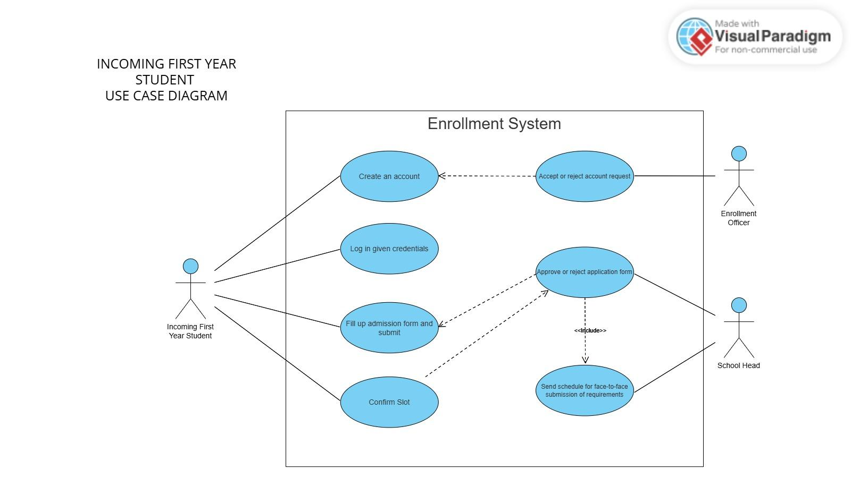

**Regular Student Enrollment**

* The Regular Student registers to have an account.
* The Regular Student logs in to the system.

After logging in, the Regular Student can access the enrollment page and must follow the steps to complete their enrollment.

* The first step is the society fee payment, which is done face-to-face through the Society Officer.
* The Society Officer then verifies and updates the society fee status in the system.
* The submission of the COG and checklist by the Regular Student through the system is followed by verification from the Society Officer.
* The adviser’s scheduling of a face-to-face session through the system facilitates in-person advising.
* The filling out of the pre-enrollment form for the student will be handled by the Adviser.
* The updating of the enrollment status for the regular student will be handled by the Enrollment Officer.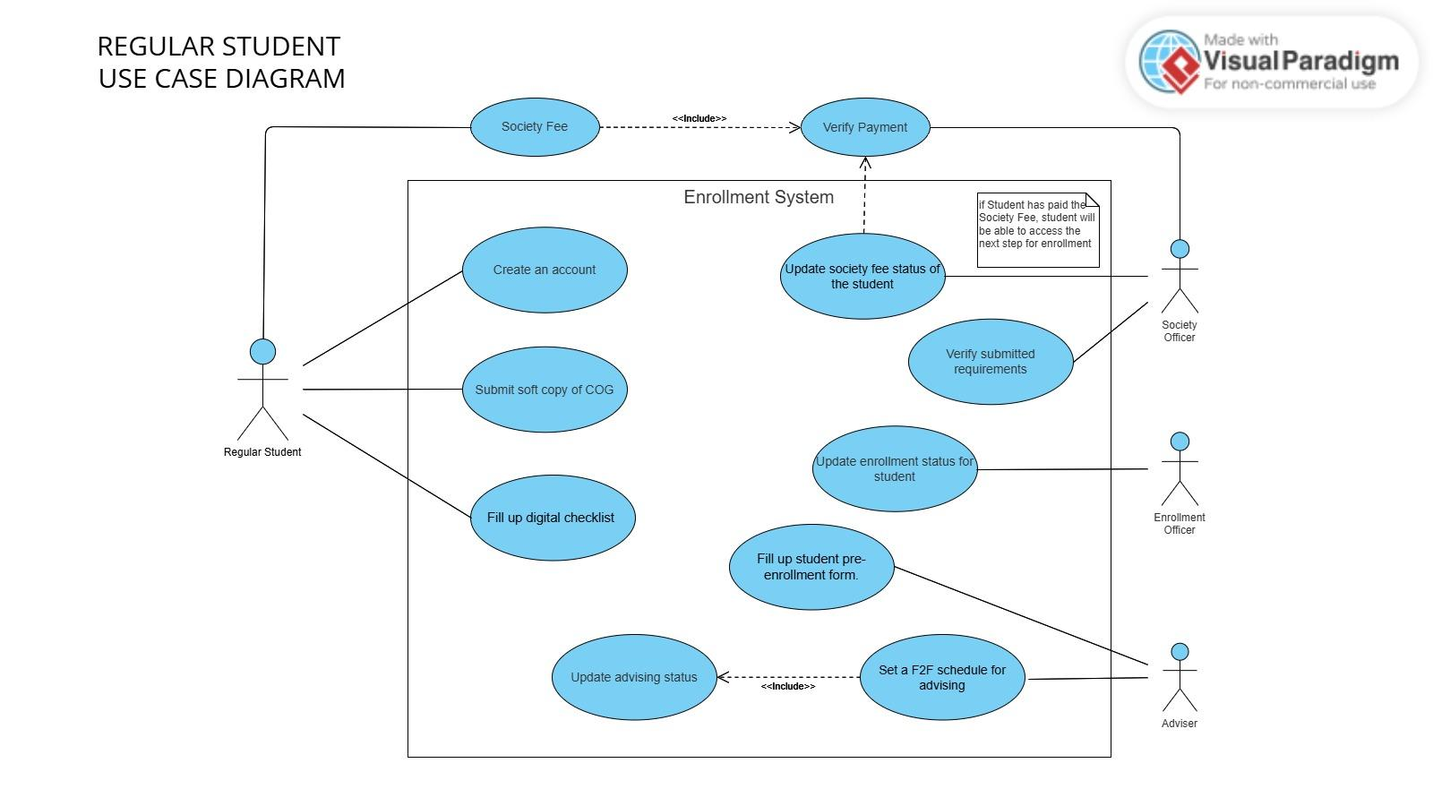

**Irregular Student**

* The Irregular Student registers to have an account.
* The Irregular Student logs in to the system.

After logging in, the Irregular Student can access the enrollment page and must follow the steps to complete their enrollment.

* The first step is the society fee payment, which is done face-to-face through the Society Officer.
* The Society Officer then verifies and updates the society fee status in the system.
* The submission of the COG and checklist by the Irregular Student through the system is followed by verification from the Society Officer.
* The adviser’s scheduling of a face-to-face session through the system facilitates in-person advising.
* The filling out of the pre-enrollment form for the student will be handled by the Adviser.
* The Irregular Student can choose a preferred class schedule.
* The updating of the enrollment status for the regular student will be handled by the Enrollment Officer.

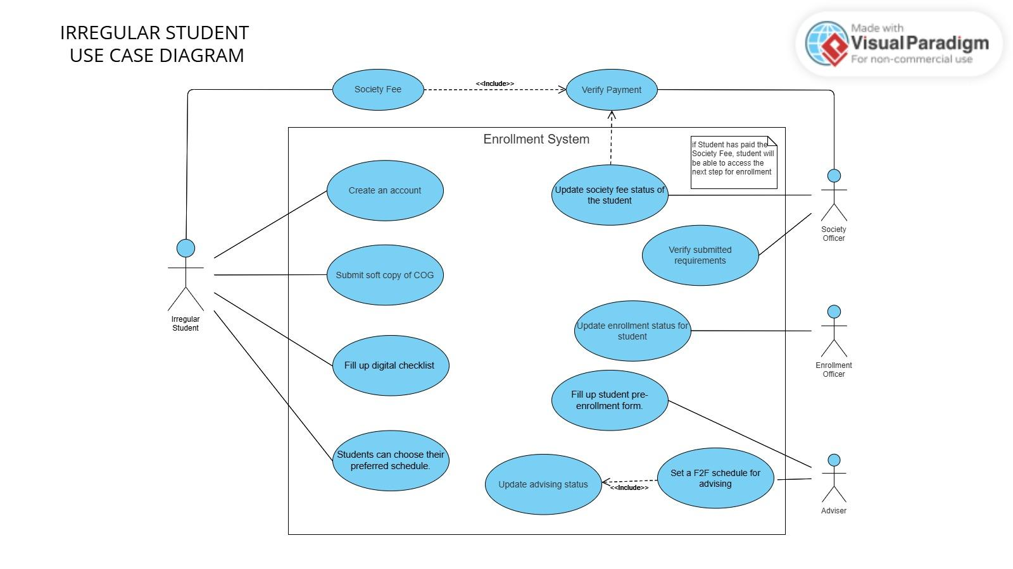

**Shiftee Student**

* The Shiftee Student will request permission to shift from the previous program to a new program.
* The Shiftee Student registers an account, which the Enrollment Officer approves or rejects.
* The Shiftee Student logs in using the provided credentials.
* The Shiftee Student fills out a shifting form and submits it for review by the DCS Head.
* The DCS Head reviews and either approves or rejects applications.
* The DCS Head sends a schedule for requirements submission after approval.

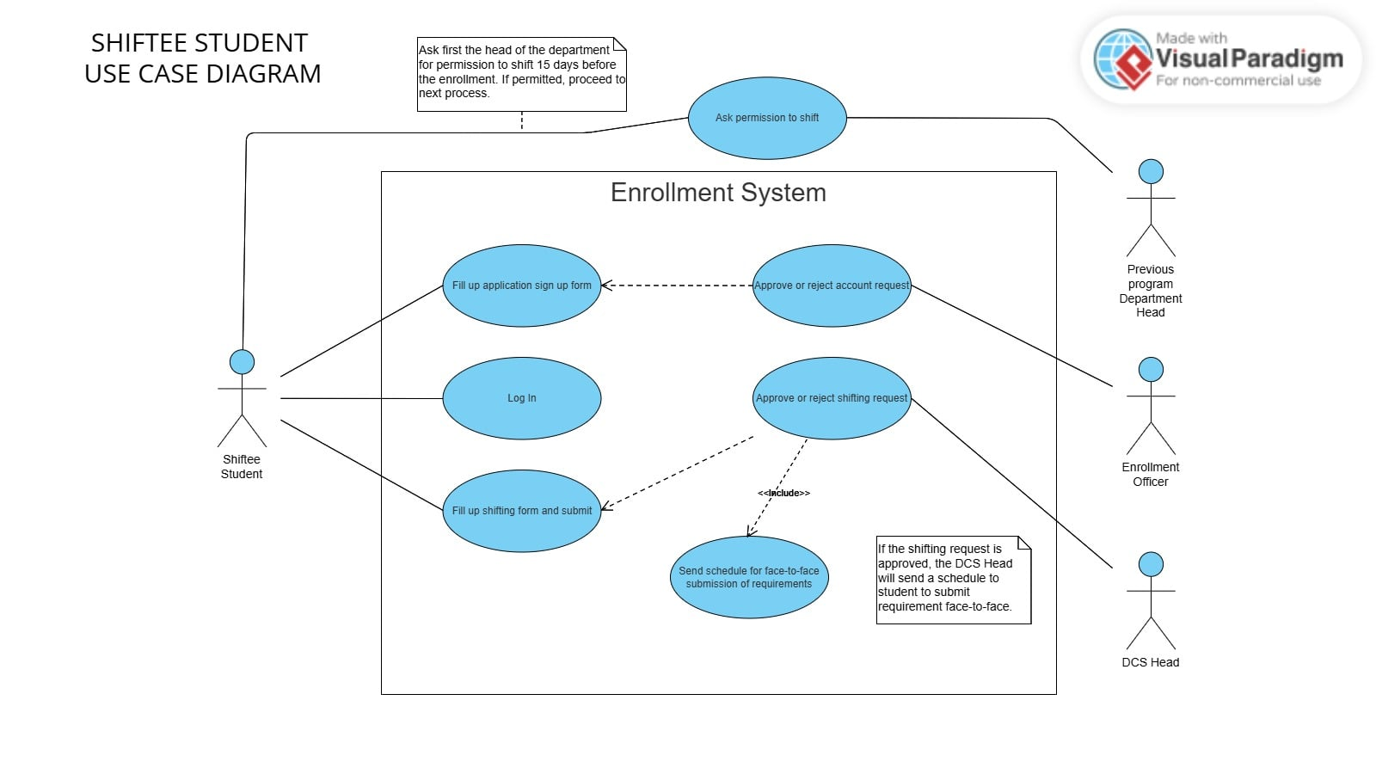

**Transferee Student**

* The Transferee Student registers an account, which the Enrollment Officer approves or rejects.
* The Transferee Student logs in using provided credentials.
* The Transferee Student fills out an admission form and submits it for review by the School Head.
* The School Head reviews and either approves or rejects applications.
* The School Head sends a schedule for requirements submission after approval.

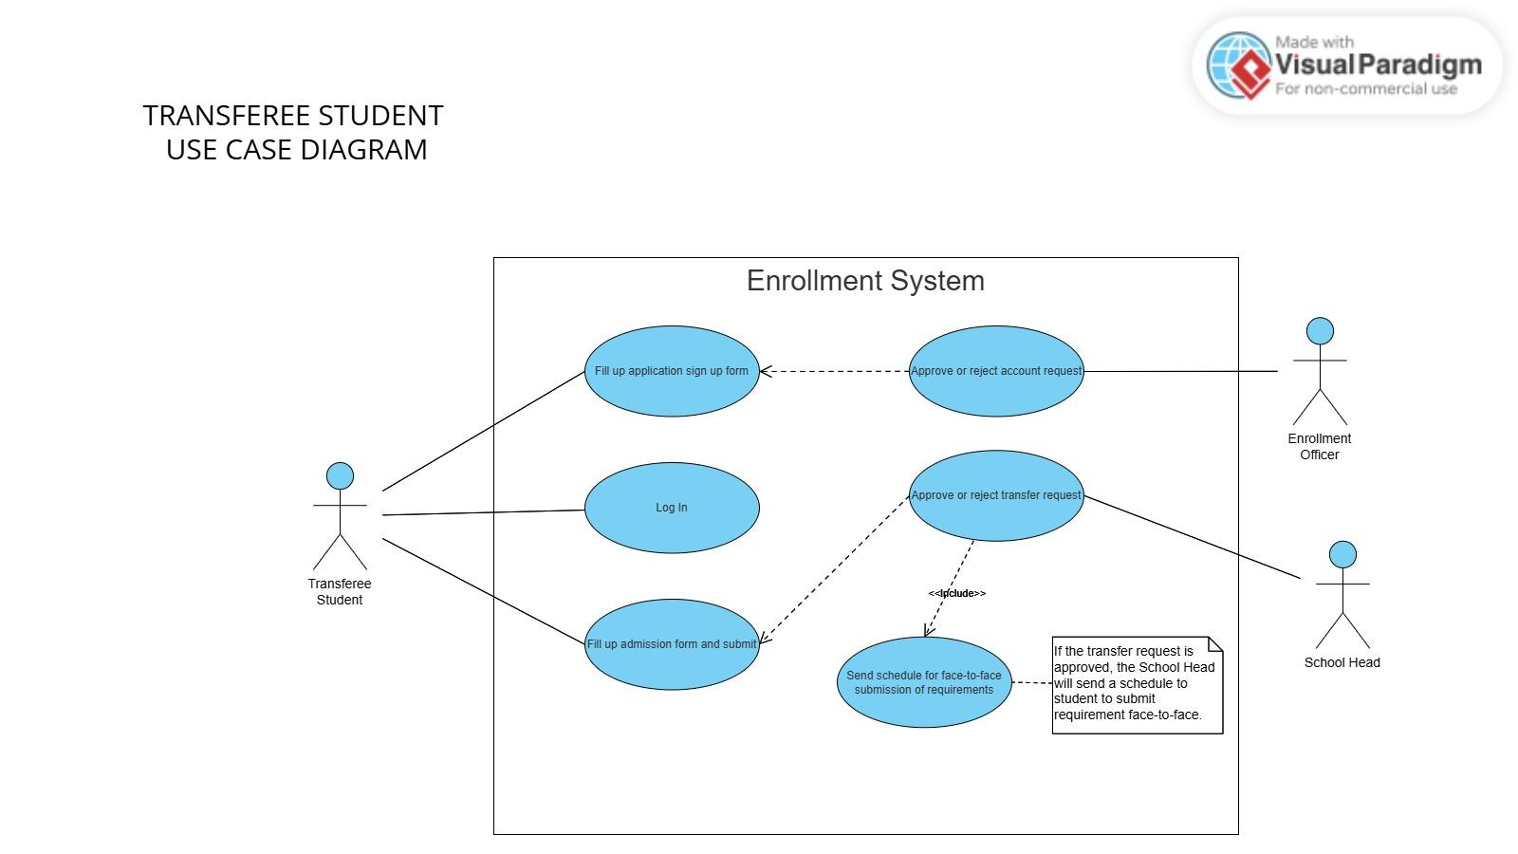

**Adviser:** The adviser is able to set the advising status of the students and is the one who will fill out the pre-enrollment form for students.

**Society Officer:** The society officer is able to set the society fee payment status and verify the submitted requirements of students.

**Registrar**

* The Registrar validates student records to ensure they are complete and accurate for enrollment, academic progression, or graduation purposes.
* The Registrar verifies details such as personal information, course grades, credits earned, and compliance with program requirements.
  1. **Process Flow**
* Incoming Students Sequence Diagram

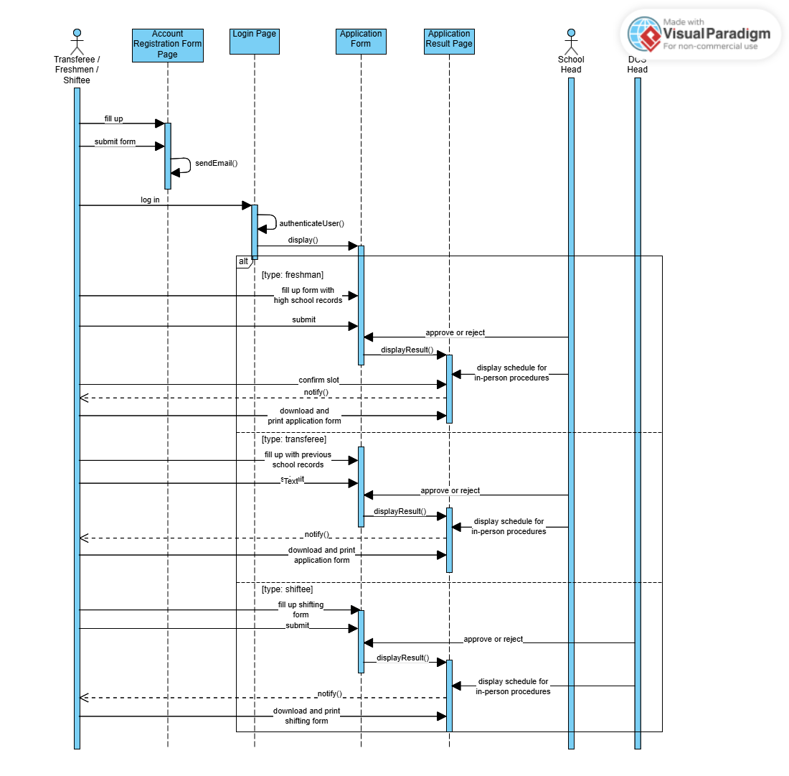

* Returning Students Sequence Diagram

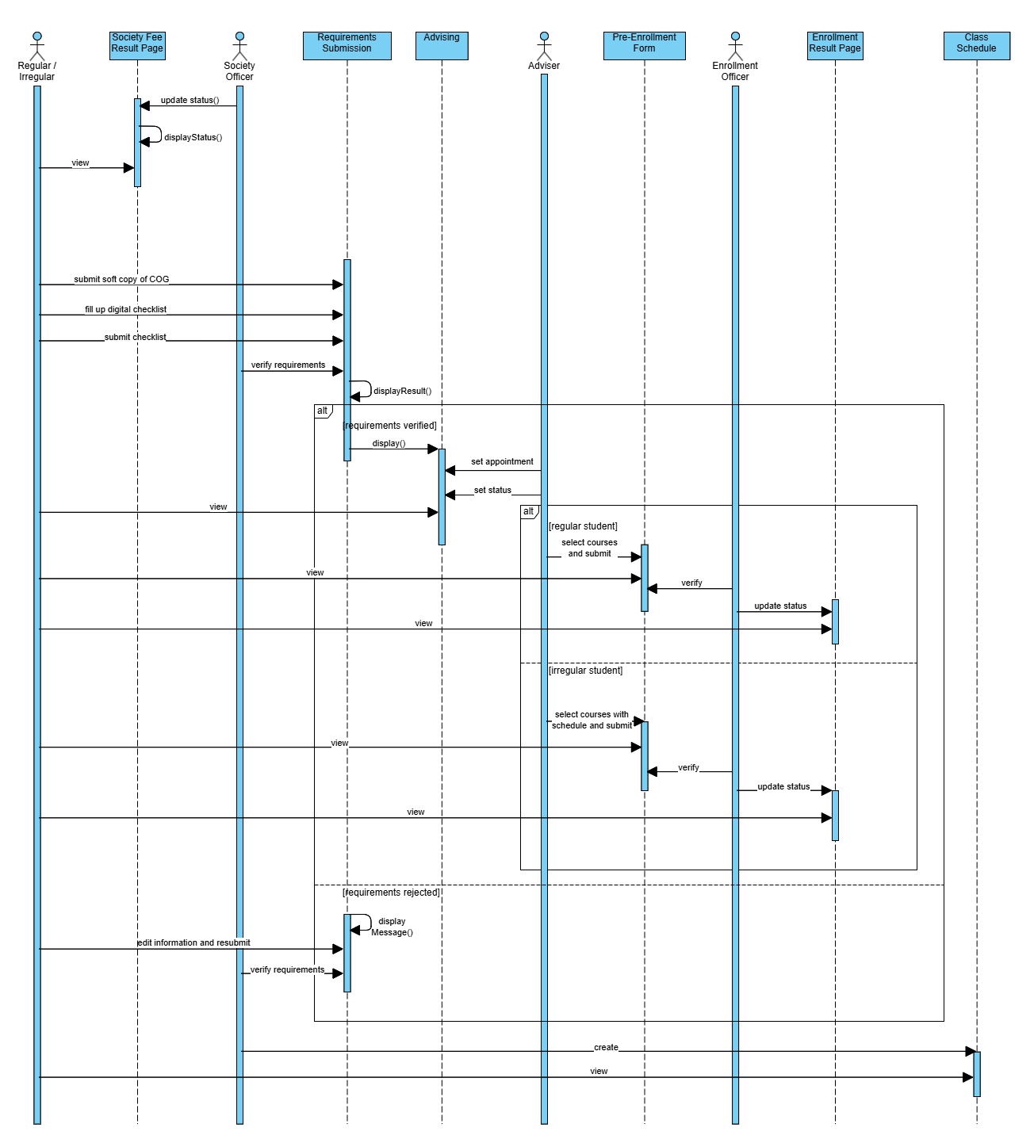

# 5. System Design

* 1. **Architecture**
* **System Architecture Diagram**

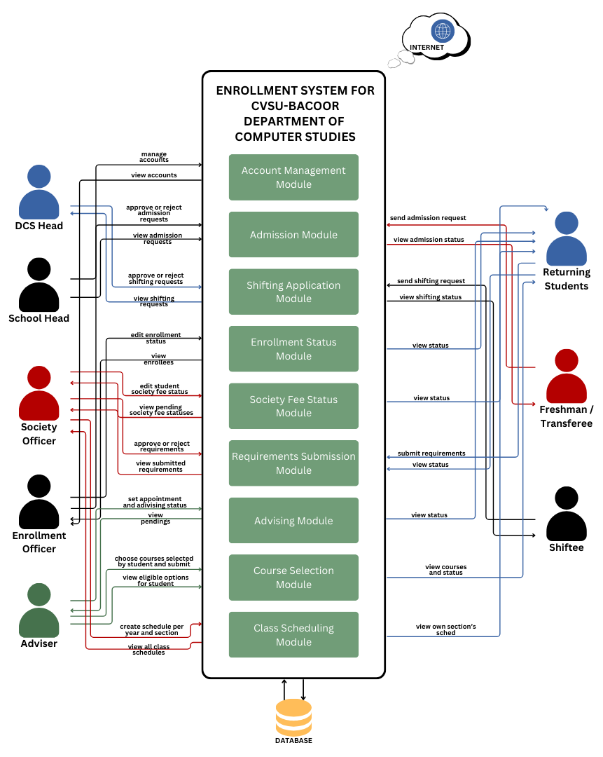

1. **Presentation Layer:** The Presentation Layer forms the user interface of the system. It encompasses the various roles (DCS Head, School Head, Society Officer, Enrollment Officer, Adviser, and Students) and their interactions with the system modules. These interactions involve web pages, forms, and other visual elements through which users input data, view information, and navigate the system.
2. **Business Logic Layer:** The Business Logic Layer constitutes the core of the system’s functionality. It houses the core business rules and logic, processing requests, performing calculations, and managing data transactions. In the diagram, the modules themselves (Account Management, Admission, Shifting Application, Enrollment Status, etc.) represent this layer. These modules encapsulate the specific functionalities and processes of the enrollment system.
3. **Data Access Layer:** The Data Access Layer or Database Layer, is responsible for interacting with the underlying database. It handles the retrieval, storage, and updates of data. The modules in the Business Logic Layer would interact with this layer to access and manipulate the stored data.

* **Technologies used**
  + **Frontend:** React.js + Vite
  + **Backend:** Node.js with Express.js
  + **Database:** MySQL
  + **Version Control:** Git and GitHub

**5.2 Database Design**

* **Entity-Relationship Diagram**

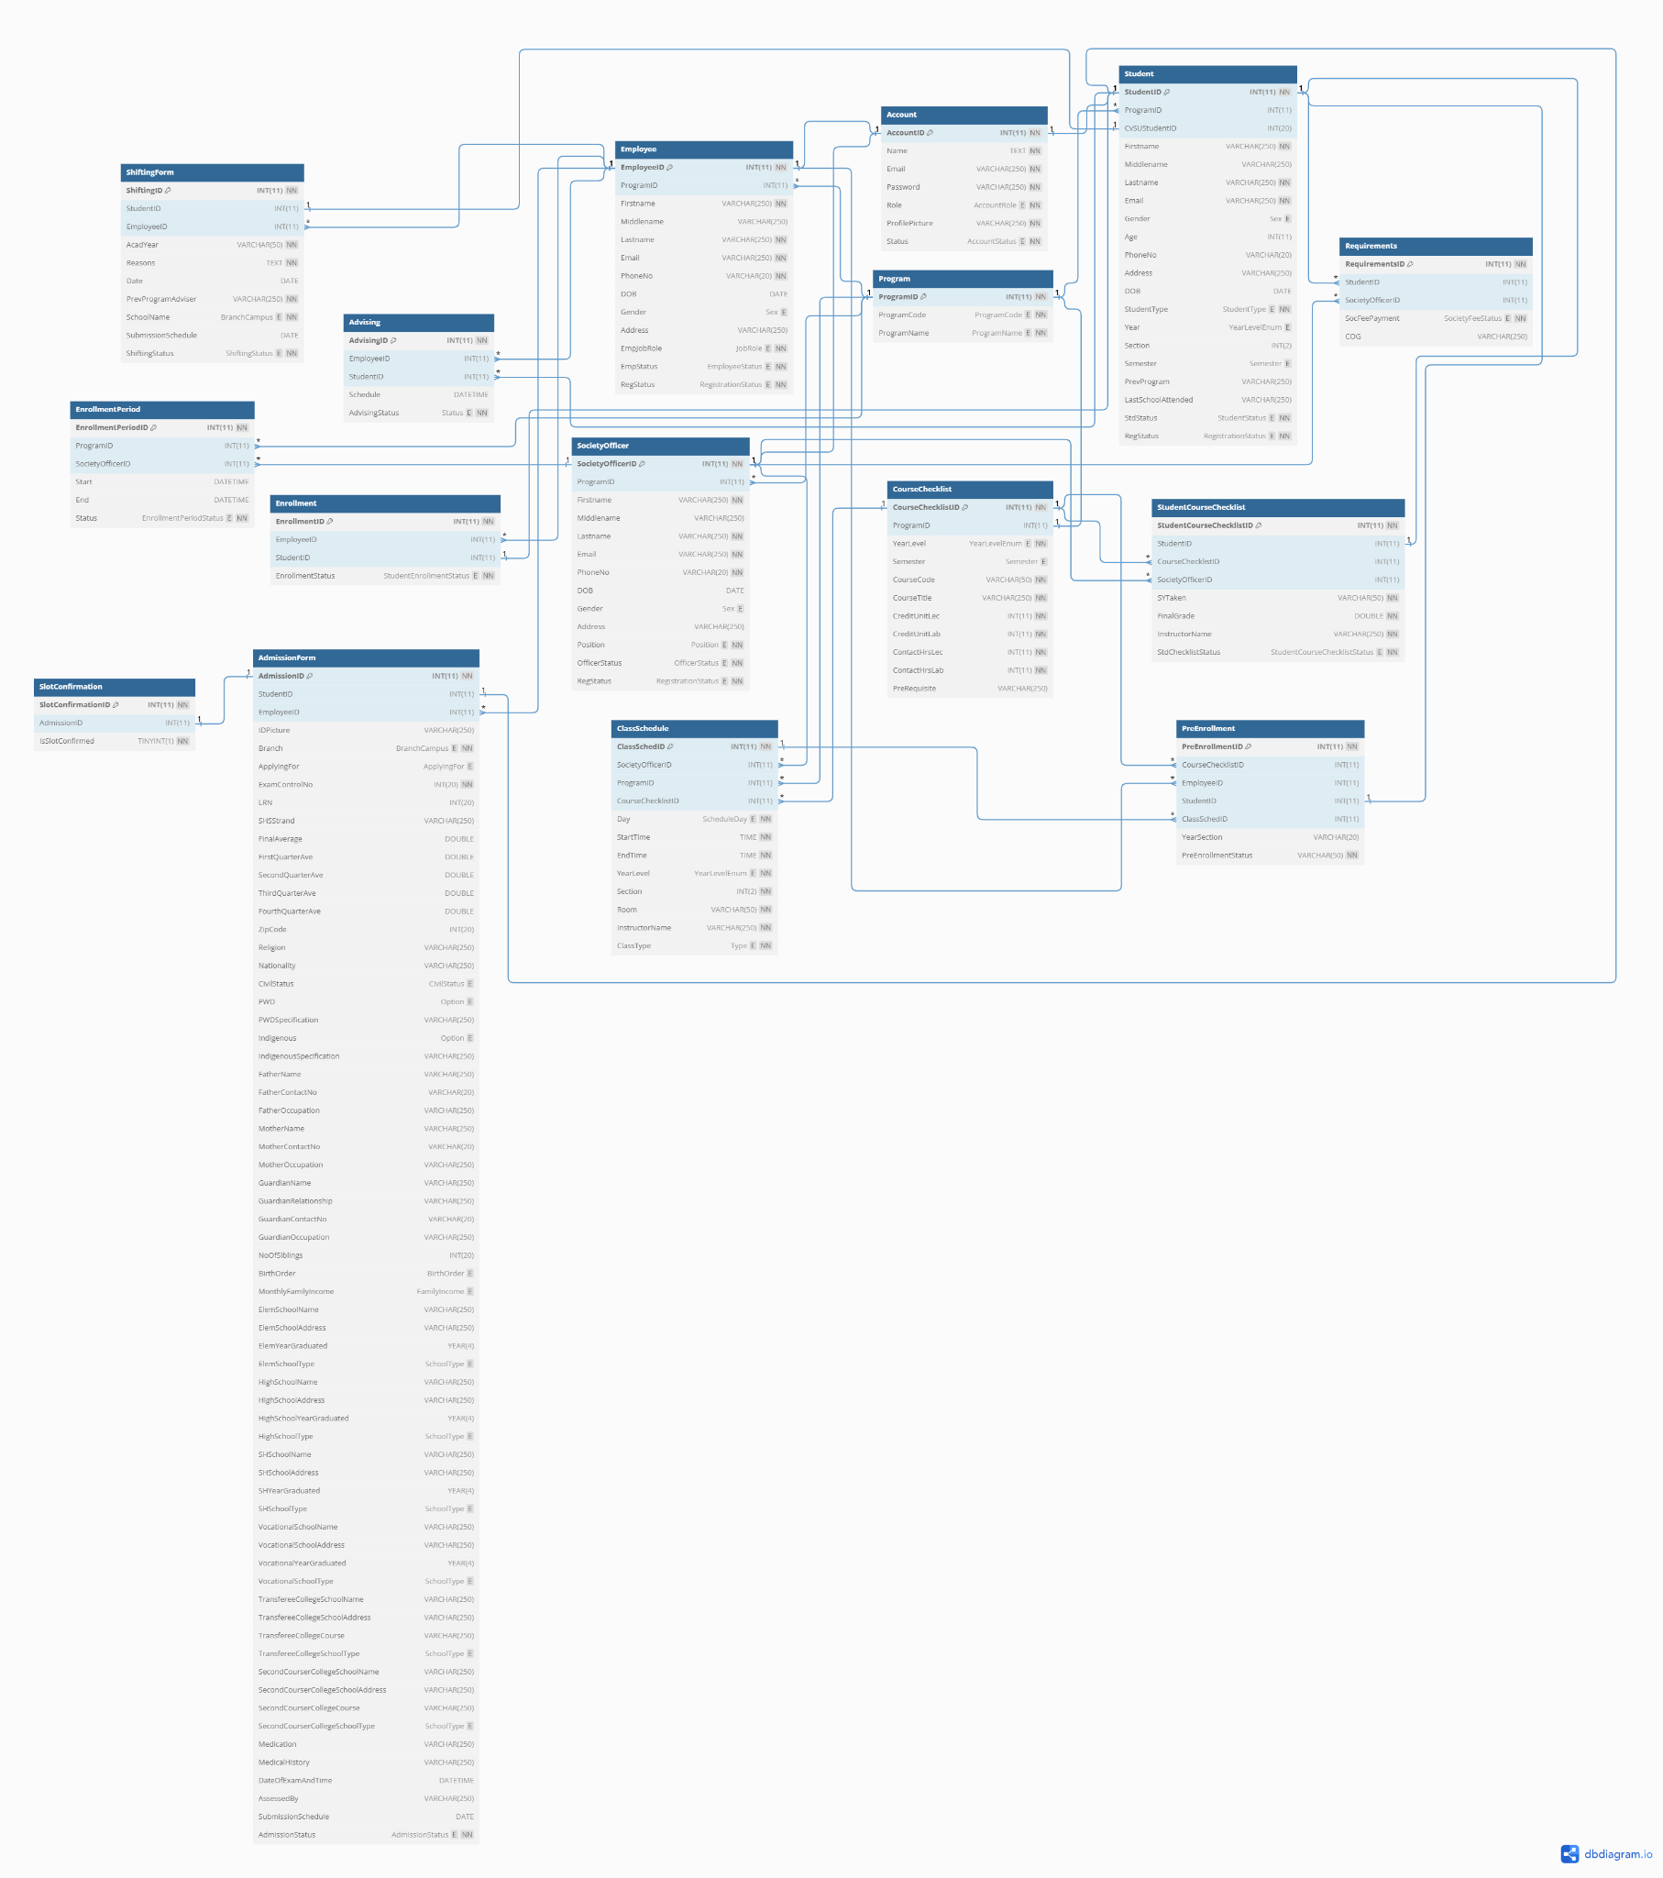

**Account Table**

|  |  |  |
| --- | --- | --- |
| **Column name** | **Data Type** | **Constraints** |
| AccountID | INT (11) | PRIMARY KEY, AUTO_INCREMENT, NOT NULL |
| Name | TEXT | NOT NULL |
| Email | VARCHAR (250) | UNIQUE, NOT NULL |
| Password | VARCHAR (250) | NOT NULL |
| Role | ENUM(‘Student’, ‘Enrollment Officer’, ‘School Head’, ‘DCS Head’, ‘Society Officer’, ‘Adviser’) | NOT NULL |
| ProfilePicture | VARCHAR (250) | NOT NULL, DEFAULT ‘uploads\default-pfp.jpg’ |
| Status | ENUM(‘Active’, ‘Terminated’) | NOT NULL |

**Program Table**

|  |  |  |
| --- | --- | --- |
| **Column name** | **Data Type** | **Constraints** |
| ProgramID | INT (11) | PRIMARY KEY, AUTO_INCREMENT, NOT NULL |
| ProgramCode | ENUM(‘BSCS’, ‘BSIT’) | UNIQUE, NOT NULL |
| ProgramName | ENUM(‘Bachelor of Science in Computer Science’, ‘Bachelor of Science in Information Technology’) | UNIQUE, NOT NULL |

**Student Table**

|  |  |  |
| --- | --- | --- |
| **Column name** | **Data Type** | **Constraints** |
| StudentID | INT (11) | PRIMARY KEY, AUTO_INCREMENT, NOT NULL |
| ProgramID | INT (11) | FOREIGN KEY REFERENCES Program(ProgramID) |
| CvSUStudentID | INT (20) | UNIQUE |
| Firstname | VARCHAR (250) | NOT NULL |
| Middlename | VARCHAR (250) |  |
| Lastname | VARCHAR (250) | NOT NULL |
| Email | VARCHAR (250) | UNIQUE, NOT NULL |
| Gender | ENUM(‘F’, ‘M’) |  |
| Age | INT (11) |  |
| PhoneNo | VARCHAR (20) |  |
| Address | VARCHAR (250) |  |
| DOB | DATE |  |
| StudentType | ENUM(‘Regular’, ‘Irregular’, ‘Transferee’, ‘Freshman’, ‘Shiftee’) | NOT NULL |
| Year | ENUM(‘First Year’, ‘Second Year’, ‘Third Year’, ‘Mid-Year’, ‘Fourth Year’) |  |
| Section | INT (2) |  |
| Semester | ENUM(‘First Semester’, ‘Second Semester’) |  |
| PrevProgram | VARCHAR (250) |  |
| LastSchoolAttended | VARCHAR (250) |  |
| StdStatus | ENUM(‘Active’, ‘Inactive’, ‘Dropped’, ‘Graduated’, ‘Suspended’, ‘Withdrawn’, ‘On Leave’, ‘Alumni’, ‘Transfer’) | NOT NULL |
| RegStatus | ENUM(‘Pending’, ‘Accepted’, ‘Rejected’) | NOT NULL, DEFAULT ‘Pending’ |

**Employee Table**

|  |  |  |
| --- | --- | --- |
| **Column name** | **Data Type** | **Constraints** |
| EmployeeID | INT (11) | PRIMARY KEY, NOT NULL |
| ProgramID | INT (11) | FOREIGN KEY REFERENCES Program(ProgramID) |
| Firstname | VARCHAR (250) | NOT NULL |
| Middlename | VARCHAR (250) |  |
| Lastname | VARCHAR (250) | NOT NULL |
| Email | VARCHAR (250) | UNIQUE, NOT NULL |
| PhoneNo | VARCHAR (20) | UNIQUE, NOT NULL |
| DOB | DATE |  |
| Gender | ENUM(‘F’, ‘M’) |  |
| Address | VARCHAR (250) |  |
| EmpJobRole | ENUM(‘Adviser’, ‘DCS Head’, ‘School Head’, ‘Enrollment Officer’) | NOT NULL |
| EmpStatus | ENUM(‘Employed’, ‘Resigned’) | NOT NULL |
| RegStatus | ENUM(‘Pending’, ‘Accepted’, ‘Rejected’) | NOT NULL, DEFAULT ‘Pending’ |

**SocietyOfficer Table**

|  |  |  |
| --- | --- | --- |
| **Column name** | **Data Type** | **Constraints** |
| SocietyOfficerID | INT (11) | PRIMARY KEY, AUTO_INCREMENT, NOT NULL |
| ProgramID | INT (11) | FOREIGN KEY REFERENCES Program(ProgramID) |
| Firstname | VARCHAR (250) | NOT NULL |
| Middlename | VARCHAR (250) |  |
| Lastname | VARCHAR (250) | NOT NULL |
| Email | VARCHAR (250) | UNIQUE, NOT NULL |
| PhoneNo | VARCHAR (20) | UNIQUE, NOT NULL |
| DOB | DATE |  |
| Gender | ENUM(‘F’, ‘M’) |  |
| Address | VARCHAR (250) |  |
| Position | ENUM(‘President’, ‘Vice President’, ‘Secretary’, ‘Assistant Secretary’, ‘Treasurer’, ‘Assistant Treasurer’, ‘Business Manager’, ‘Auditor’, ‘P.R.O.’, ‘Assistant P.R.O.’, ‘GAD Representative’, ‘1st Year Chairperson’, ‘2nd Year Chairperson’, ‘3rd Year Chairperson’, ‘4th Year Chairperson’, ‘1st Year Senator’, ‘2nd Year Senator’, ‘3rd Year Senator’, ‘4th Year Senator’) | NOT NULL |
| OfficerStatus | ENUM(‘Elected’, ‘Resigned’) | NOT NULL |
| RegStatus | ENUM(‘Pending’, ‘Accepted’, ‘Rejected’) | NOT NULL, DEFAULT ‘Pending’ |

**EnrollmentPeriod Table**

|  |  |  |
| --- | --- | --- |
| **Column name** | **Data Type** | **Constraints** |
| EnrollmentPeriodID | INT (11) | PRIMARY KEY, AUTO_INCREMENT, NOT NULL |
| ProgramID | INT (11) | FOREIGN KEY REFERENCES Program(ProgramID) |
| SocietyOfficerID | INT (11) | FOREIGN KEY REFERENCES SocietyOfficer(SocietyOfficerID) |
| Start | DATETIME |  |
| End | DATETIME |  |
| Status | ENUM(‘Pending’, ‘Ongoing’, ‘Finished’) | NOT NULL, DEFAULT ‘Pending’ |

**ClassSchedule Table**

|  |  |  |
| --- | --- | --- |
| **Column name** | **Data Type** | **Constraints** |
| ClassSchedID | INT (11) | PRIMARY KEY, AUTO_INCREMENT, NOT NULL |
| SocietyOfficerID | INT (11) | FOREIGN KEY REFERENCES SocietyOfficer(SocietyOfficerID) |
| ProgramID | INT (11) | FOREIGN KEY REFERENCES Program(ProgramID) |
| CourseChecklistID | INT (11) | FOREIGN KEY REFERENCES CourseChecklist(CourseChecklistID) |
| Day | ENUM(‘Monday’, ‘Tuesday’, ‘Wednesday’, ‘Thursday’, ‘Friday’, ‘Saturday’) | NOT NULL |
| StartTime | TIME | NOT NULL |
| EndTime | TIME | NOT NULL |
| YearLevel | ENUM(‘First Year’, ‘Second Year’, ‘Third Year’, ‘Mid-Year’, ‘Fourth Year’) | NOT NULL |
| Section | INT (2) | NOT NULL |
| Room | VARCHAR (50) | NOT NULL |
| InstructorName | VARCHAR (250) | NOT NULL |
| ClassType | ENUM(‘Lecture’, ‘Laboratory’) | NOT NULL |

**Requirements Table**

|  |  |  |
| --- | --- | --- |
| **Column name** | **Data Type** | **Constraints** |
| RequirementsID | INT (11) | PRIMARY KEY, AUTO_INCREMENT, NOT NULL |
| StudentID | INT (11) | FOREIGN KEY REFERENCES Student(StudentID) |
| SocietyOfficerID | INT (11) | FOREIGN KEY REFERENCES SocietyOfficer(SocietyOfficerID) |
| SocFeePayment | ENUM(‘Pending’, ‘Paid’, ‘Unpaid’) | NOT NULL, DEFAULT ‘Pending’ |
| COG | VARCHAR (250) |  |

**CourseChecklist Table**

|  |  |  |
| --- | --- | --- |
| **Column name** | **Data Type** | **Constraints** |
| CourseChecklistID | INT (11) | PRIMARY KEY, AUTO_INCREMENT, NOT NULL |
| ProgramID | INT (11) | FOREIGN KEY REFERENCES Program(ProgramID) |
| YearLevel | ENUM(‘First Year’, ‘Second Year’, ‘Third Year’, ‘Mid-Year’, ‘Fourth Year’) | NOT NULL |
| Semester | ENUM(‘First Semester’, ‘Second Semester’) |  |
| CourseCode | VARCHAR (50) | NOT NULL |
| CourseTitle | VARCHAR (250) | NOT NULL |
| CreditUnitLec | INT (11) | NOT NULL |
| CreditUnitLab | INT (11) | NOT NULL |
| ContactHrsLec | INT (11) | NOT NULL |
| ContactHrsLab | INT (11) | NOT NULL |
| PreRequisite | VARCHAR (250) |  |

**StudentCourseChecklist Table**

|  |  |  |
| --- | --- | --- |
| **Column name** | **Data Type** | **Constraints** |
| StudentCourseChecklistID | INT (11) | PRIMARY KEY, AUTO_INCREMENT, NOT NULL |
| StudentID | INT (11) | FOREIGN KEY REFERENCES Student(StudentID) |
| CourseChecklistID | INT (11) | FOREIGN KEY REFERENCES CourseChecklist(CourseChecklistID) |
| SocietyOfficerID | INT (11) | FOREIGN KEY REFERENCES SocietyOfficer(SocietyOfficerID) |
| SYTaken | VARCHAR (50) | NOT NULL |
| FinalGrade | DOUBLE | NOT NULL |
| InstructorName | VARCHAR (250) | NOT NULL |
| StdChecklistStatus | ENUM(‘Submitted’, ‘Verified’, ‘Rejected’) | NOT NULL, DEFAULT ‘Submitted’ |

**Advising Table**

|  |  |  |
| --- | --- | --- |
| **Column name** | **Data Type** | **Constraints** |
| AdvisingID | INT (11) | PRIMARY KEY, AUTO_INCREMENT, NOT NULL |
| EmployeeID | INT (11) | FOREIGN KEY REFERENCES Employee(EmployeeID) |
| StudentID | INT (11) | FOREIGN KEY REFERENCES Student(StudentID) |
| Schedule | DATETIME |  |
| AdvisingStatus | ENUM(‘Pending’, ‘Approved’, ‘Rejected’) | NOT NULL, DEFAULT ‘Pending’ |

**PreEnrollment Table**

|  |  |  |
| --- | --- | --- |
| **Column name** | **Data Type** | **Constraints** |
| PreEnrollmentID | INT (11) | PRIMARY KEY, AUTO_INCREMENT, NOT NULL |
| CourseChecklistID | INT (11) | FOREIGN KEY REFERENCES CourseChecklist(CourseChecklistID) |
| EmployeeID | INT (11) | FOREIGN KEY REFERENCES Employee(EmployeeID) |
| StudentID | INT (11) | FOREIGN KEY REFERENCES Student(StudentID) |
| ClassSchedID | INT (11) | FOREIGN KEY REFERENCES ClassSchedule(ClassSchedID ) |
| YearSection | VARCHAR (20) |  |
| PreEnrollmentStatus | VARCHAR (50) | NOT NULL, DEFAULT ‘Approved’ |

**Enrollment Table**

|  |  |  |
| --- | --- | --- |
| **Column name** | **Data Type** | **Constraints** |
| EnrollmentID | INT (11) | PRIMARY KEY, AUTO_INCREMENT, NOT NULL |
| EmployeeID | INT (11) | FOREIGN KEY REFERENCES Employee(EmployeeID) |
| StudentID | INT (11) | FOREIGN KEY REFERENCES Student(StudentID) |
| EnrollmentStatus | ENUM(‘Pending’, ‘Enrolled’, ‘Not Enrolled’) | NOT NULL, DEFAULT ‘Pending’ |

**AdmissionForm Table**

|  |  |  |
| --- | --- | --- |
| **Column name** | **Data Type** | **Constraints** |
| AdmissionID | INT (11) | PRIMARY KEY, AUTO_INCREMENT, NOT NULL |
| StudentID | INT (11) | FOREIGN KEY REFERENCES Student(StudentID) |
| EmployeeID | INT (11) | FOREIGN KEY REFERENCES Employee(EmployeeID) |
| IDPicture | VARCHAR (250) |  |
| Branch | ENUM(‘CvSU - Bacoor’) | NOT NULL |
| ApplyingFor | ENUM(‘1st Year 1st Sem’, ‘1st Year 2nd Sem’, ‘2nd Year 1st Sem’, ‘2nd Year 2nd Sem’, ‘3rd Year 1st Sem’, ‘3rd Year 2nd Sem’, ‘Midyear’, ‘4th Year 1st Sem’, ‘4th Year 2nd Sem’) |  |
| ExamControlNo | INT (20) | NOT NULL |
| LRN | INT (20) |  |
| SHSStrand | VARCHAR (250) |  |
| FinalAverage | DOUBLE |  |
| FirstQuarterAve | DOUBLE |  |
| SecondQuarterAve | DOUBLE |  |
| ThirdQuarterAve | DOUBLE |  |
| FourthQuarterAve | DOUBLE |  |
| ZipCode | INT (20) |  |
| Religion | VARCHAR (250) |  |
| Nationality | VARCHAR (250) |  |
| CivilStatus | ENUM(‘Single’, ‘In a relationship’, ‘Married’, ‘Widowed’, ‘Divorced’, ‘Seperated’, ‘Annulled’) |  |
| PWD | ENUM(‘Yes’, ‘No’) |  |
| PWDSpecification | VARCHAR (250) |  |
| Indigenous | ENUM(‘Yes’, ‘No’) |  |
| IndigenousSpecification | VARCHAR (250) |  |
| FatherName | VARCHAR (250) |  |
| FatherContactNo | VARCHAR (20) |  |
| FatherOccupation | VARCHAR (250) |  |
| MotherName | VARCHAR (250) |  |
| MotherContactNo | VARCHAR (20) |  |
| MotherOccupation | VARCHAR (250) |  |
| GuardianName | VARCHAR (250) |  |
| GuardianRelationship | VARCHAR (250) |  |
| GuardianContactNo | VARCHAR (20) |  |
| GuardianOccupation | VARCHAR (250) |  |
| NoOfSiblings | INT (20) |  |
| BirthOrder | ENUM(‘Eldest’, ‘Second’, ‘Middle’, ‘Youngest’, ‘Only Child’) |  |
| MonthlyFamilyIncome | ENUM(‘below - 10,000’, ‘11,000 - 20,000’, ‘21,000 - 30,000’, ‘31,000 - 40,000’, ‘41,000 - 50,000’, ‘above 50,000’) |  |
| ElemSchoolName | VARCHAR (250) |  |
| ElemSchoolAddress | VARCHAR (250) |  |
| ElemYearGraduated | YEAR (4) |  |
| ElemSchoolType | ENUM(‘Public’, ‘Private’) |  |
| HighSchoolName | VARCHAR (250) |  |
| HighSchoolAddress | VARCHAR (250) |  |
| HighSchoolYearGraduated | YEAR (4) |  |
| HighSchoolType | ENUM(‘Public’, ‘Private’) |  |
| SHSchoolName | VARCHAR (250) |  |
| SHSchoolAddress | VARCHAR (250) |  |
| SHYearGraduated | YEAR (4) |  |
| SHSchoolType | ENUM(‘Public’, ‘Private’) |  |
| VocationalSchoolName | VARCHAR (250) |  |
| VocationalSchoolAddress | VARCHAR (250) |  |
| VocationalYearGraduated | YEAR (4) |  |
| VocationalSchoolType | ENUM(‘Public’, ‘Private’) |  |
| TransfereeCollegeSchoolName | VARCHAR (250) |  |
| TransfereeCollegeSchoolAddress | VARCHAR (250) |  |
| TransfereeCollegeCourse | VARCHAR (250) |  |
| TransfereeCollegeSchoolType | ENUM(‘Public’, ‘Private’) |  |
| SecondCourserCollegeSchoolName | VARCHAR (250) |  |
| SecondCourserCollegeSchoolAddress | VARCHAR (250) |  |
| SecondCourserCollegeCourse | VARCHAR (250) |  |
| SecondCourserCollegeSchoolType | ENUM(‘Public’, ‘Private’) |  |
| Medication | VARCHAR (250) |  |
| MedicalHistory | VARCHAR (250) |  |
| DateOfExamAndTime | DATETIME |  |
| AssessedBy | VARCHAR (250) |  |
| SubmissionSchedule | DATE |  |
| AdmissionStatus | ENUM(‘Pending’, ‘Submitted’, ‘Approved’, ‘Rejected’) | NOT NULL, DEFAULT ‘Pending’ |

**SlotConfirmation Table**

|  |  |  |
| --- | --- | --- |
| **Column name** | **Data Type** | **Constraints** |
| SlotConfirmationID | INT (11) | PRIMARY KEY, AUTO_INCREMENT, NOT NULL |
| AdmissionID | INT (11) | FOREIGN KEY REFERENCES AdmissionForm(AdmissionID) |
| IsSlotConfirmed | TINYINT (1) | NOT NULL, DEFAULT 0 |

**ShiftingForm Table**

|  |  |  |
| --- | --- | --- |
| **Column name** | **Data Type** | **Constraints** |
| ShiftingID | INT (11) | PRIMARY KEY, AUTO_INCREMENT, NOT NULL |
| StudentID | INT (11) | FOREIGN KEY REFERENCES Student(CvSUStudentID) |
| EmployeeID | INT (11) | FOREIGN KEY REFERENCES Employee(EmployeeID) |
| AcadYear | VARCHAR (50) | NOT NULL |
| Reasons | TEXT | NOT NULL |
| Date | DATE |  |
| PrevProgramAdviser | VARCHAR (250) | NOT NULL |
| SchoolName | ENUM(‘CvSU - Bacoor’) | NOT NULL |
| SubmissionSchedule | DATE |  |
| ShiftingStatus | ENUM(‘Pending’, ‘Submitted’, ‘Approved’, ‘Rejected’) | NOT NULL, DEFAULT ‘Pending’ |

**5.3 User Interface Design**

**Mobile Wireframe**

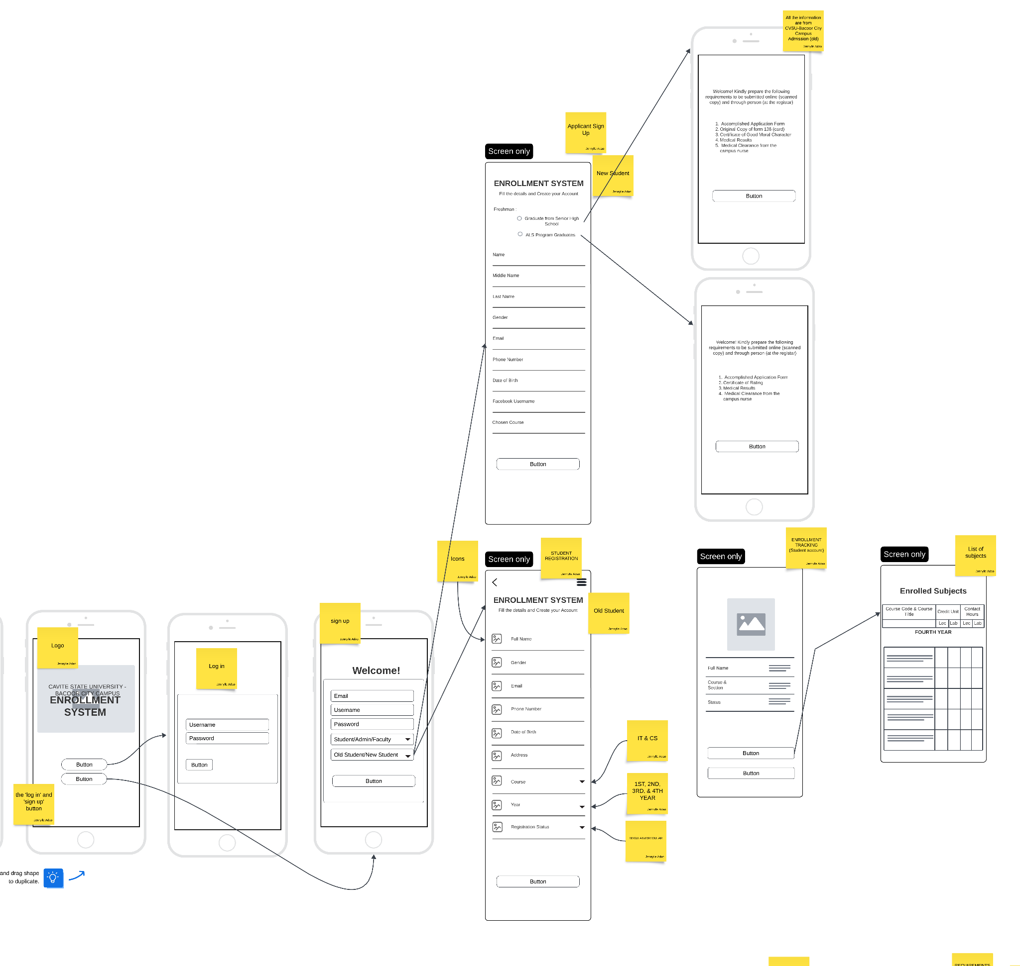

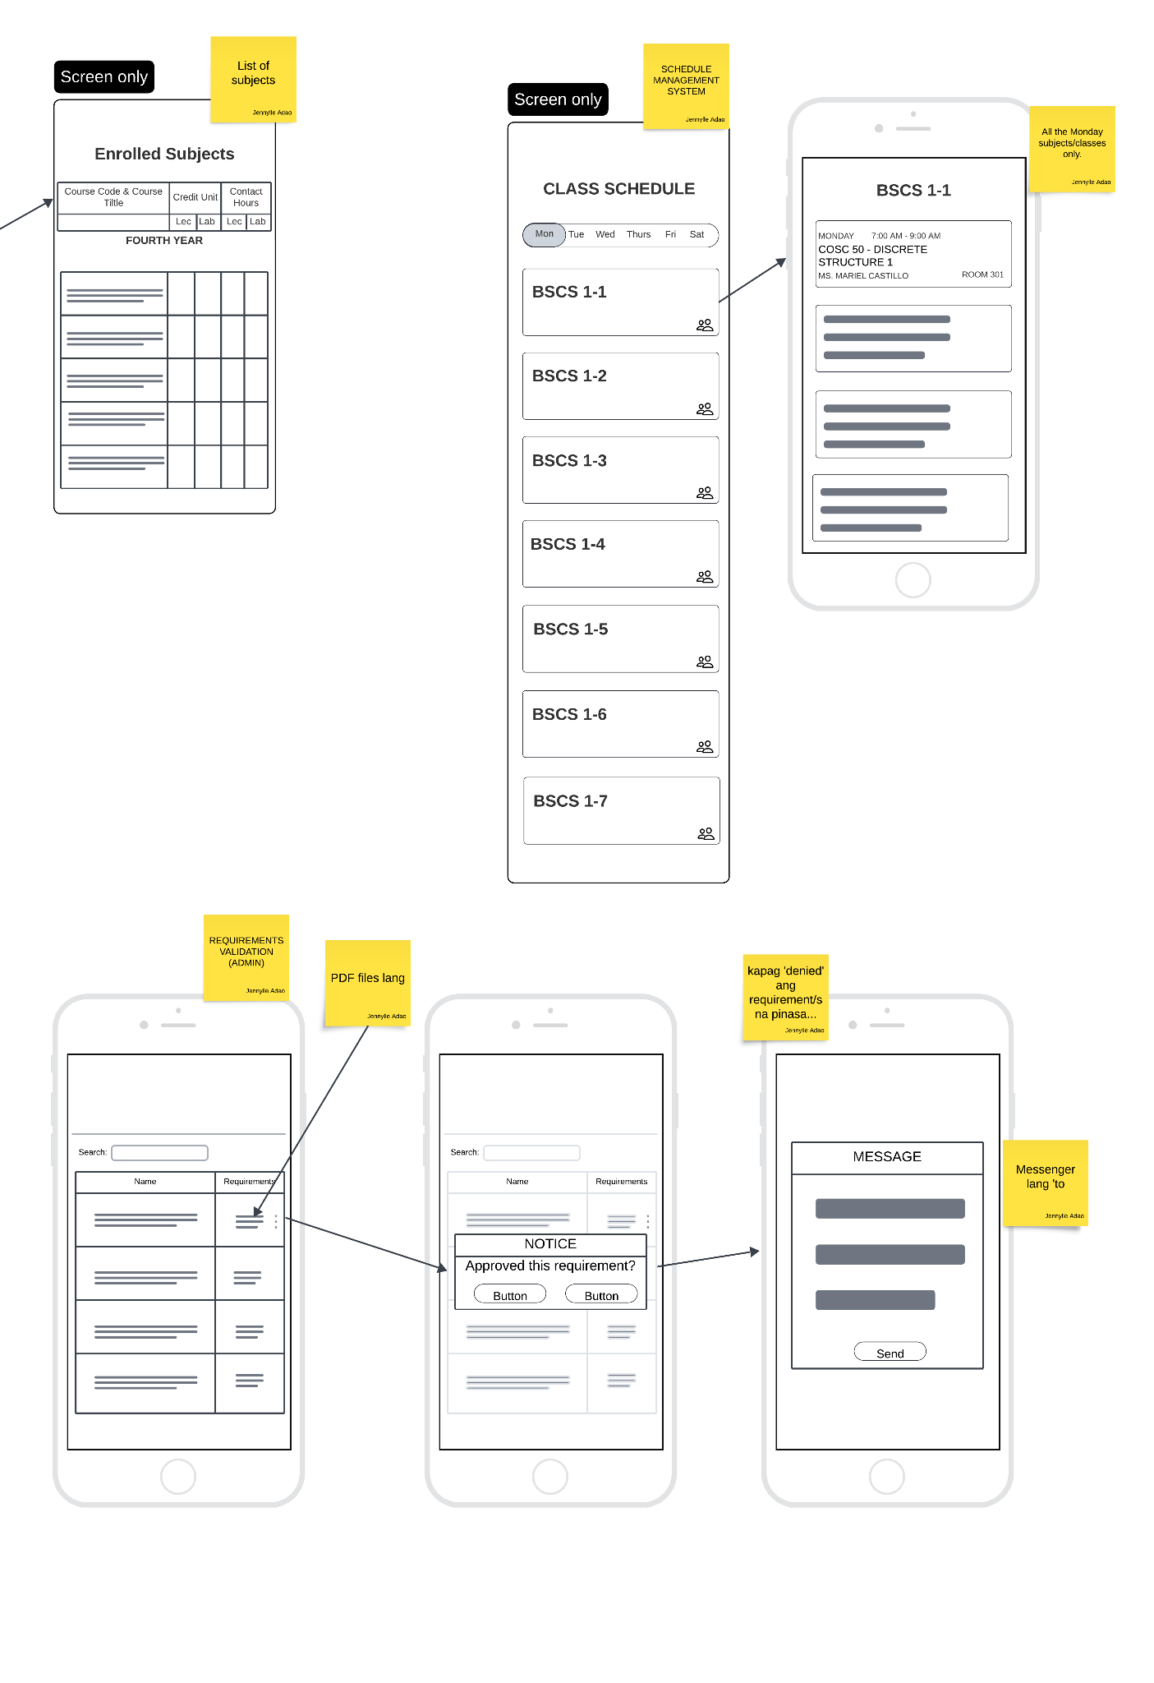

**Web Design**

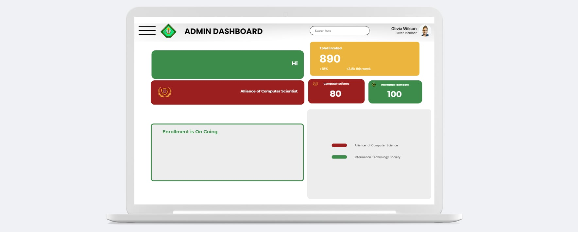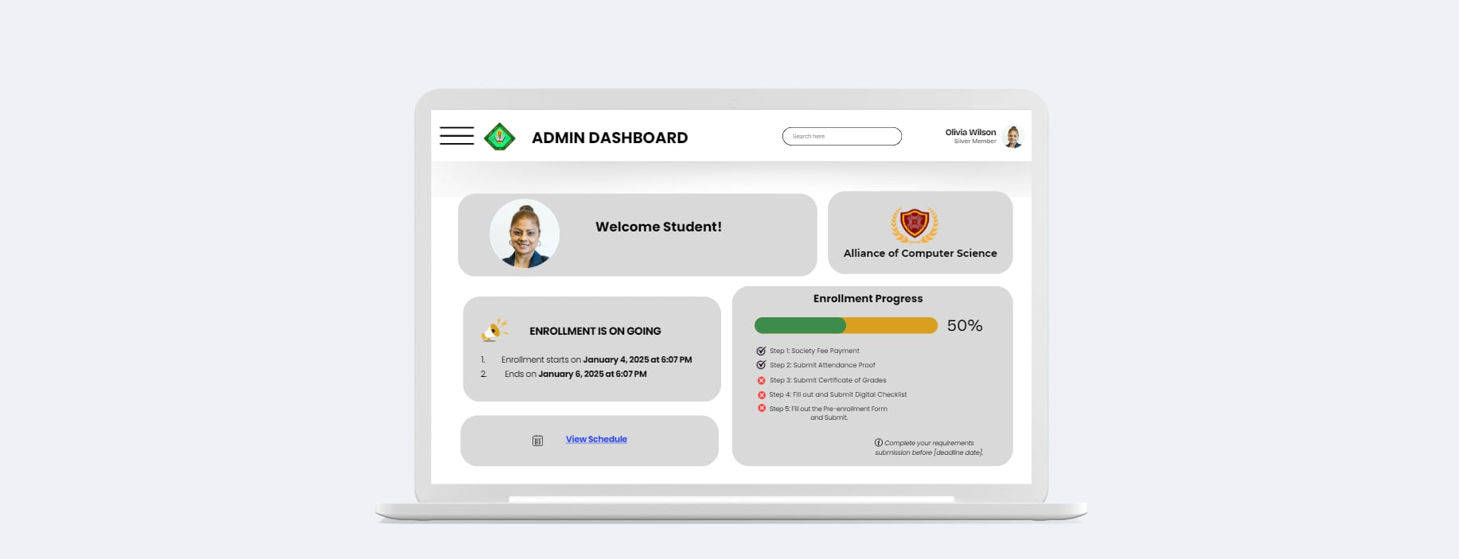

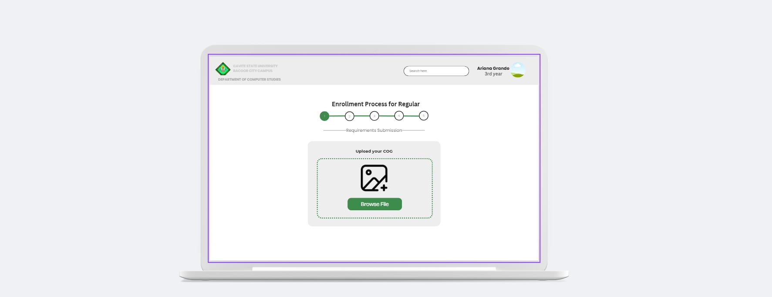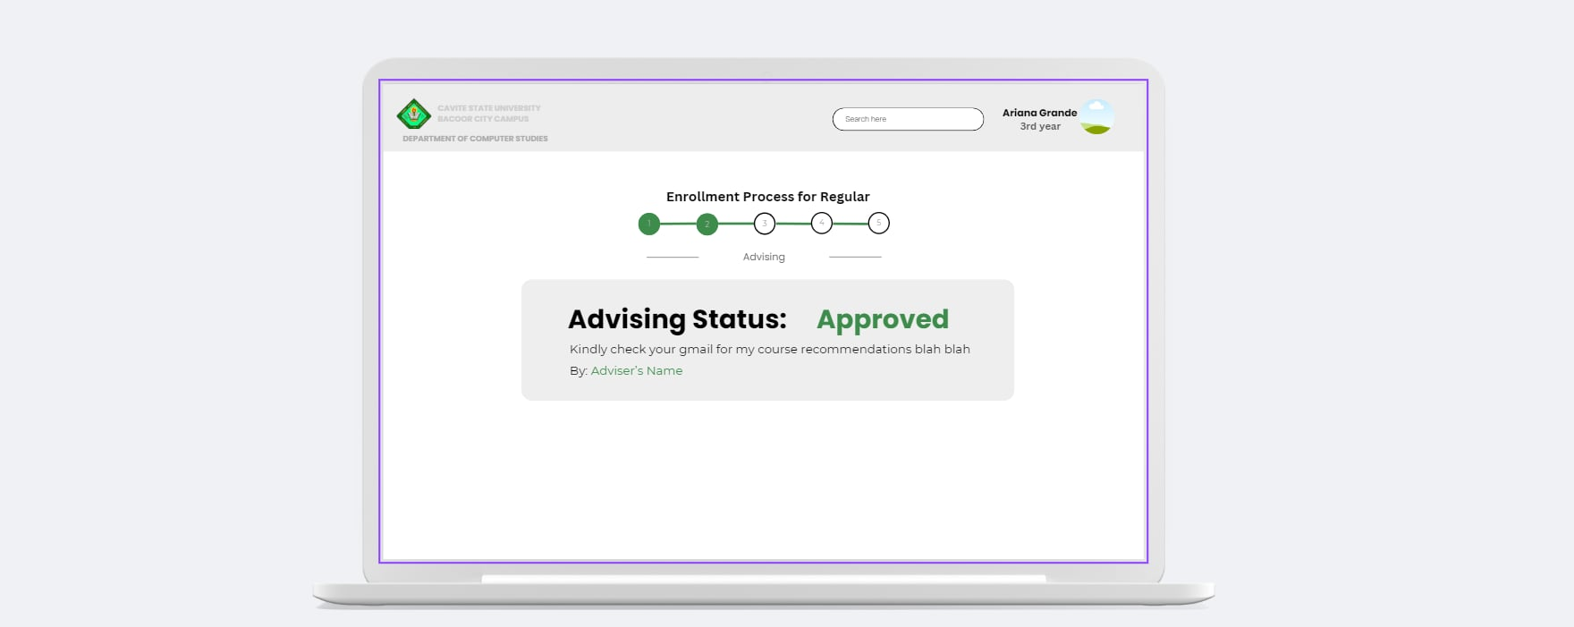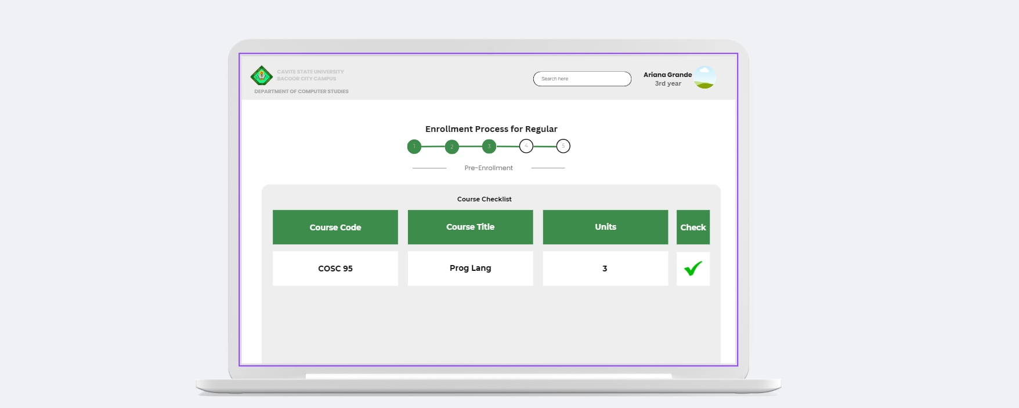

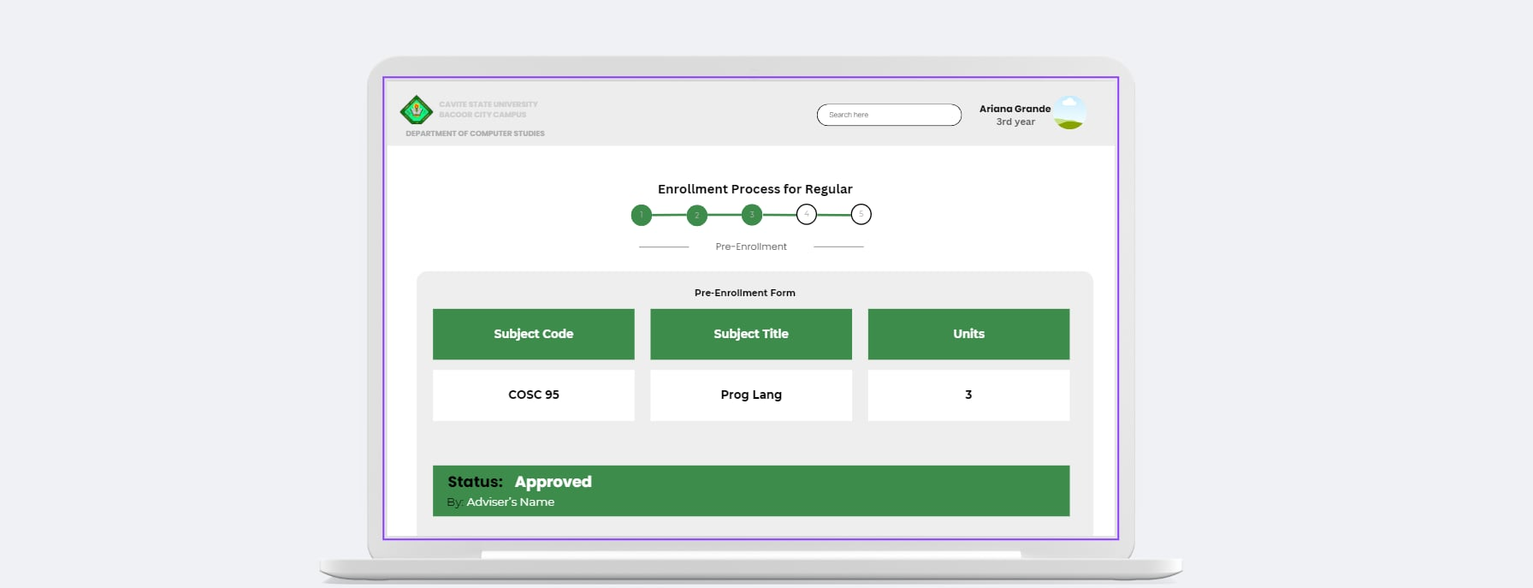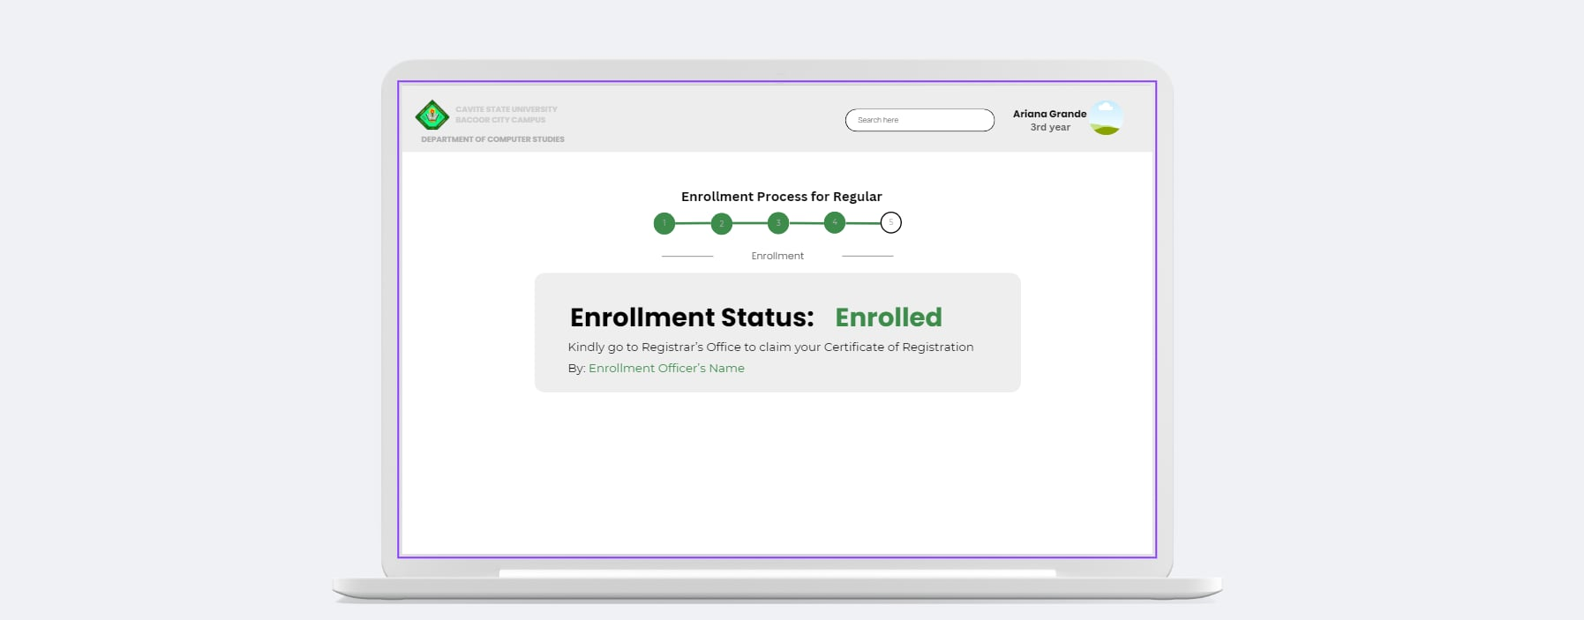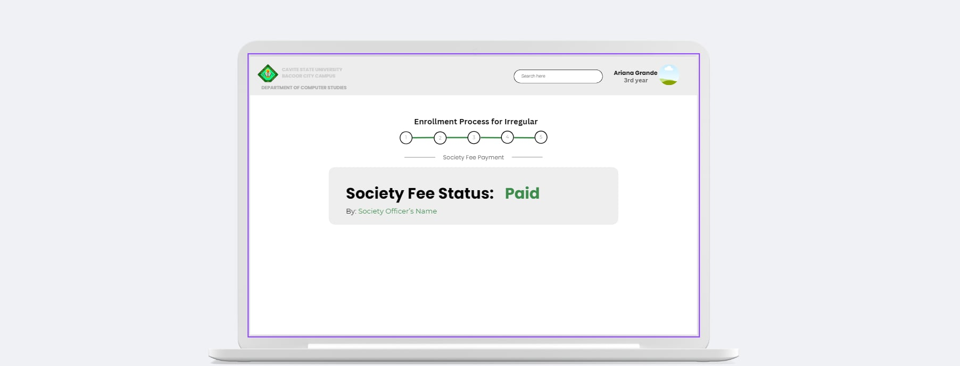

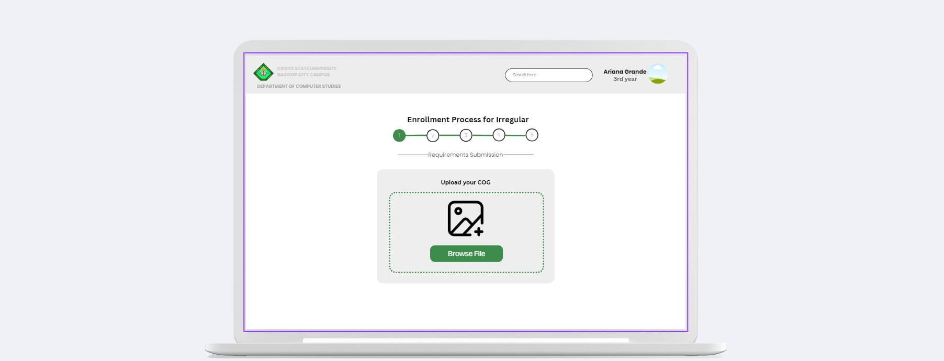

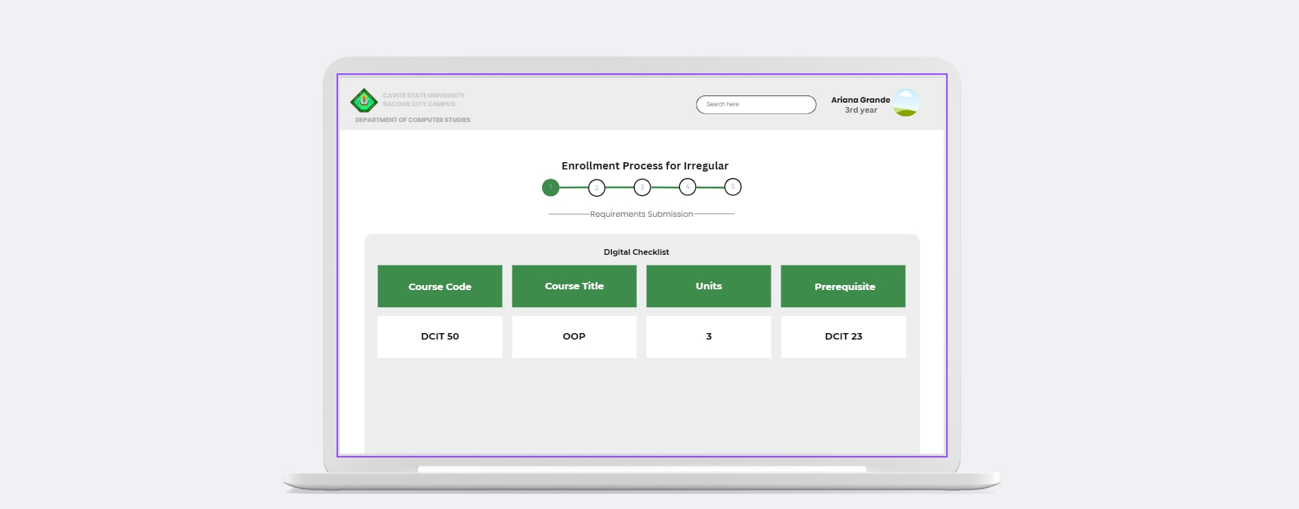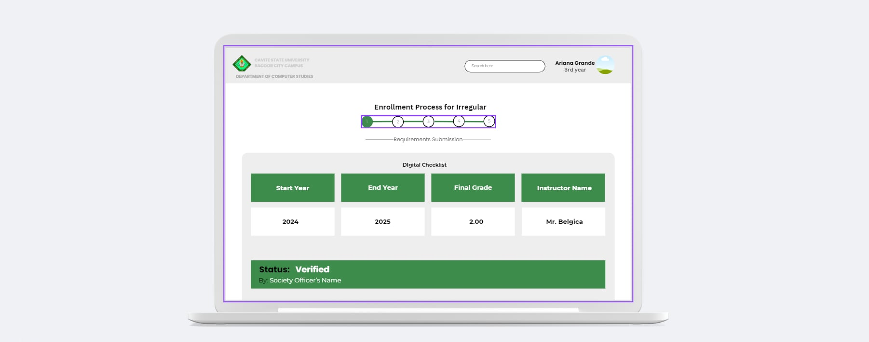

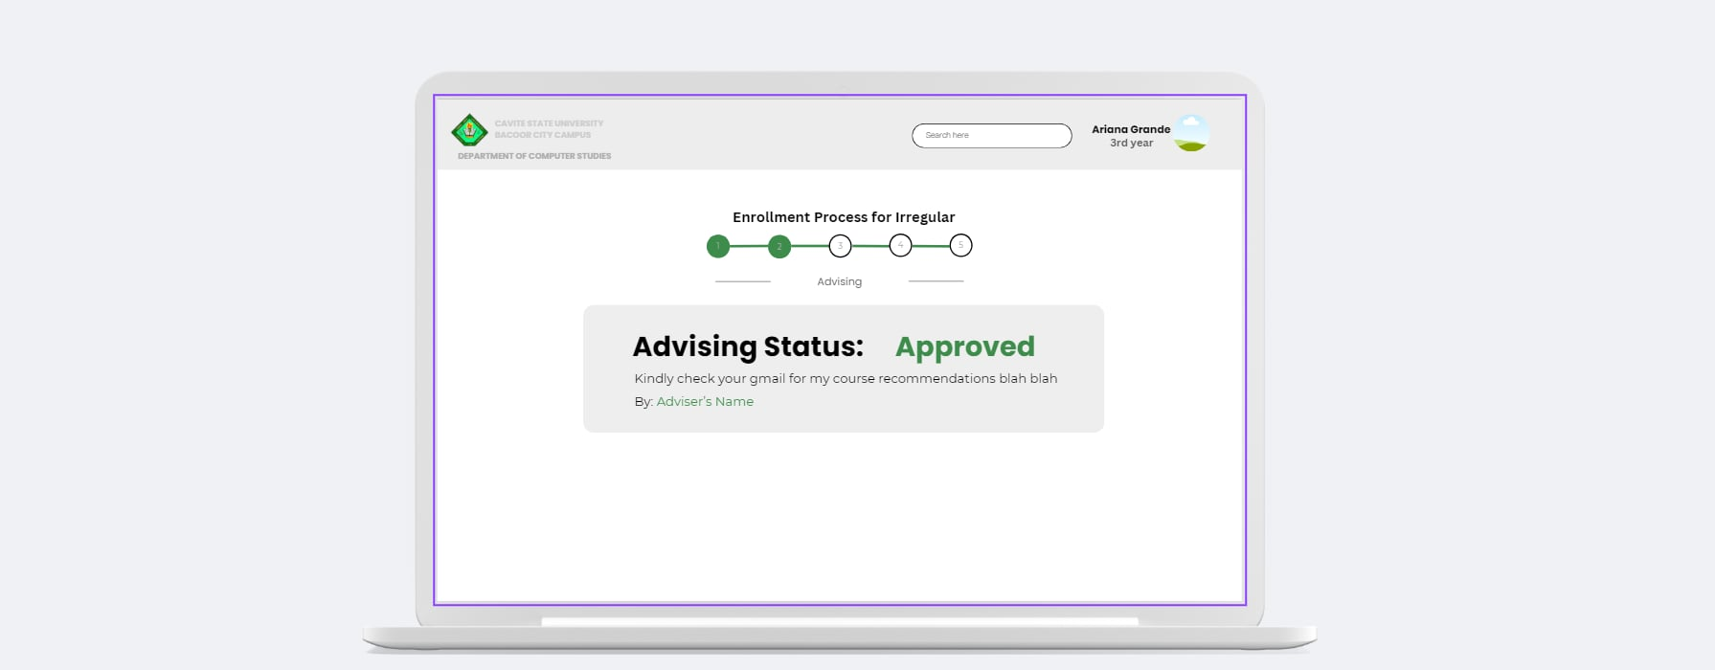

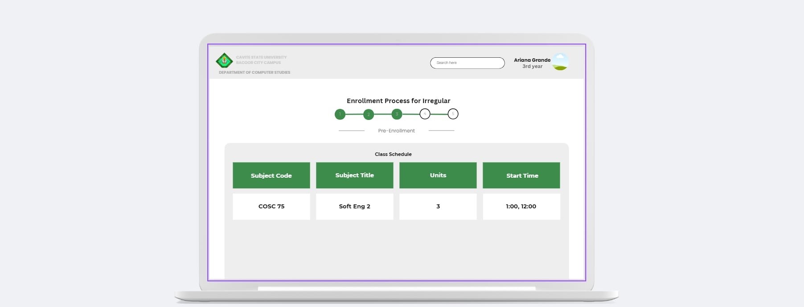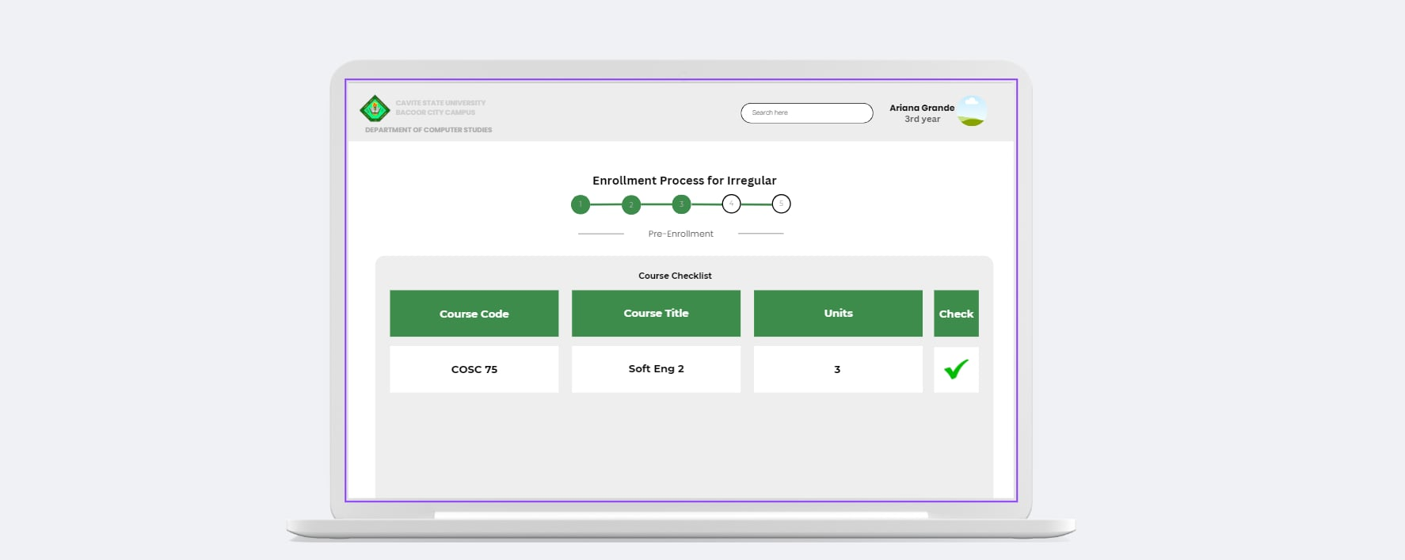

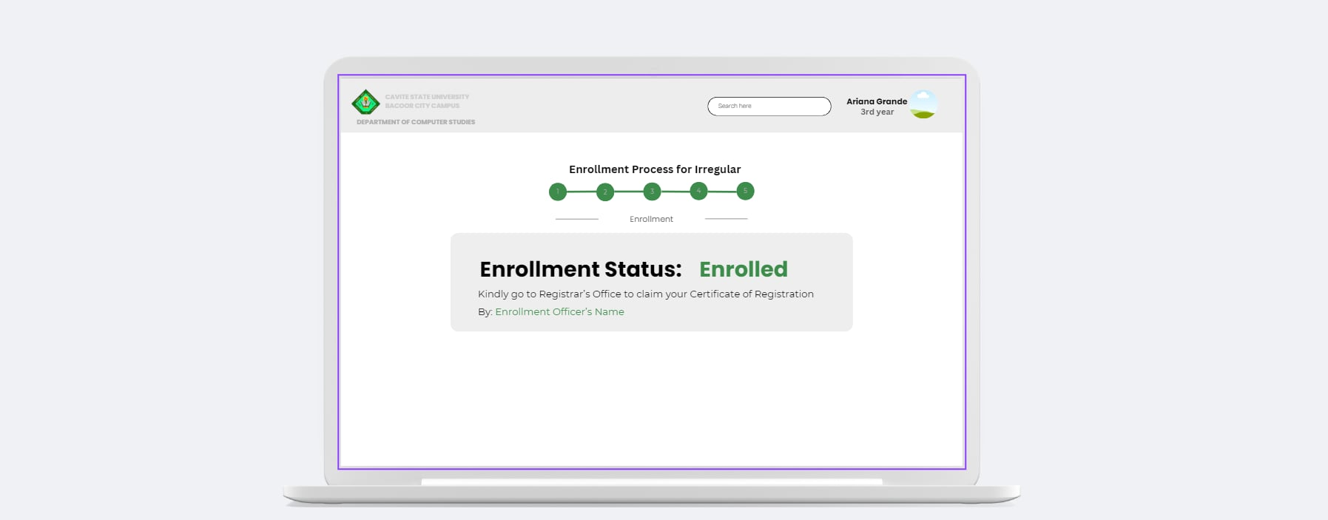**Mobile Design**

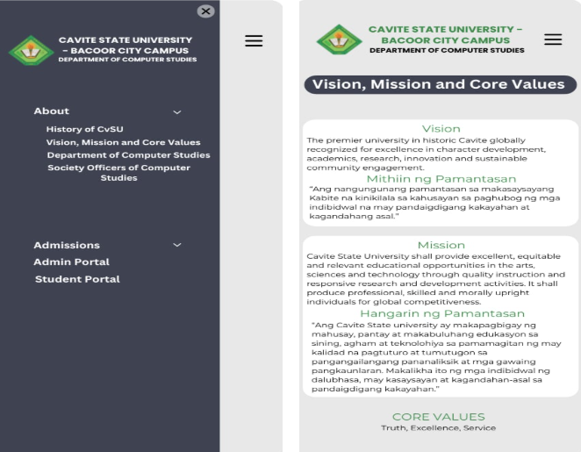

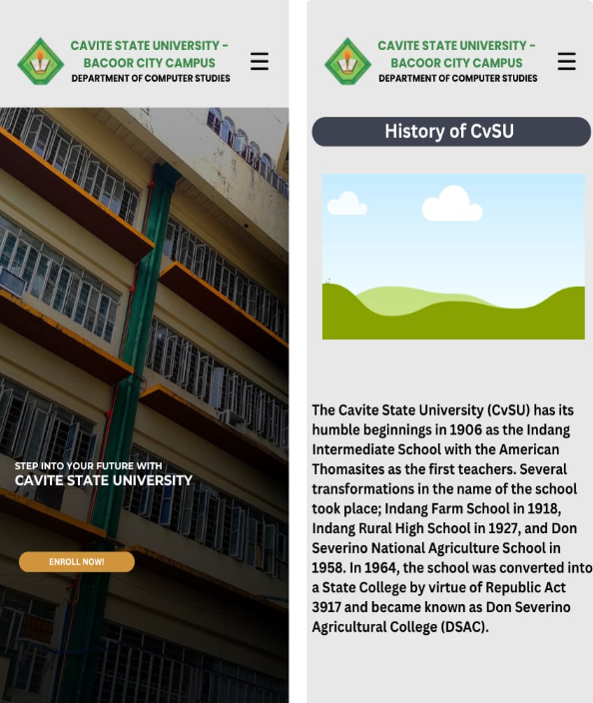

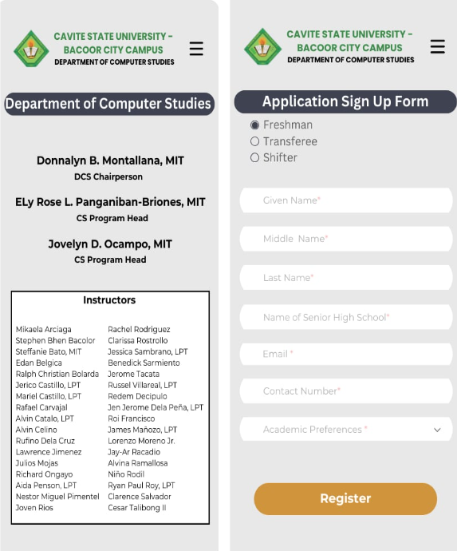

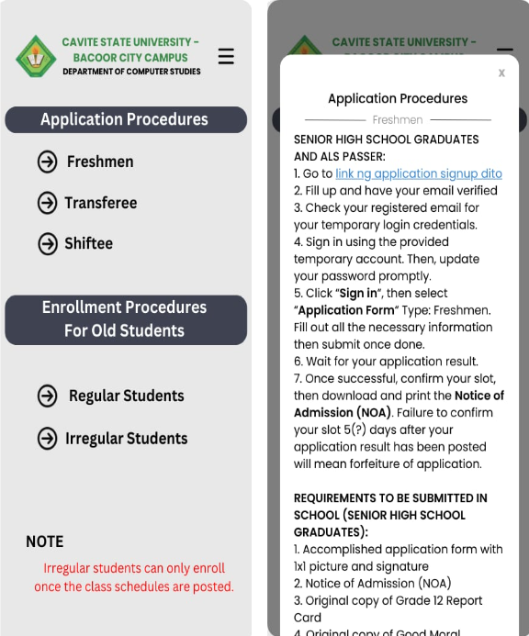

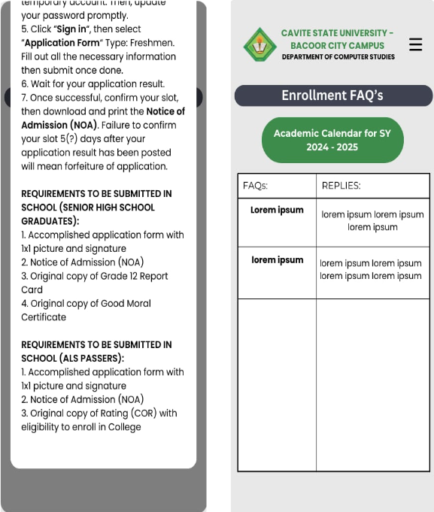

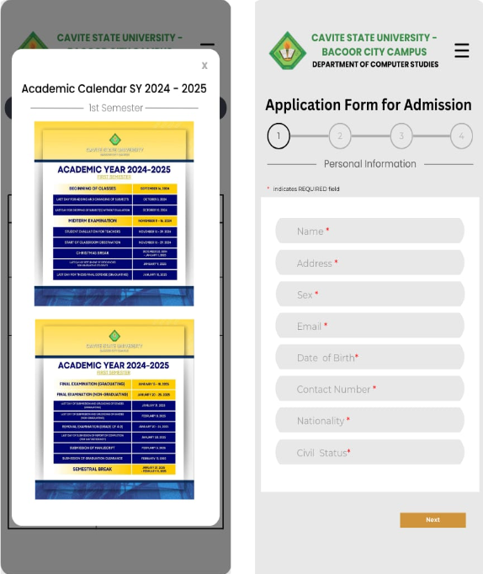

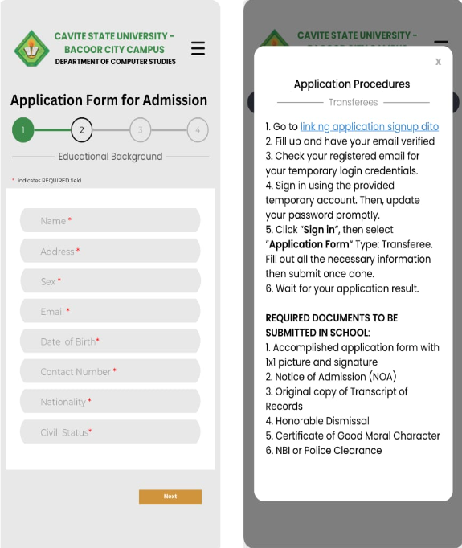

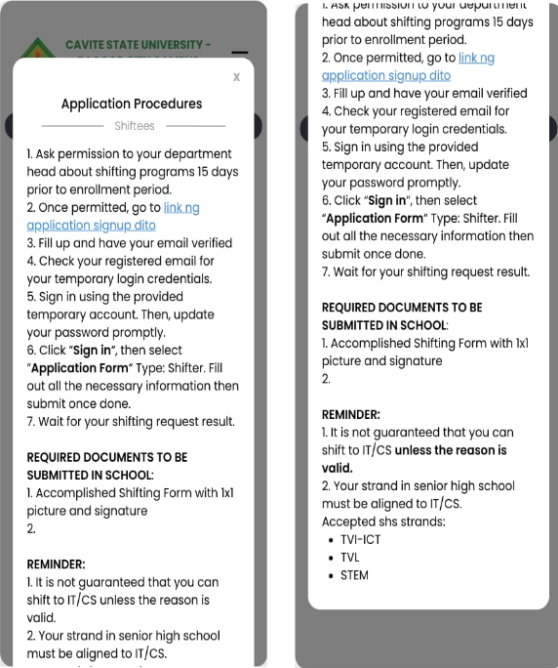

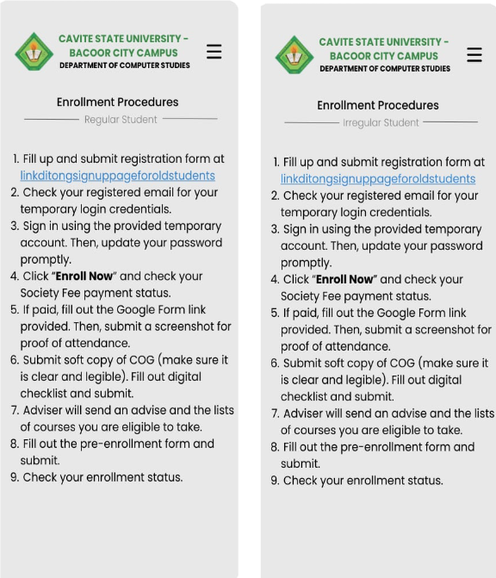

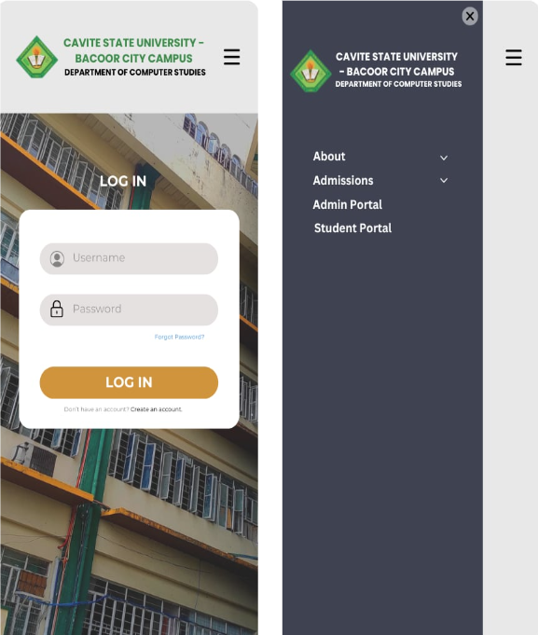

# 6. Implementation

* 1. **Development Tools and Environment**
* **Development Tools**
  + Visual Studio Code as the code editor
  + Axios for API calls and testing
  + Git and GitHub Desktop for version control
  + Node Package Manager (npm)
  + Trello for tracking project progress and tasks
  + dbdiagram.io and Visual Paradigm for creating diagrams and visual representations
  + Canva and Lucidchart for designing pages and workflows
  + Google Docs for documentation
  + Google Meet for team meetings and real-time collaborations
  + XAMPP Control Panel for managing the local server environment
  + phpMyAdmin for managing database
* **Programming Languages and Frameworks**
  + *JavaScript* for both frontend and backend
  + *HTML5* and *CSS3* for UI design
  + *Jest + React Testing Library* for testing frontend components
  + *Jest* with *Supertest* for testing backend functionalities

**6.2 Features and Functionalities**

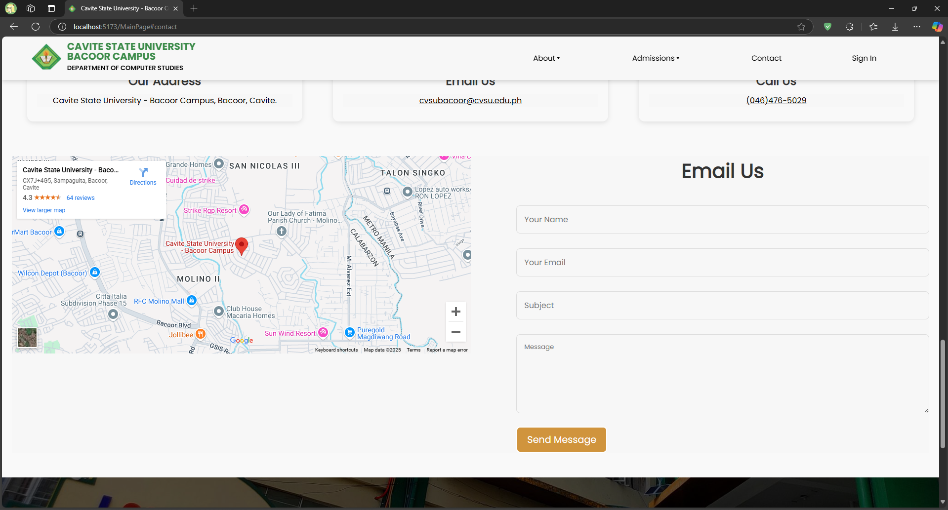

*Contact form for submitting inquiries*

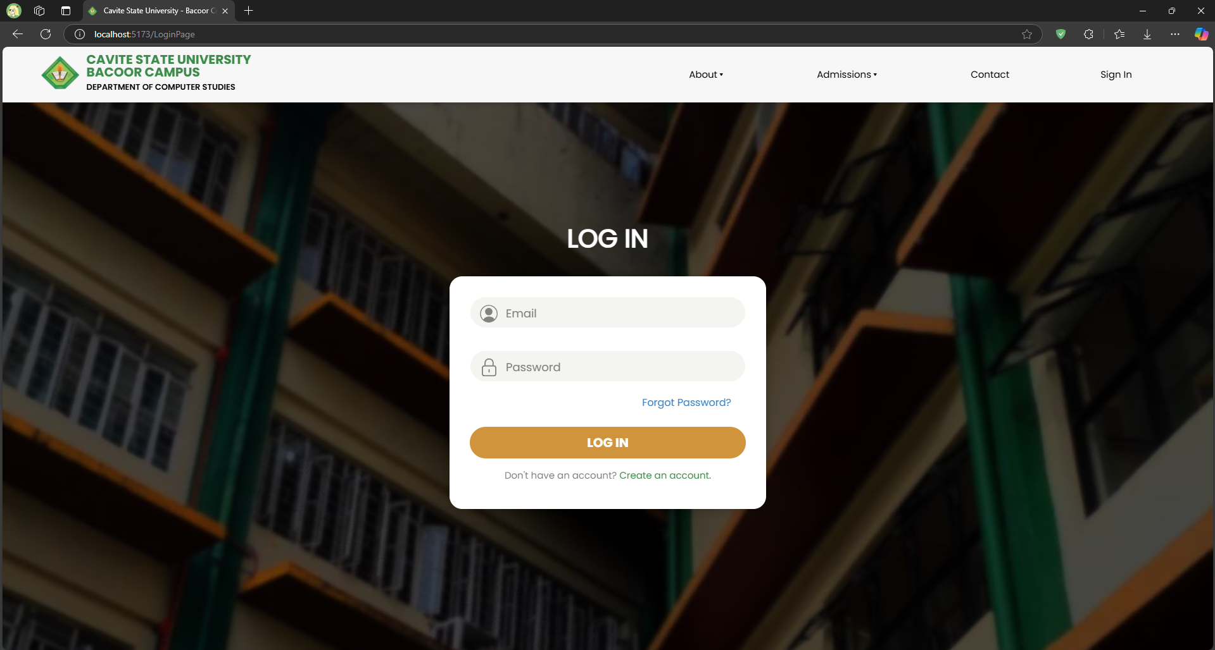

*User login for all account types*

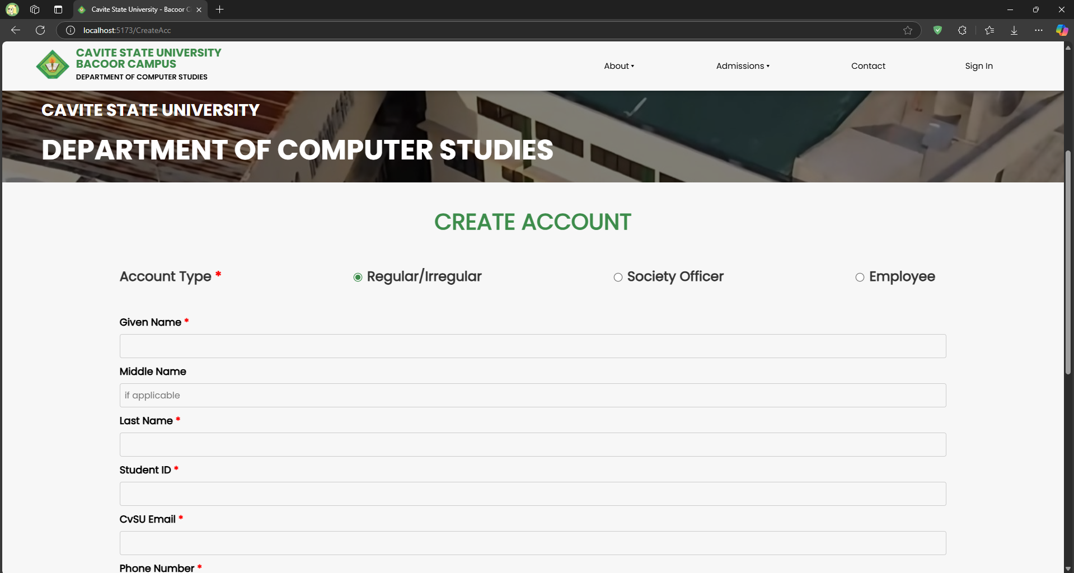

*User registration for returning students, society officers, and employees*

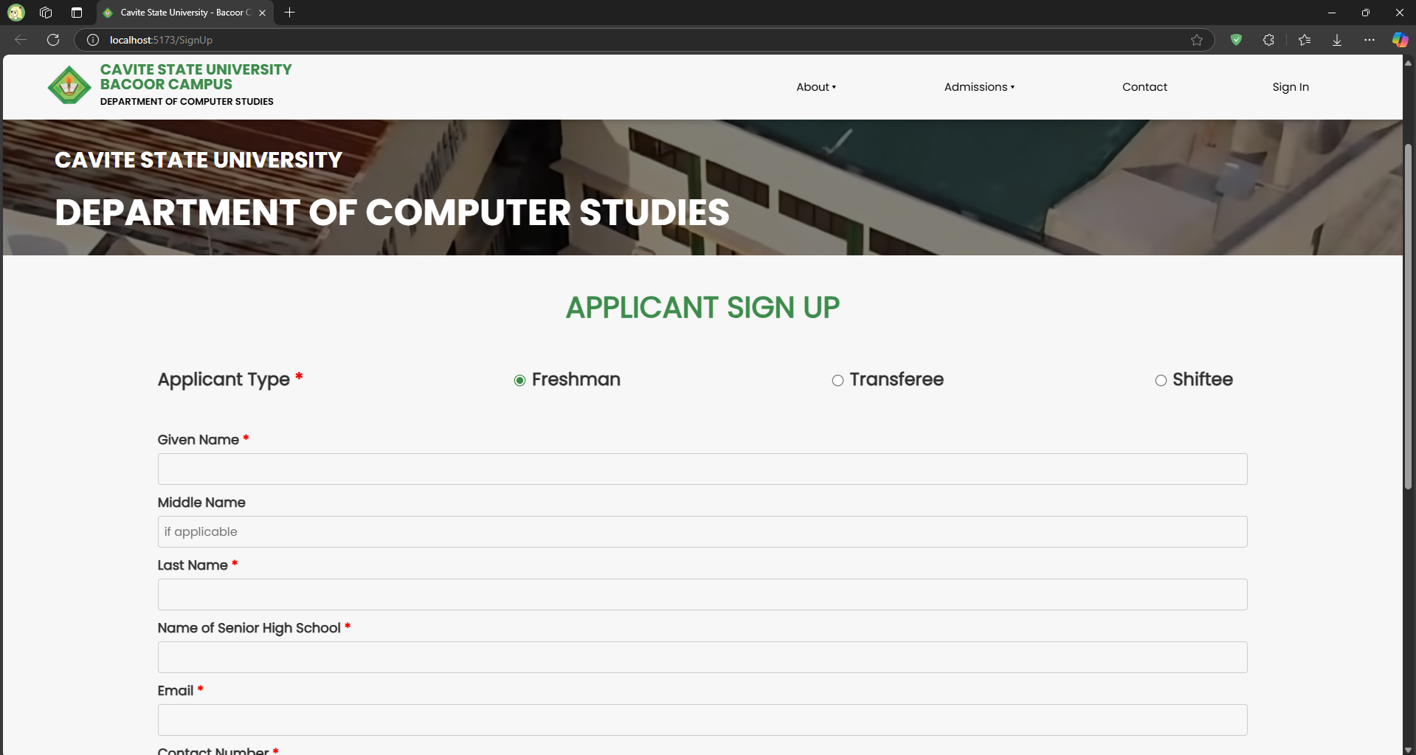

*User registration for incoming students*

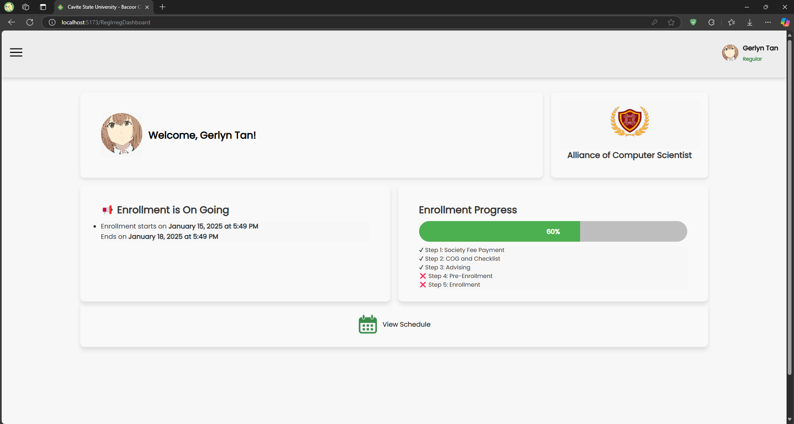

*Returning student dashboard for tracking enrollment progress*

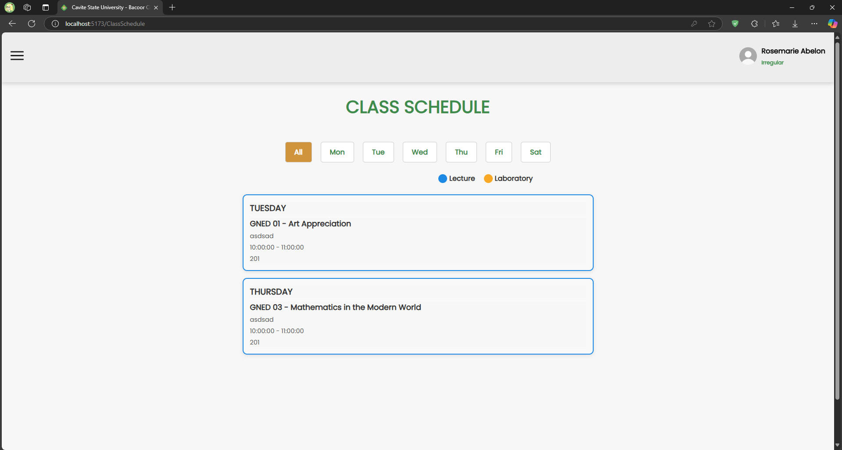

*Class schedule overview for enrolled courses*

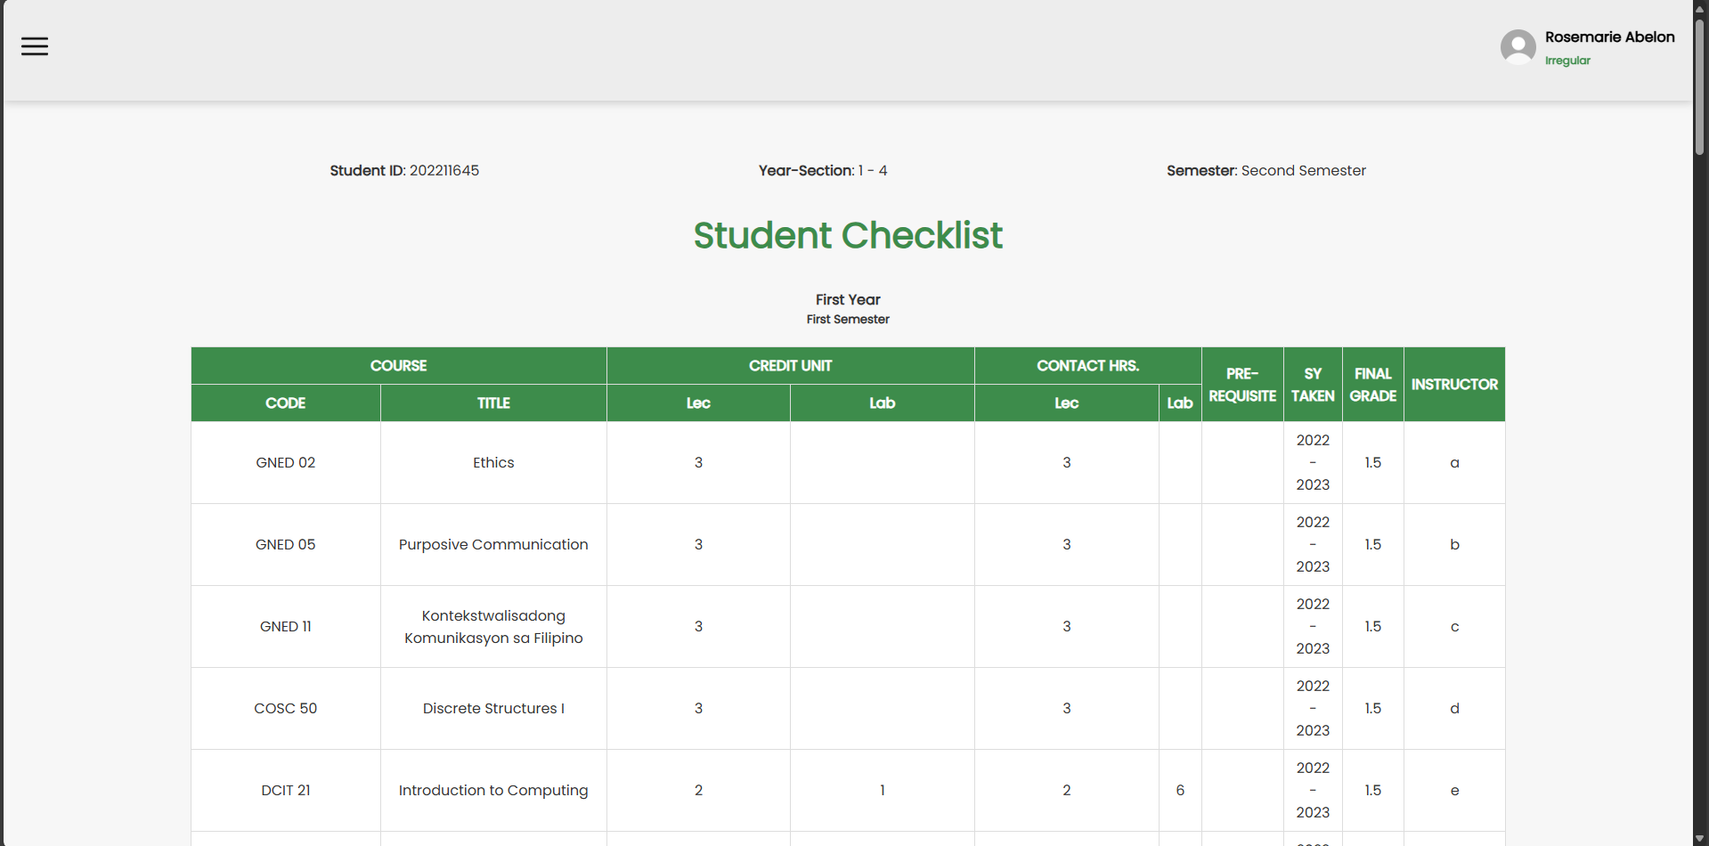

*Student digital checklist overview for monitoring courses*

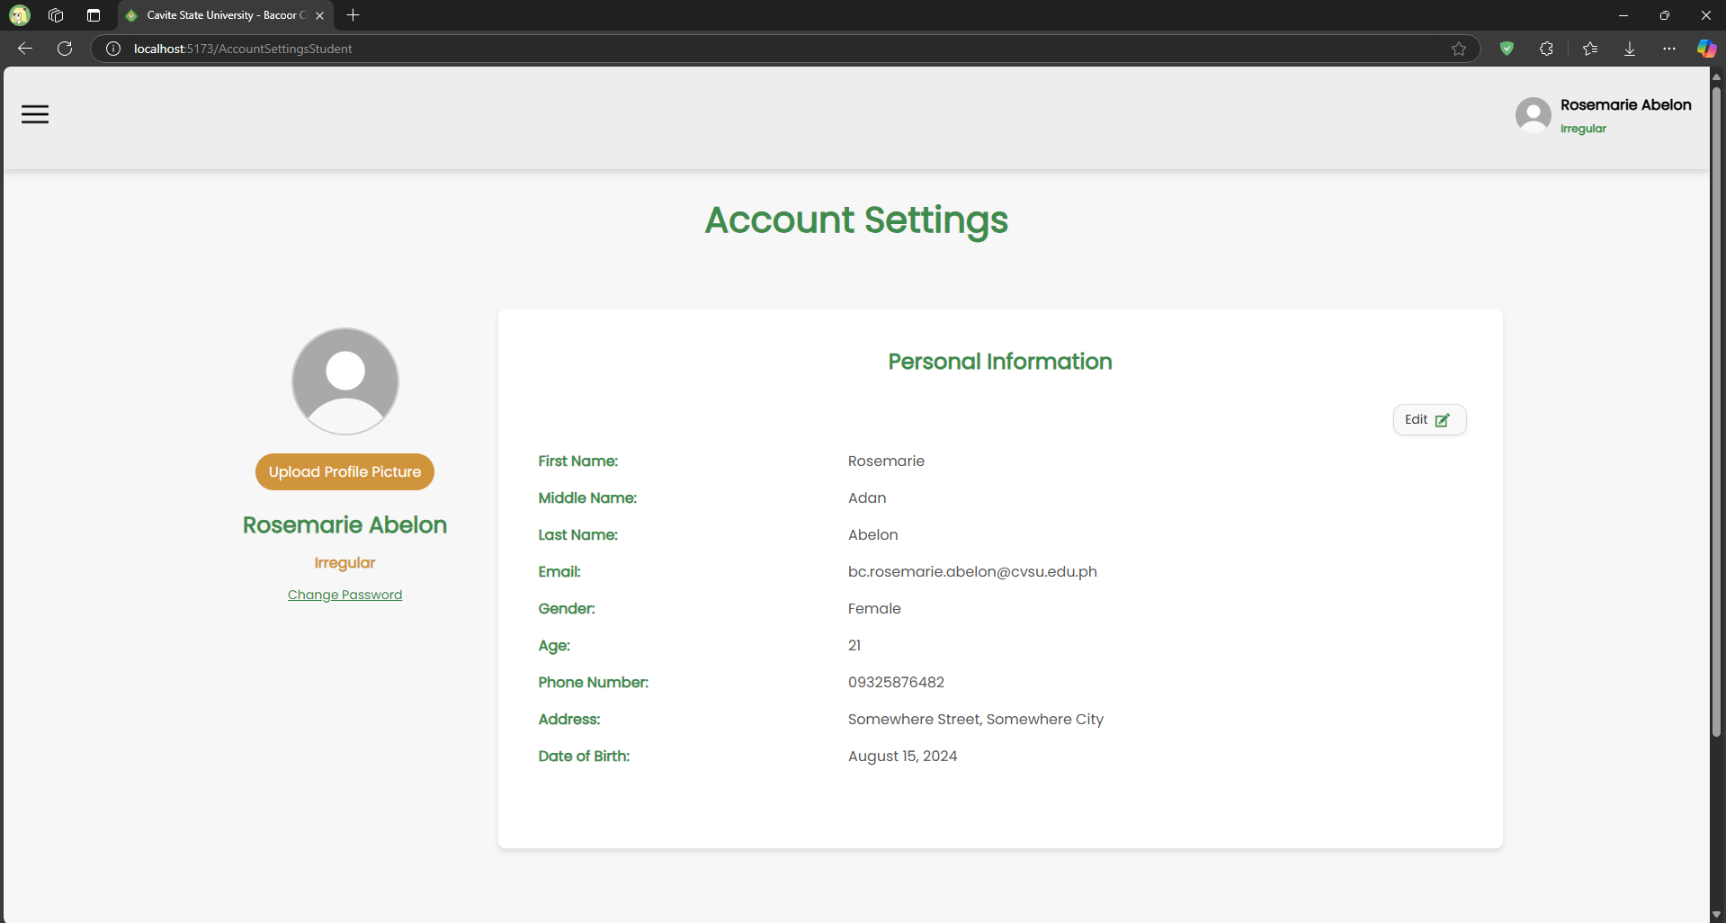

*User account settings for managing account information*

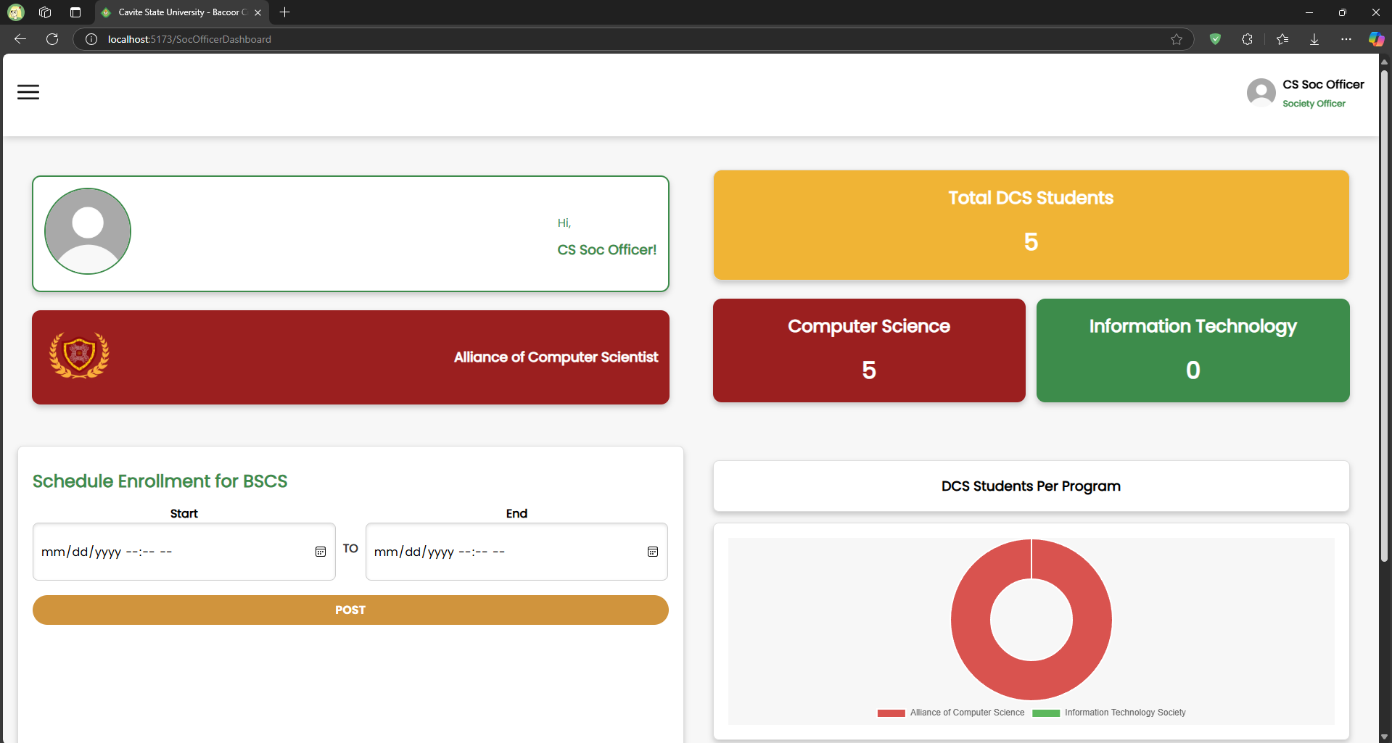

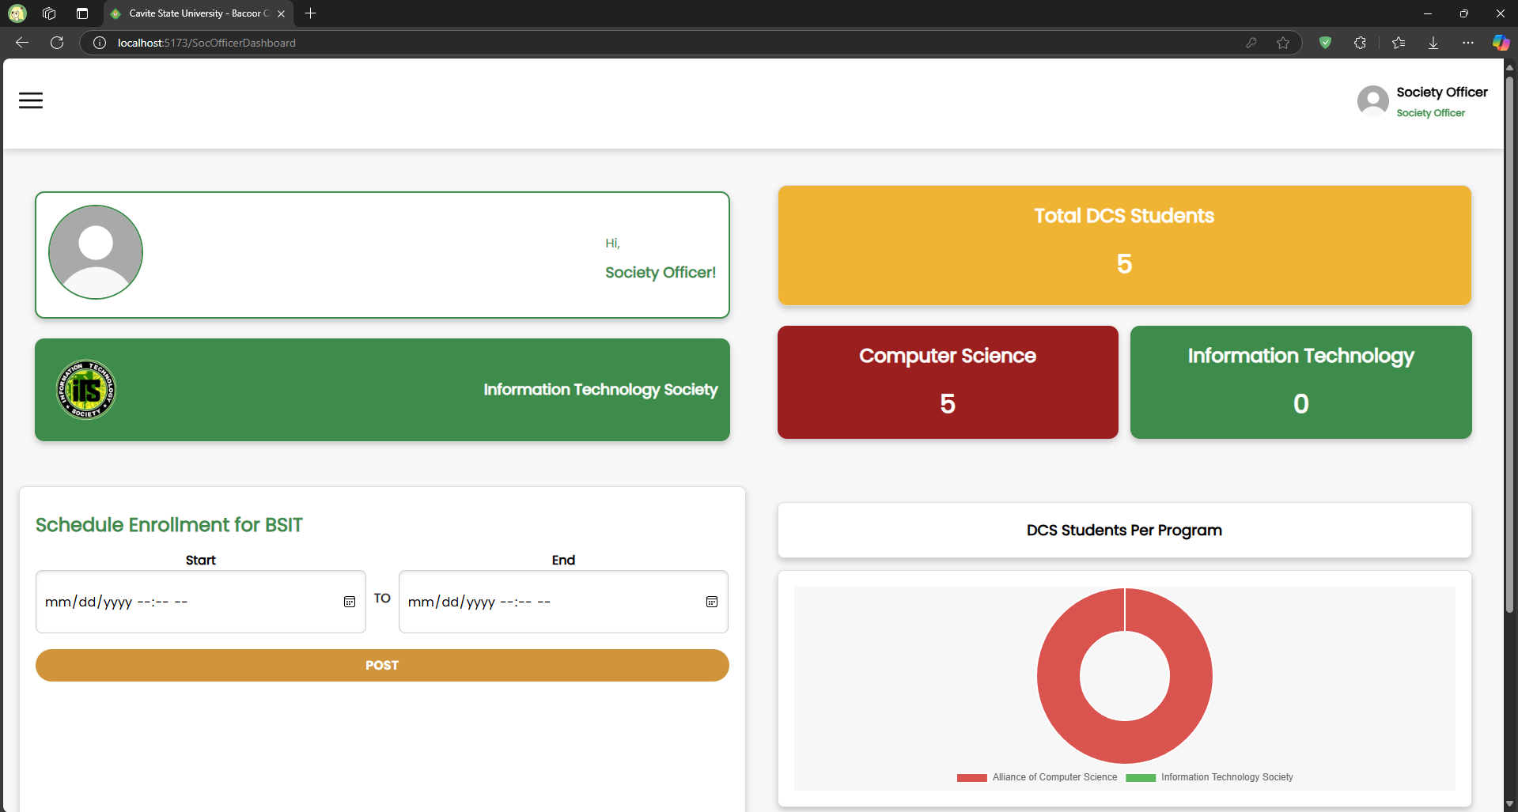

*Separate enrollment period for ITS and ACS*

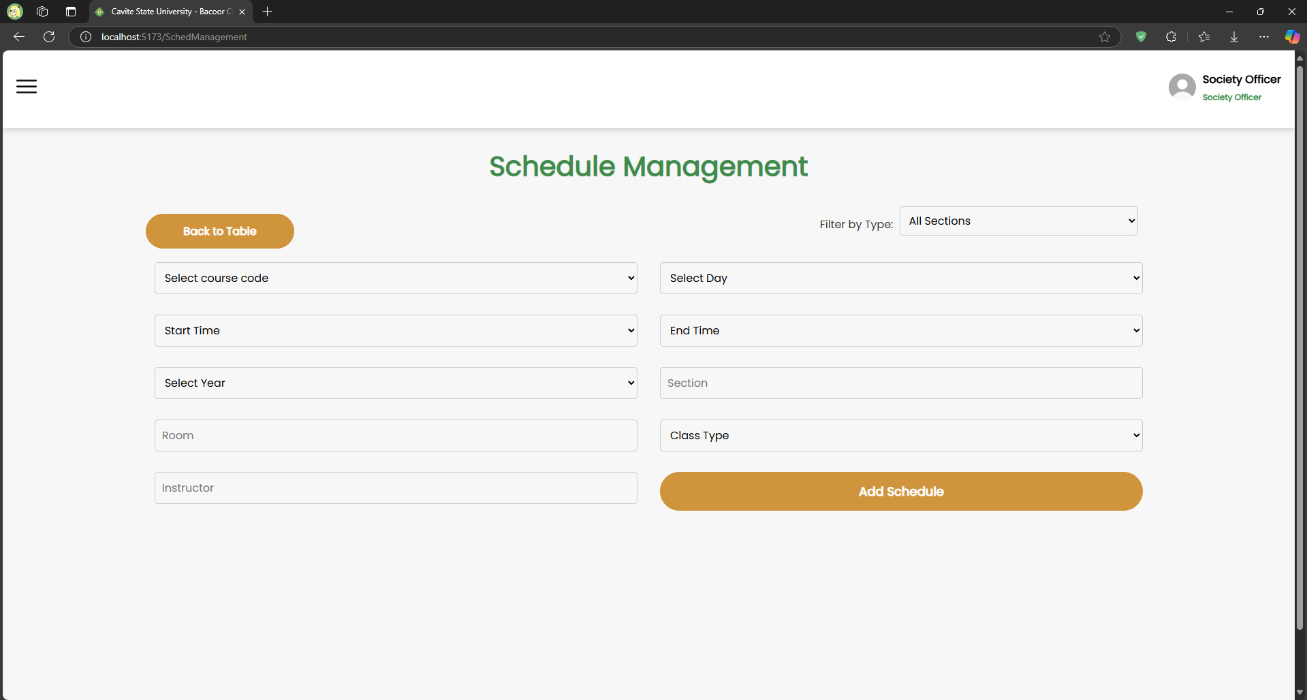

*Class schedule management for society officers*

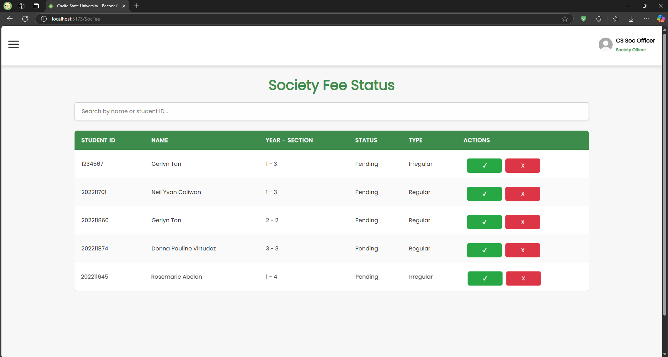

*Management of society fee status for society officers*

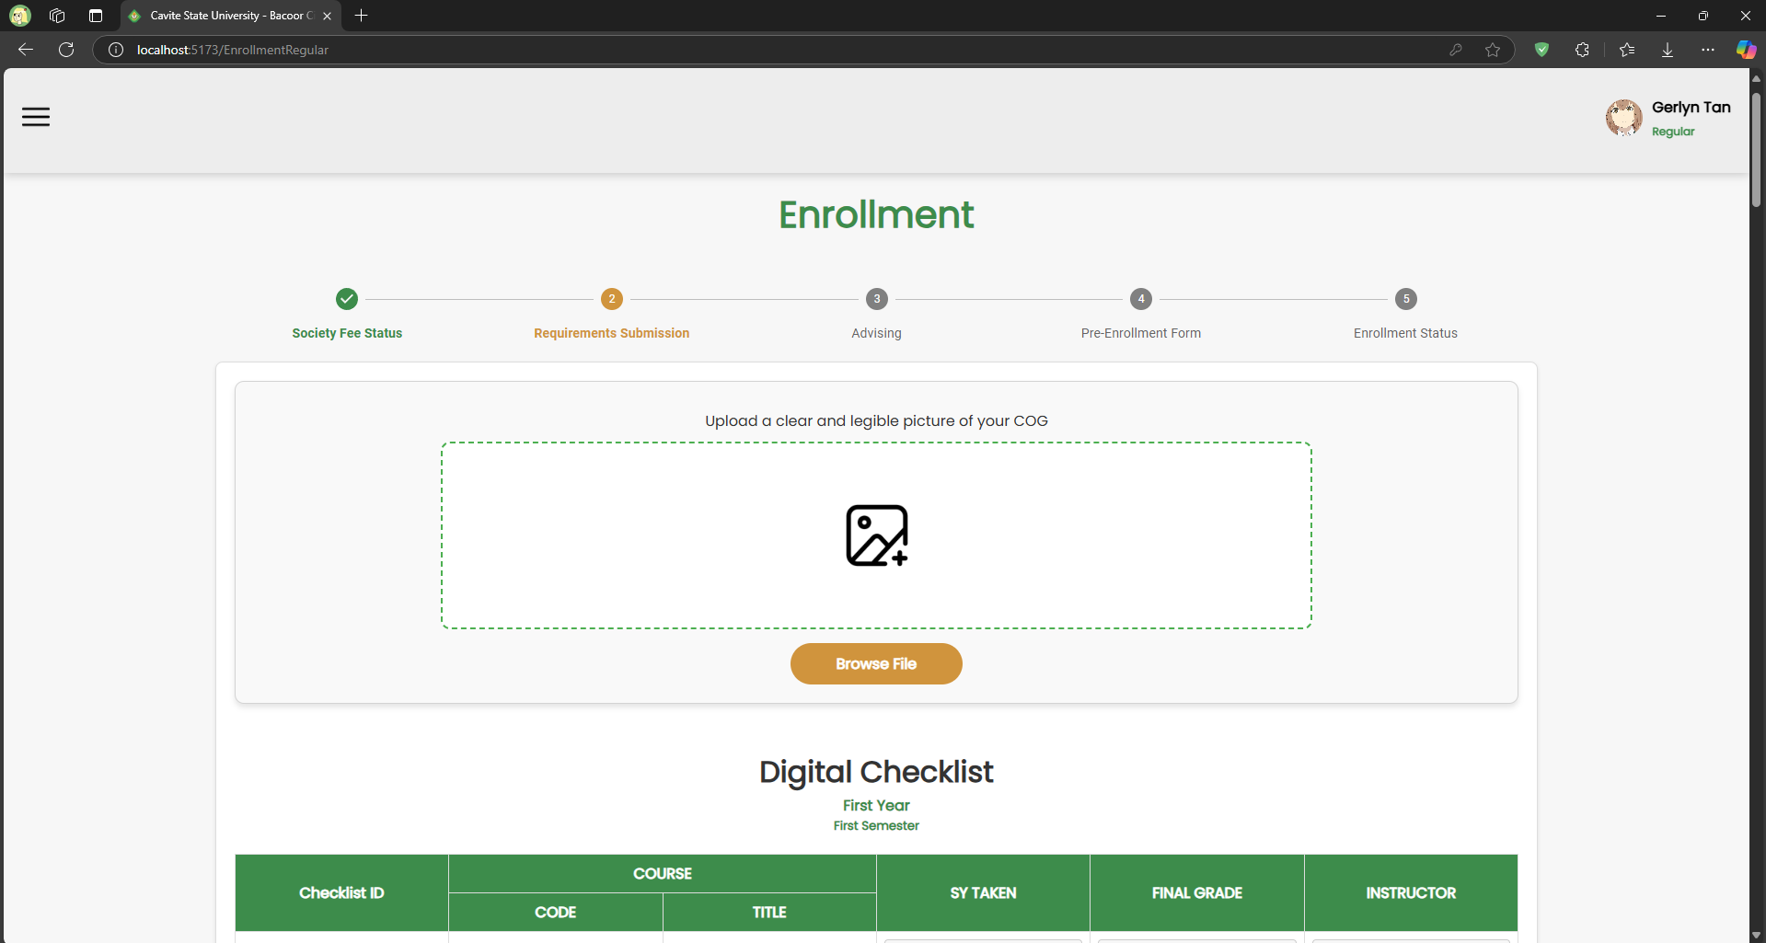

*Requirements submission for COG and digital checklist*

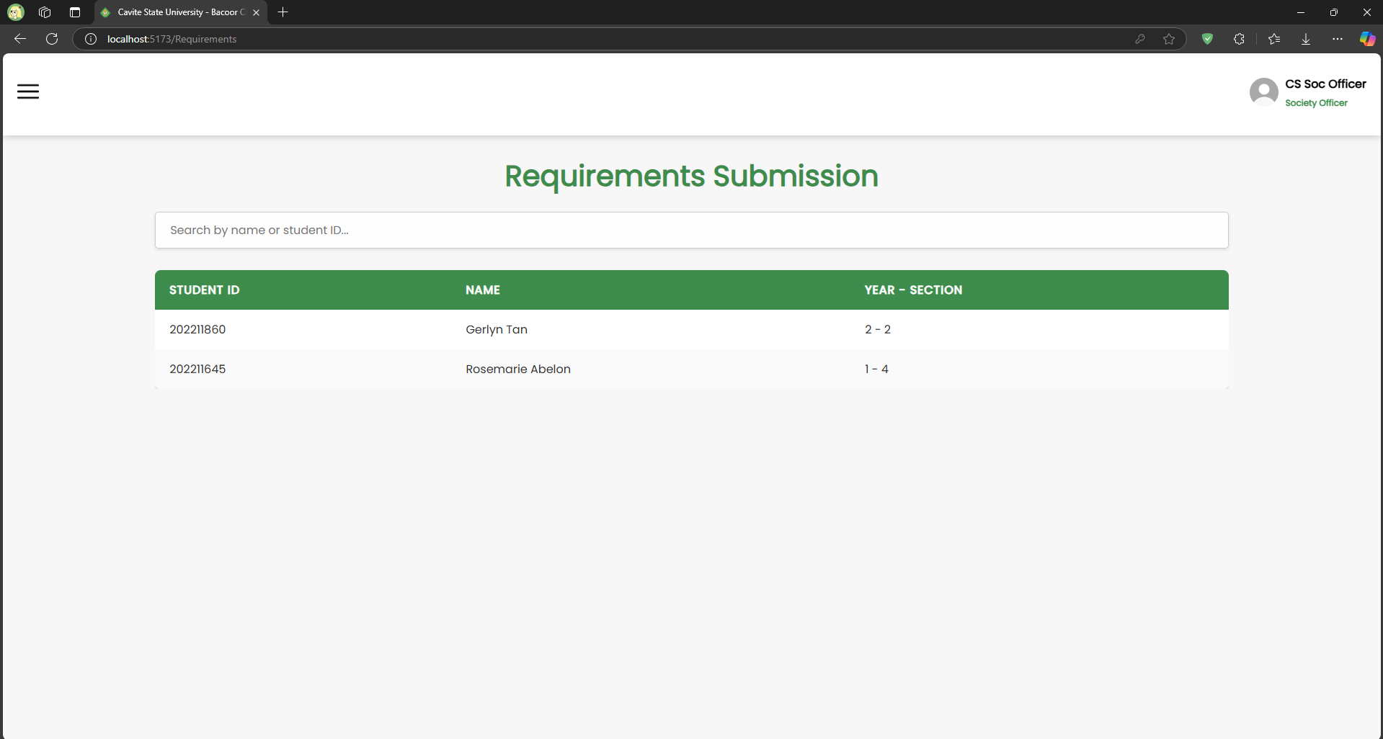

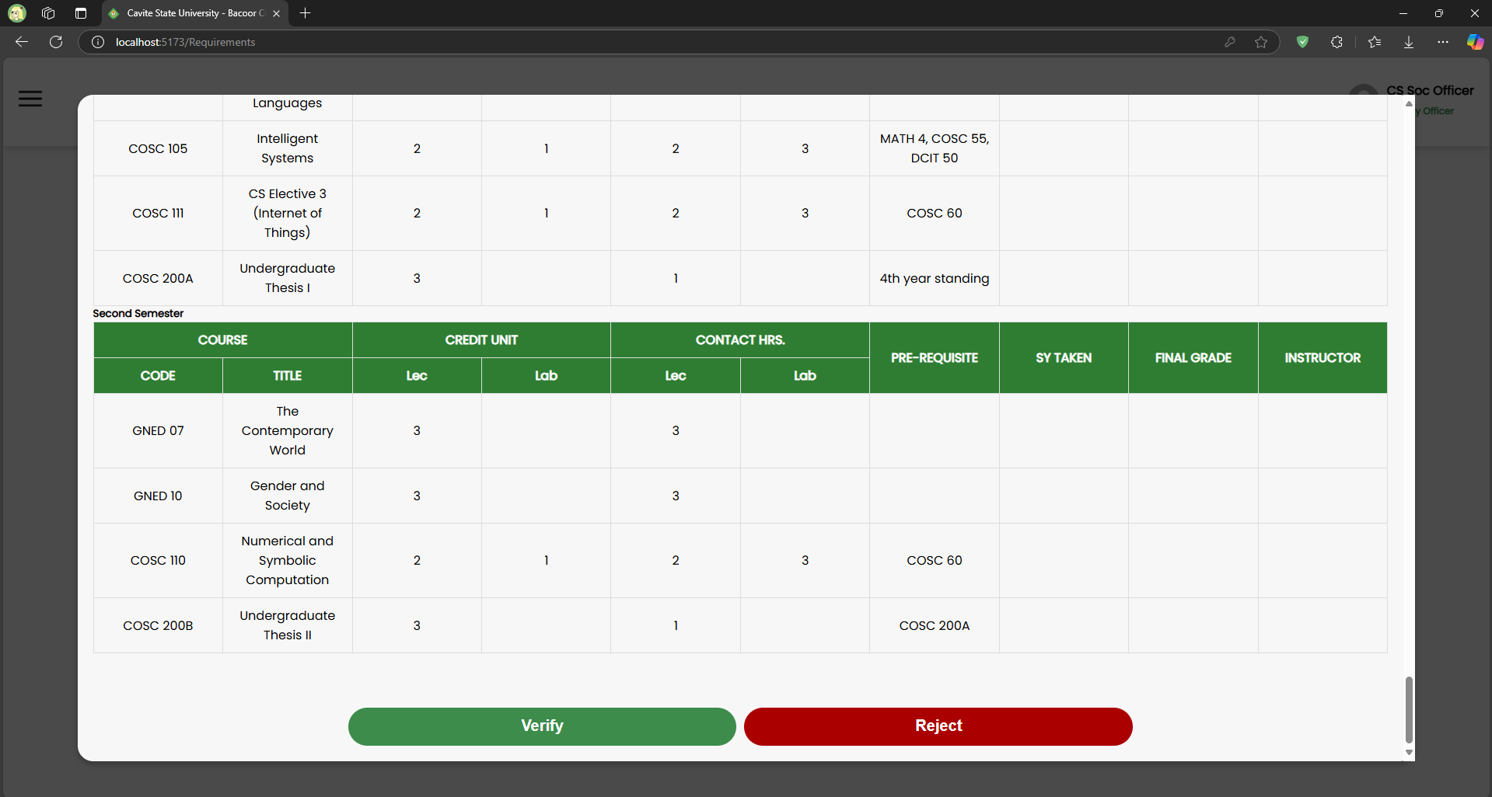

*Requirements verification for society officers*

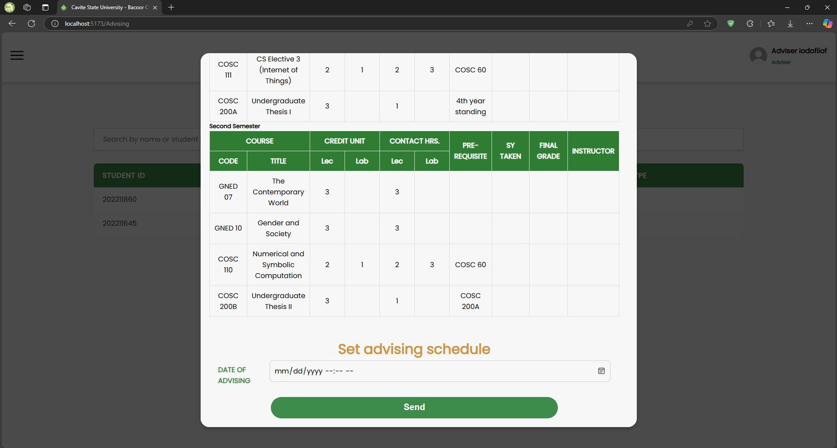

*Advising appointment scheduling for advisers*

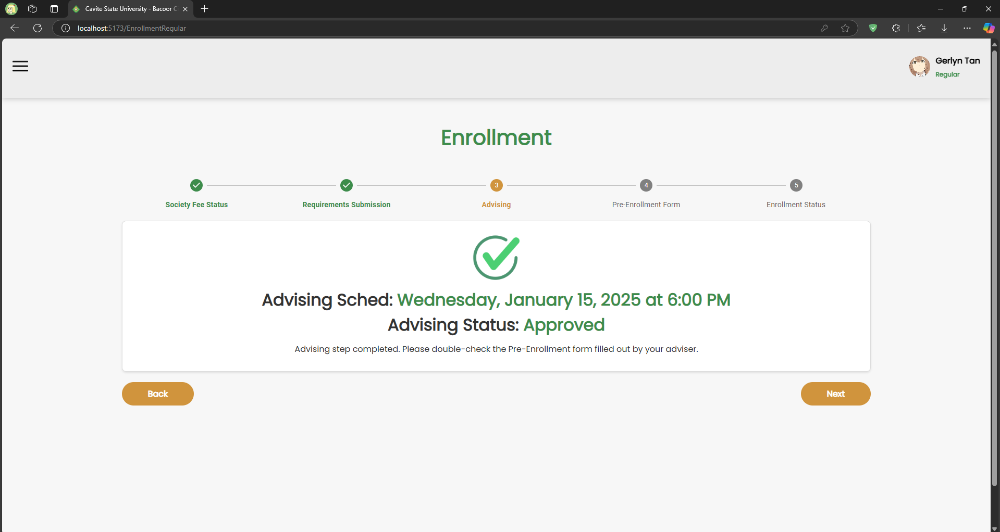

*Advising status page for monitoring advising schedule and status*

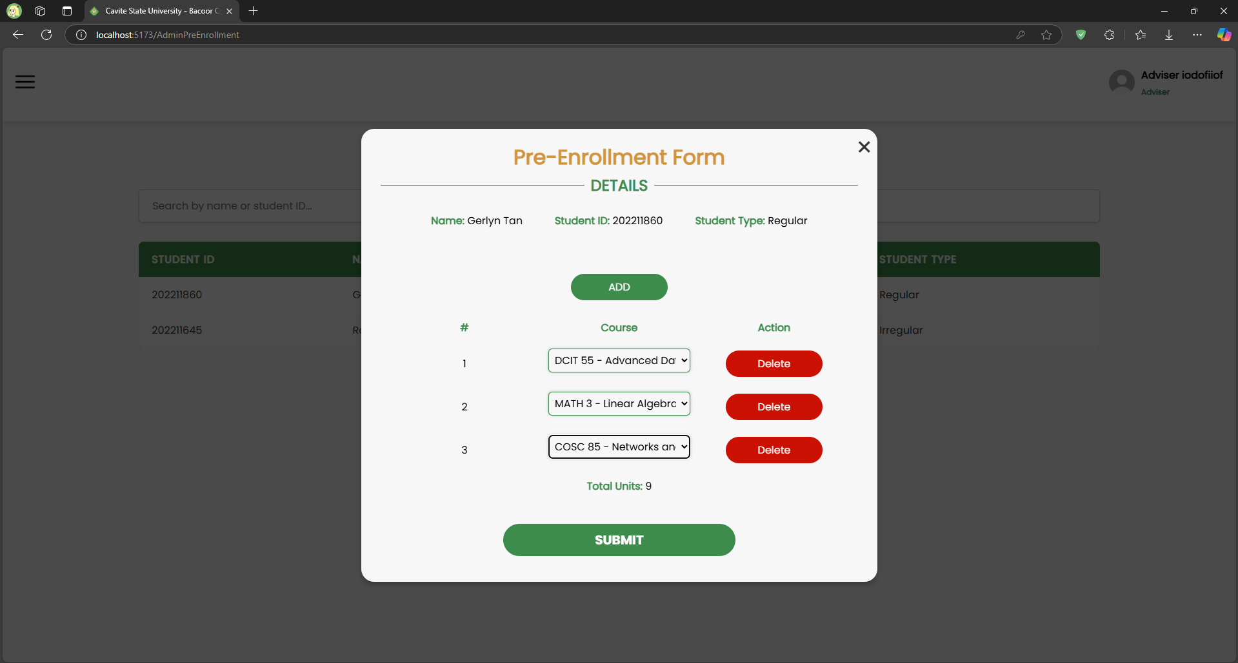

*Adviser course selection page showing a regular student’s selected courses during in-person advising*

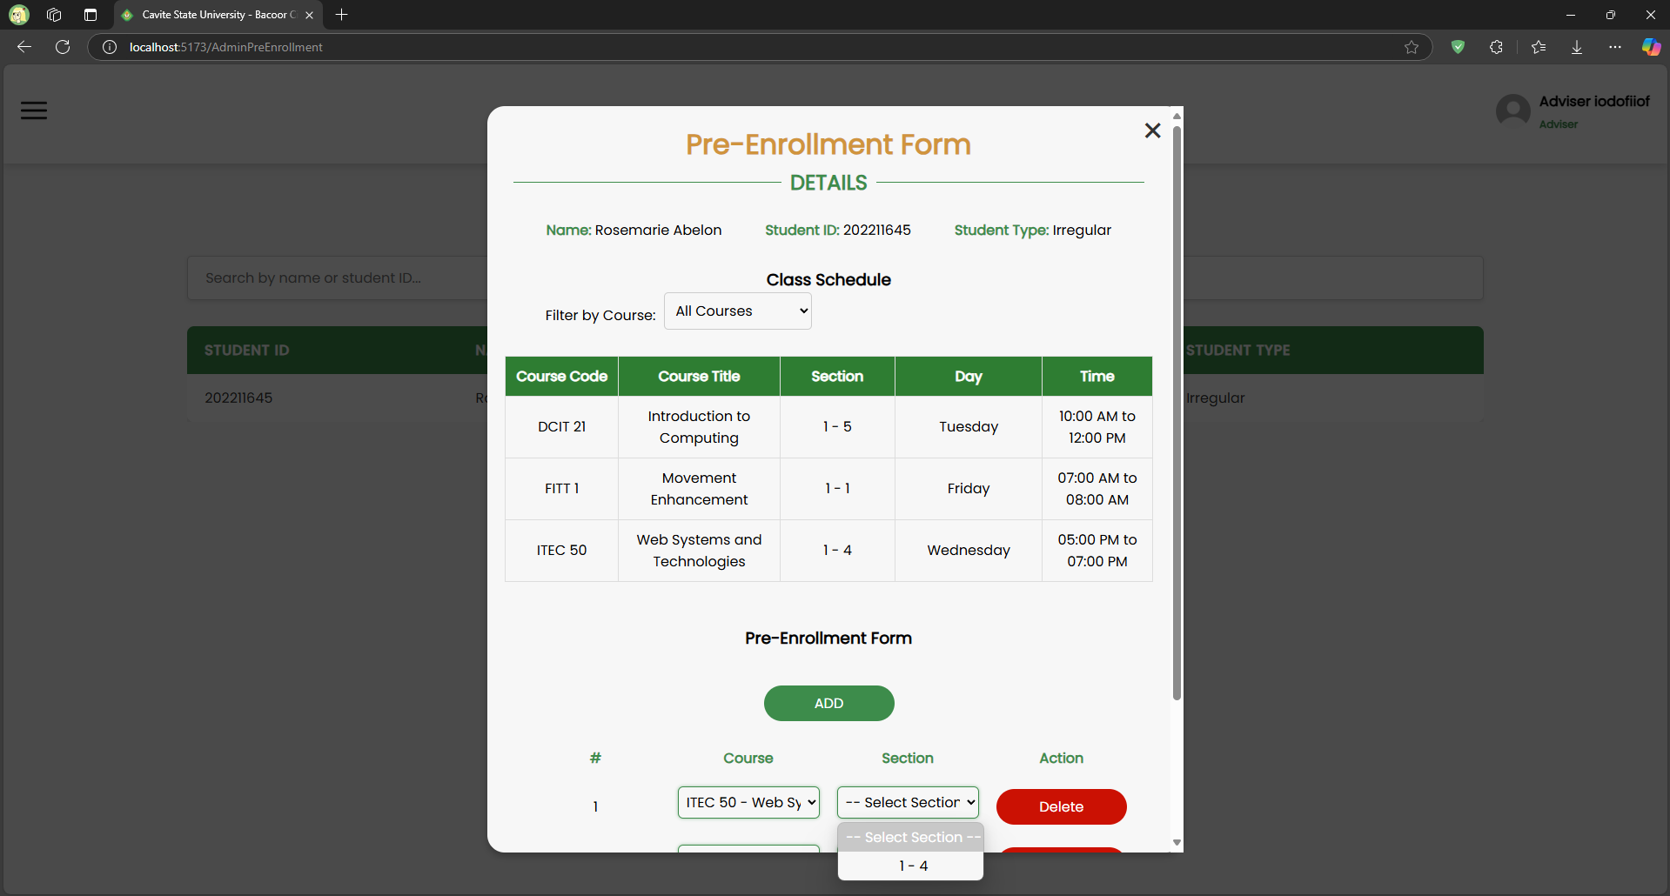

*Adviser course and class schedule selection page showing a irregular student’s selected courses during in-person advising*

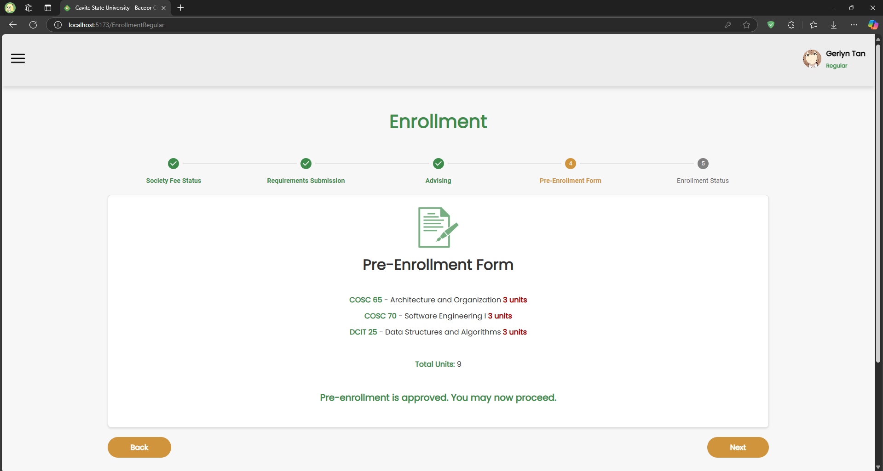

*Pre-Enrollment Form preview for showing enrollee’s selected courses*

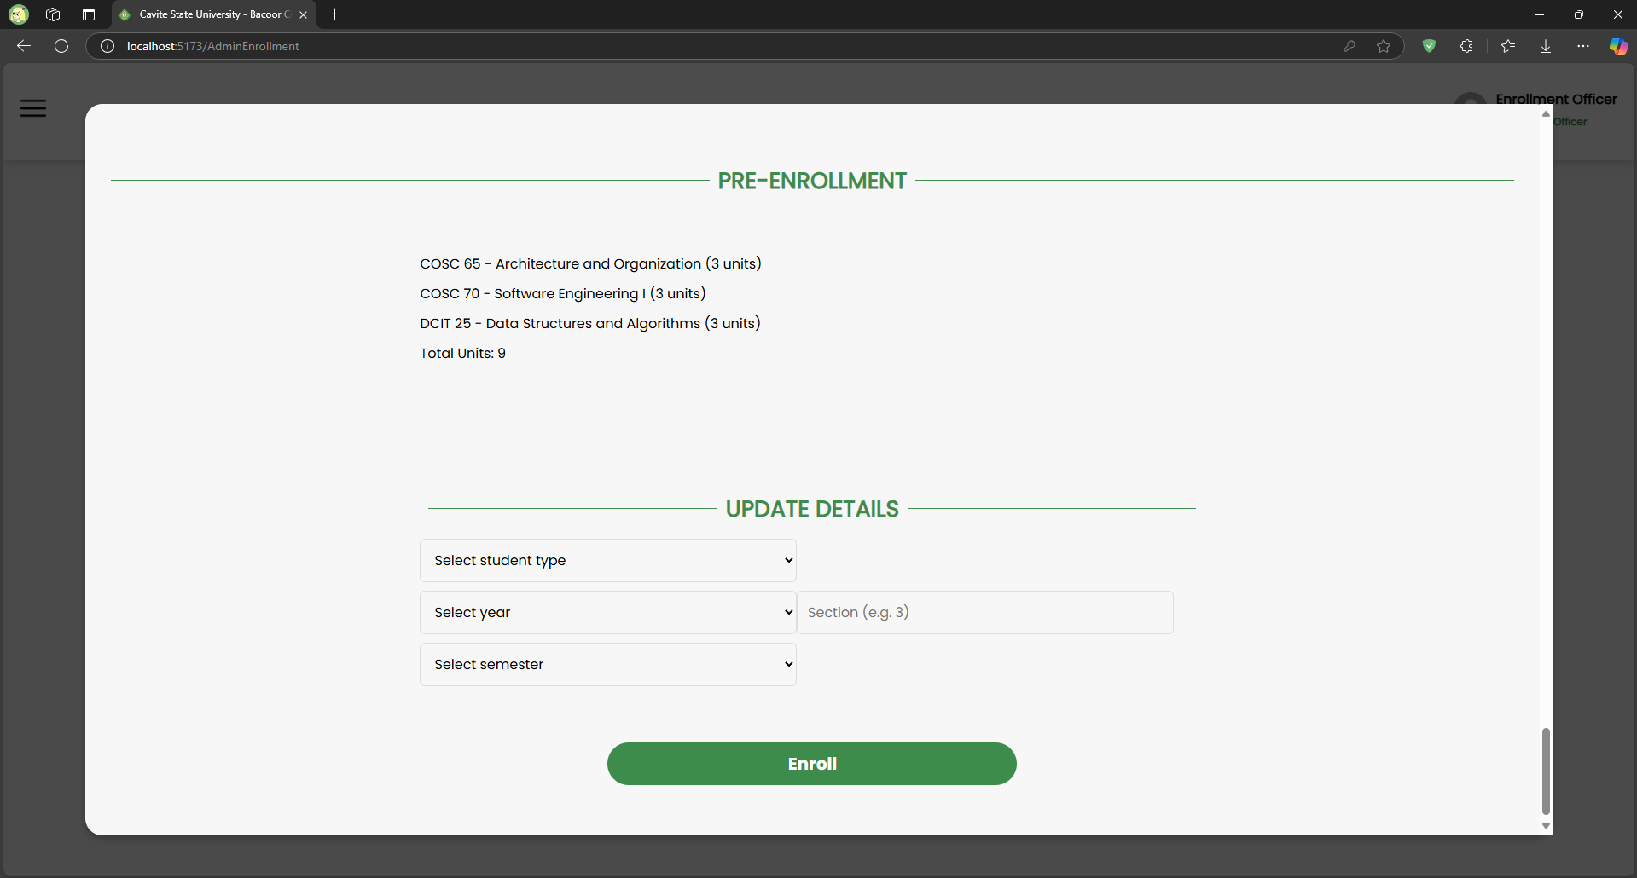

*Enrollment management page for handling enrollee’s academic information*

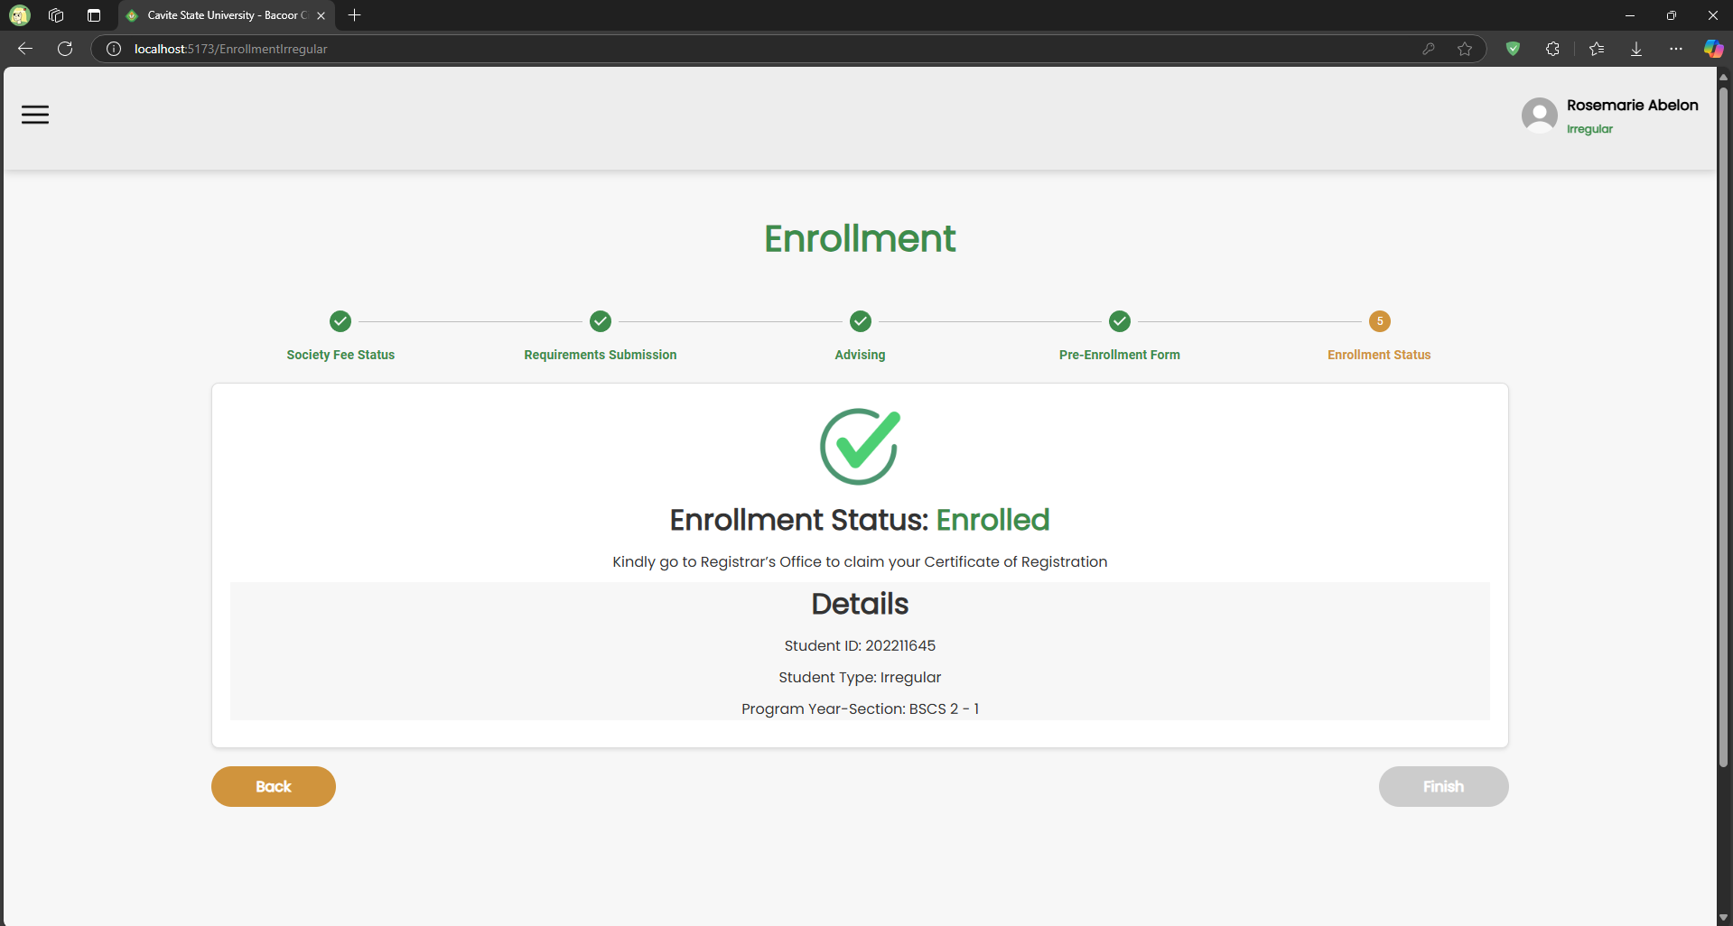

*Enrollment status page for enrollees*

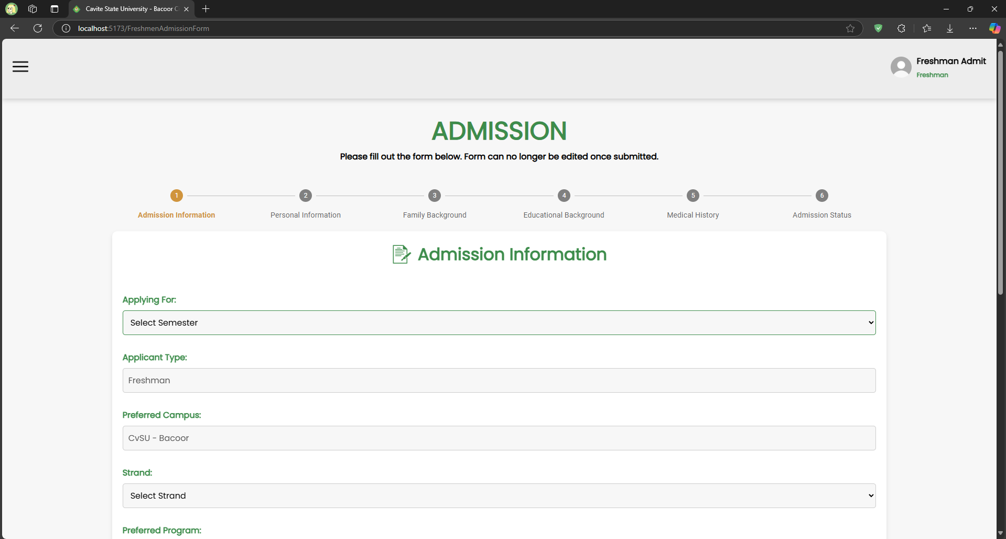

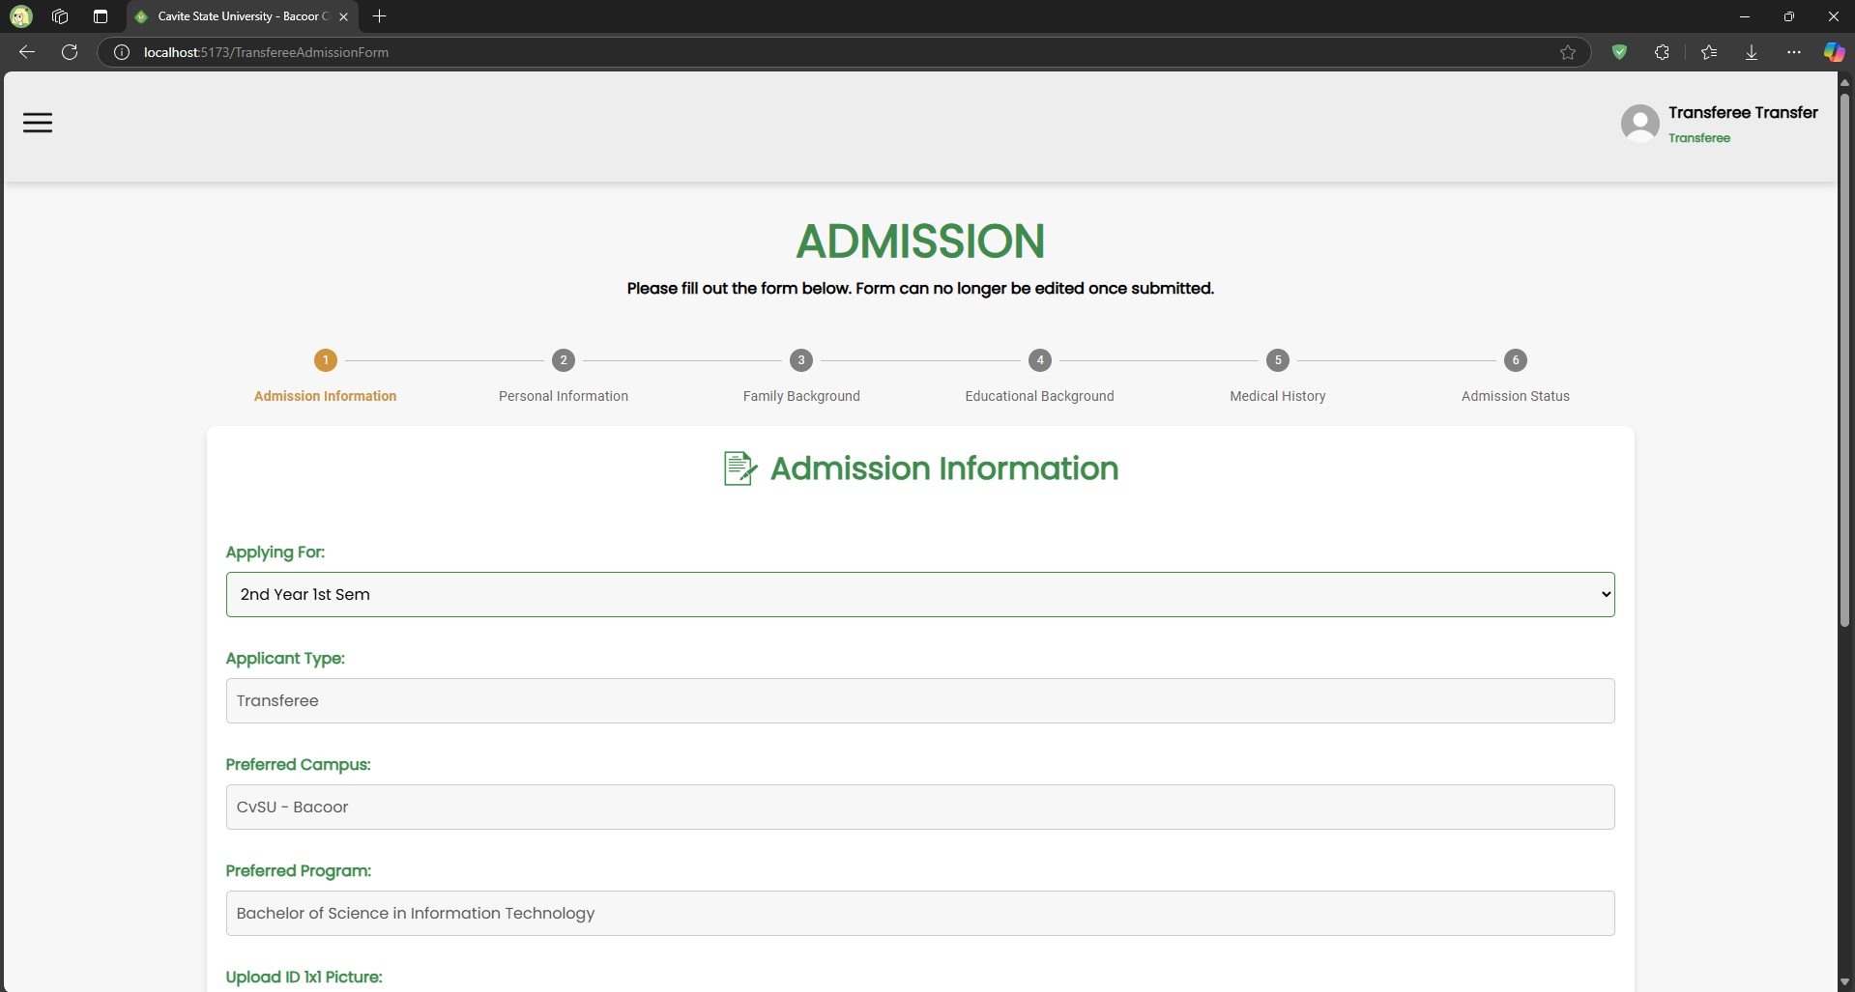

*Admission form for freshmen and transferees*

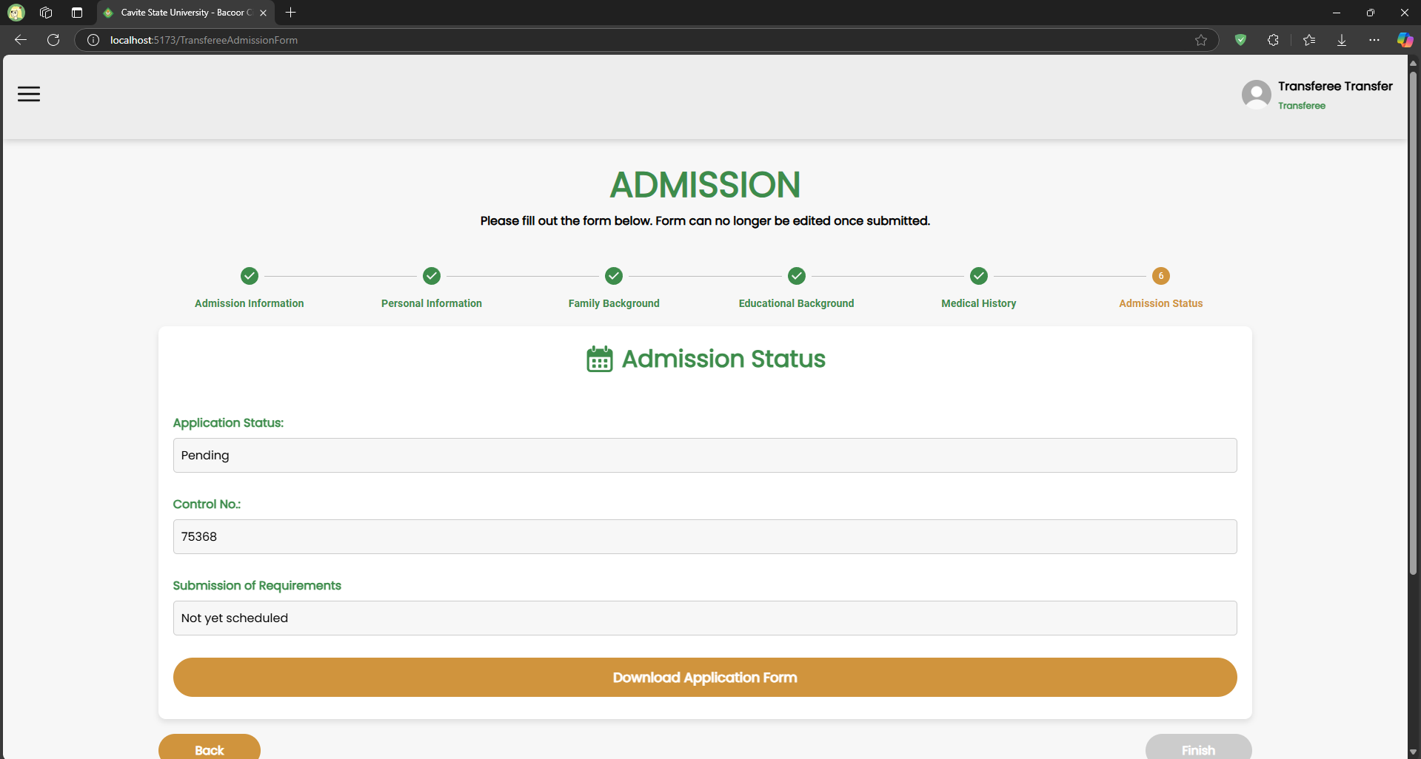

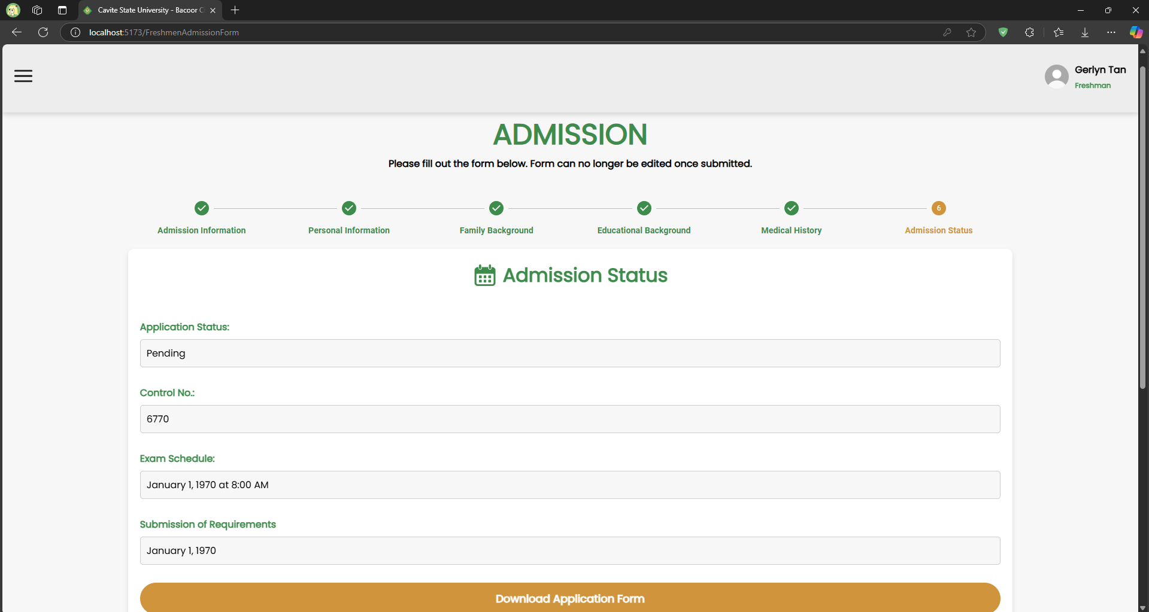

*Admission page for monitoring admission status*

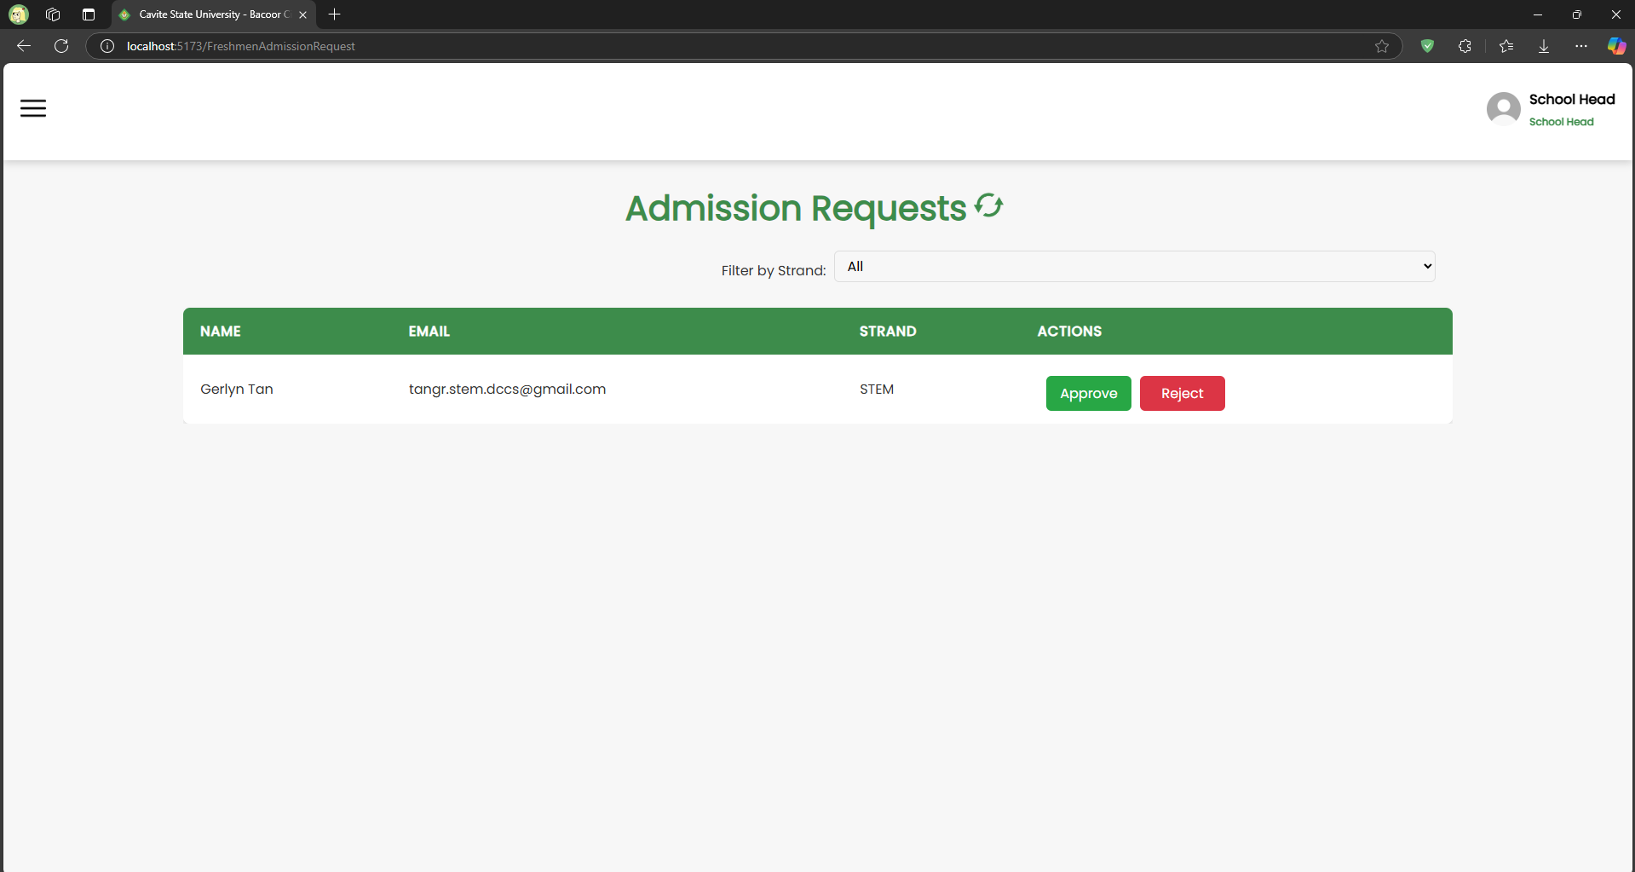

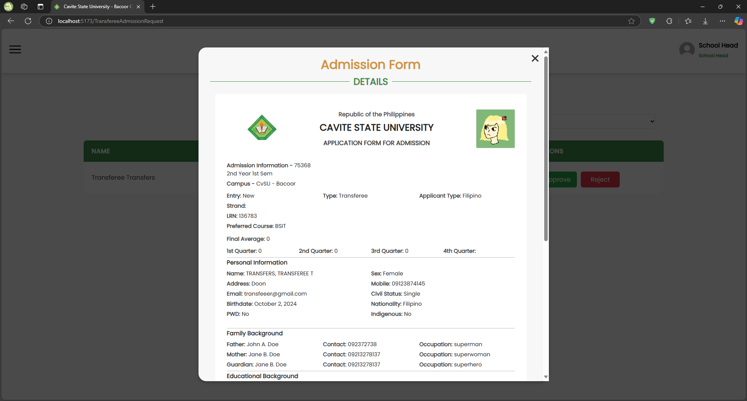

*Transferees and Freshmen admission requests page for monitoring submitted forms*

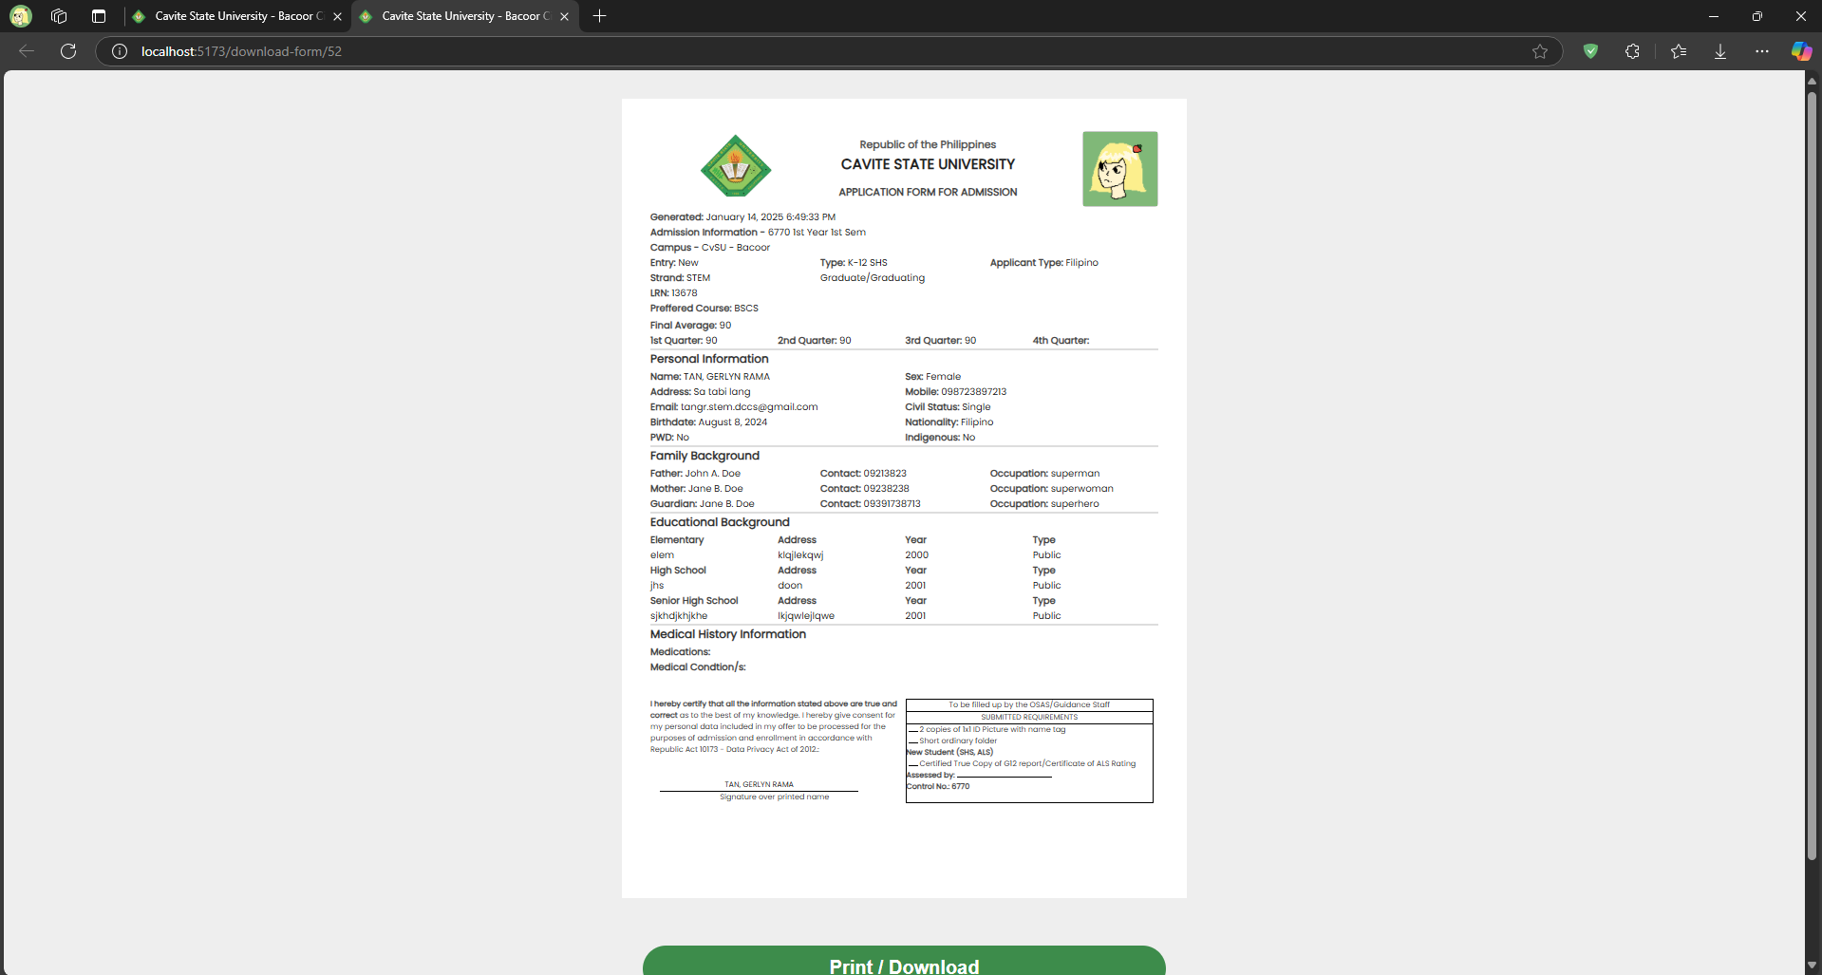

*Admission form preview page for printing and downloading*

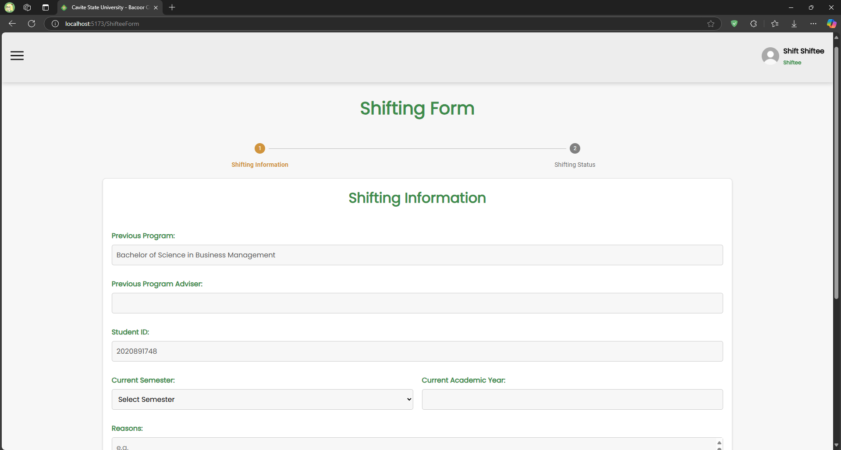

*Shifting form for shiftees*

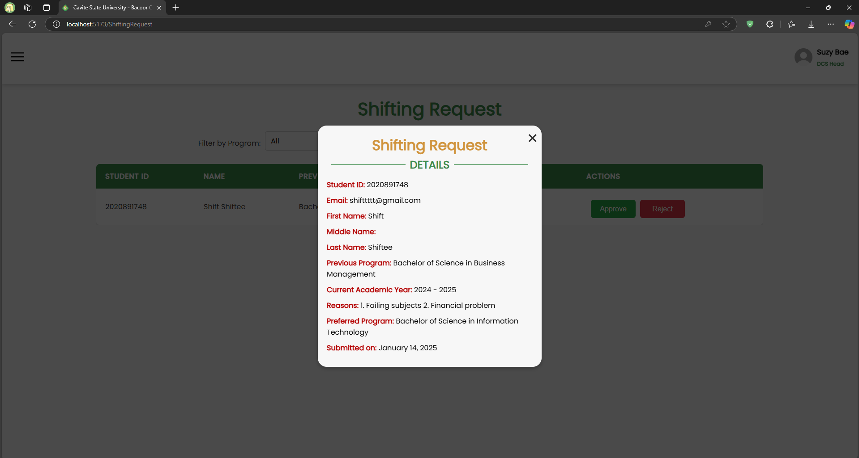

*Shifting request page for DCS Head for approving or rejecting requests*

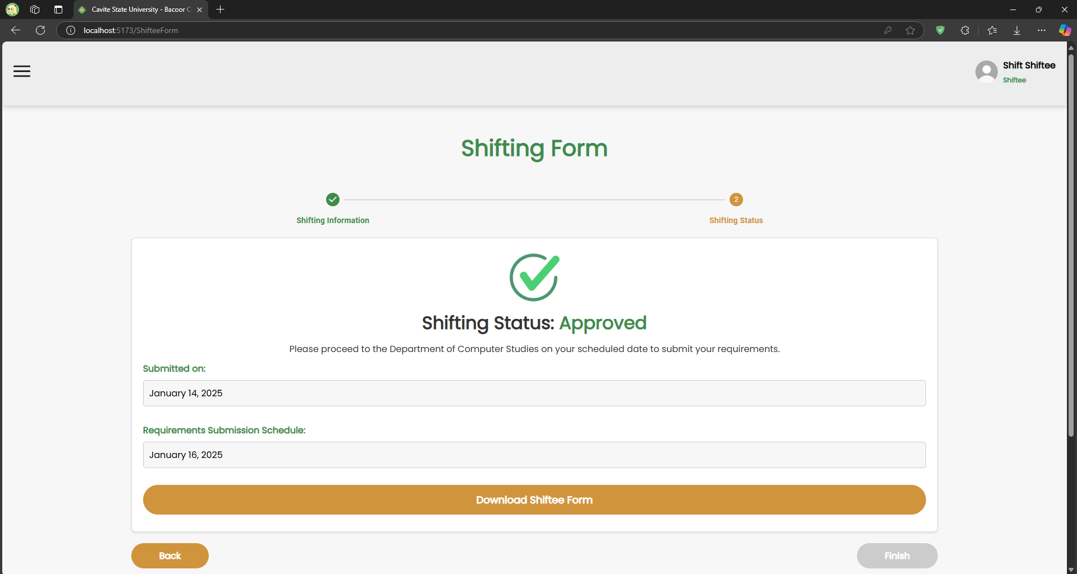

*Shifting status page for monitoring appointments*

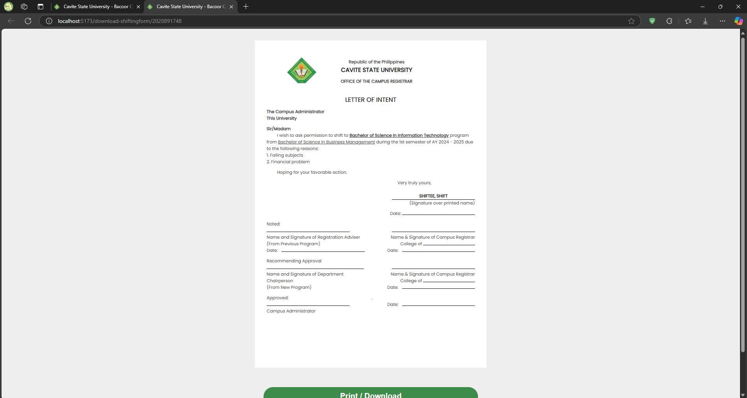

*Shifting form preview page for printing and downloading*

# 7. Testing

**7.1 Test Plan**

This test plan is to outline the testing strategy, objective, scope, and approach to verify the functionality, usability, and performance of the Enrollment System. The purpose of this is to ensure that the system meets its requirements and performs as expected in various conditions before being deployed for use by different stakeholders involved: Students, DCS heads, School Head, Society Officer, and Enrollment Officer.

**7.1.1 Objectives**

The primary objectives of testing the *Enrollment System for Department of Computer Studies – Cavite State University – Bacoor Campus* are:

* To validate the core functionalities of the system.
* To ensure the system is user-friendly and easy to navigate.
* To verify the system is secure and protects user data.
* To assess system performance under various usage scenarios.
* To identify and resolve any issues that may impact the user experience.

**7.1.2 Scope**

The testing scope includes:

* **Functional Testing:** Testing all features of the Enrollment System.
* **Usability Testing:** Assessing the system’s ease of use.
* **Security Testing:** Ensuring the system protects sensitive information.
* **Performance Testing:** Evaluating the system’s response time and behavior under normal and peak loads.
  + 1. **Test Levels**
* **Unit Testing:** Testing individual components and functionalities.
* **Integration Testing:** Testing interactions between different modules.
* **System Testing:** Validating the system as a whole, ensuring all integrated components work together.
* **Acceptance Testing:** Verifying the system meets user requirements and is ready for deployment.
  + 1. **Test Types**
* **Functional Testing:** Ensuring the system features worked as expected.
* **Security Testing:** Verifying that user data, such as personal information and other sensitive details involved in the system, are stored and transmitted securely.
* **Usability Testing:** Ensuring that the system is intuitive and user-friendly.
* **Performance Testing:** Assessing how well the system performs under unexpected peak usage conditions.
* **Regression Testing:** Verifying that new changes do not negatively impact existing functionality or the software tests still work as expected after changes.
  + 1. **Test Deliverables**
* **Test Plan:** This document outlining the testing approach and strategy.
* **Test Cases:** Detailed test cases for all functional and non-functional requirements.
* **Test Data:** A mock data user information for testing.

**7.1.6 Tests**

Presented below are screenshots of each test file that was successfully passed for both UI components and its functionalities.

**Main Page**

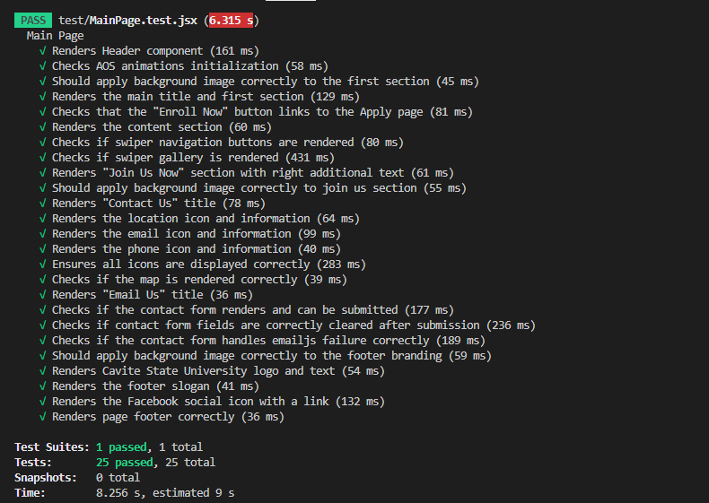

**CvSU History Page**

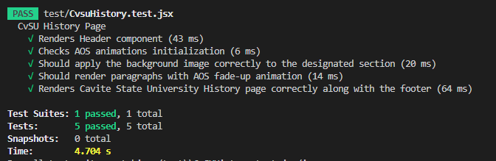

**Mission and Vision Page**

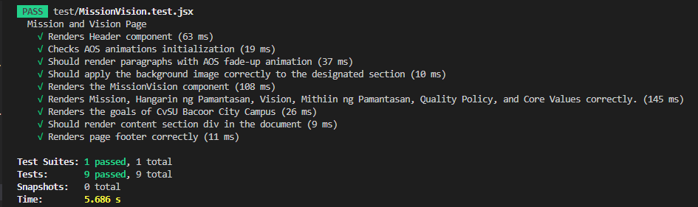

**DCS Page**

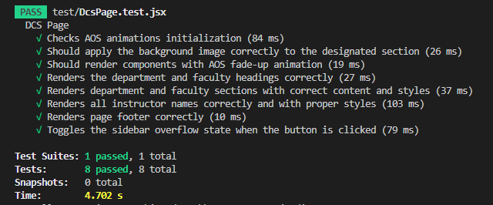

**Society Officer Page**

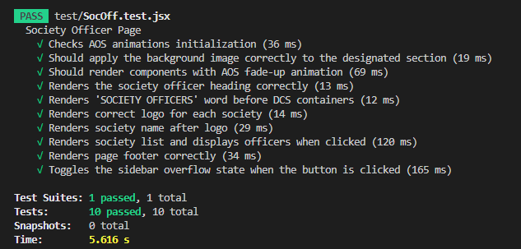

**Apply Page**

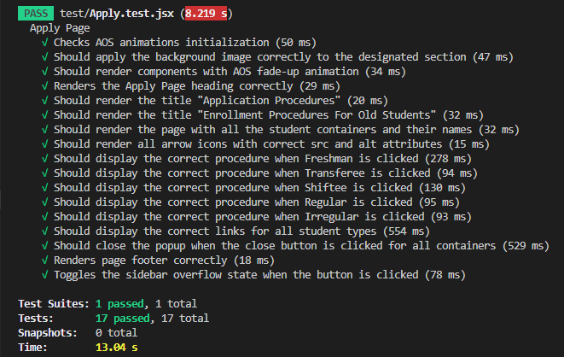

**FAQs Page**

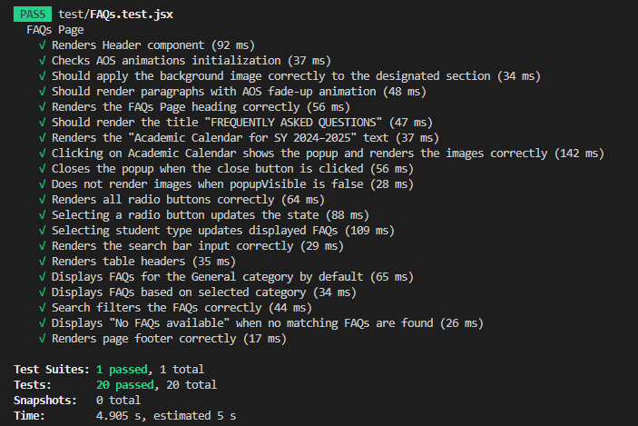

**Undergraduate Programs Page**

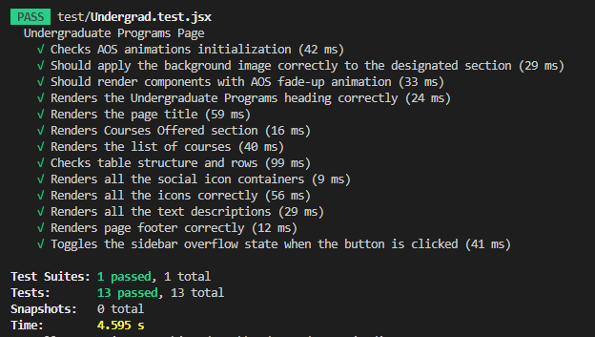

**Sign Up Page**

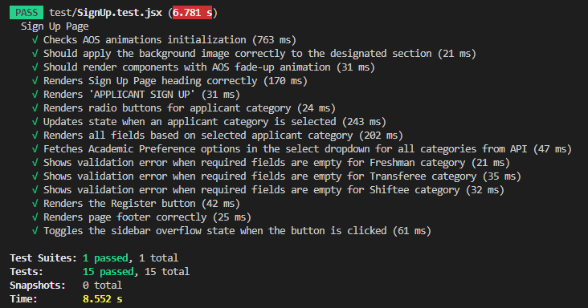

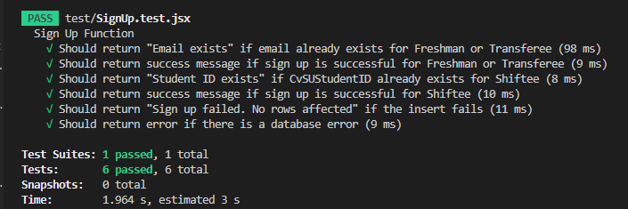

**Login Page**

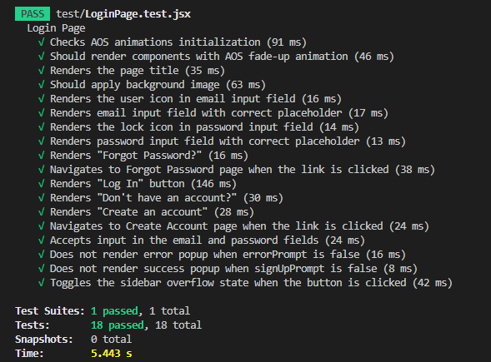

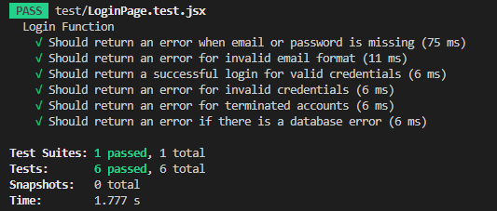

**Create Account Page**

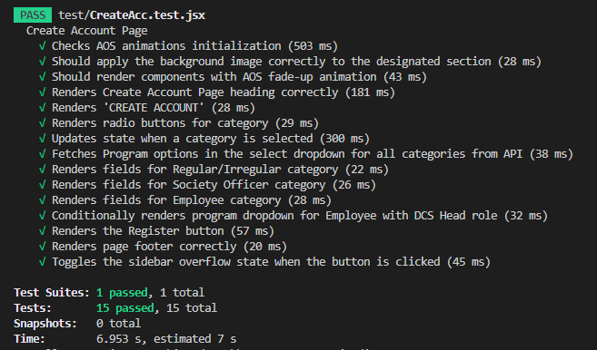

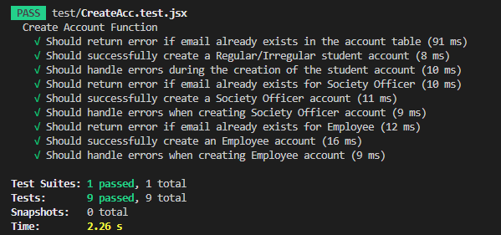

**Forgot Password Page**

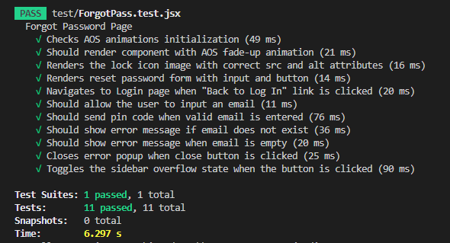

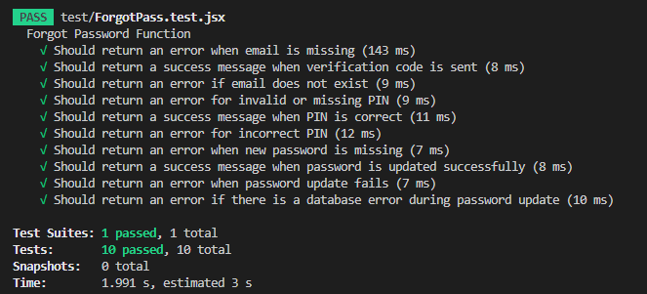

**DCS Head Dashboard Page**

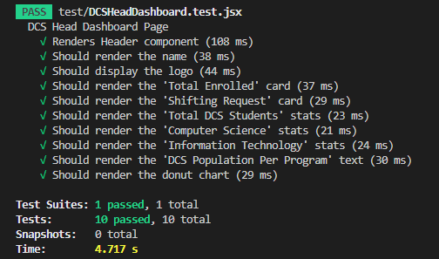

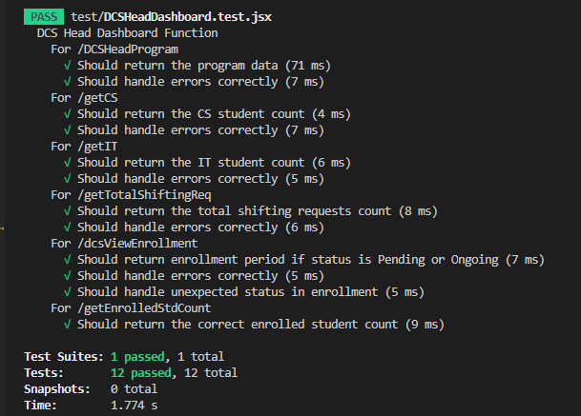

**Shifting Request Page**

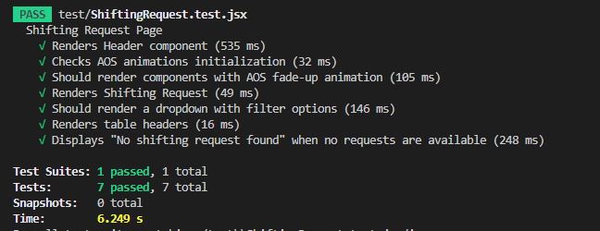

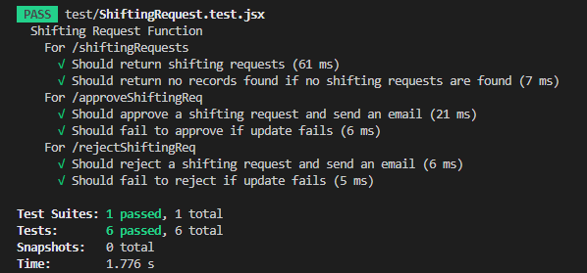

**School Head Dashboard**

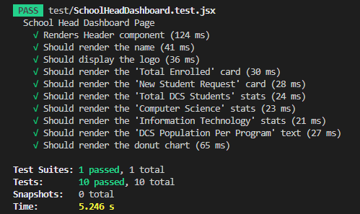

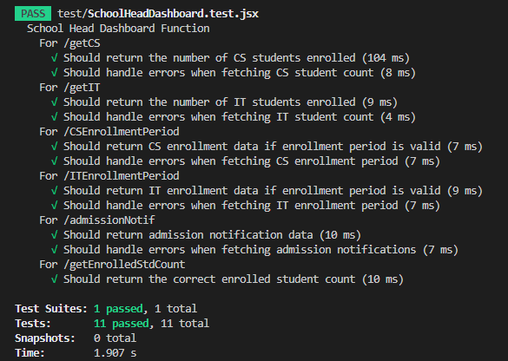

**Freshmen Admission Request Page**

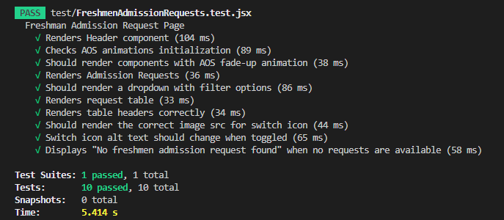

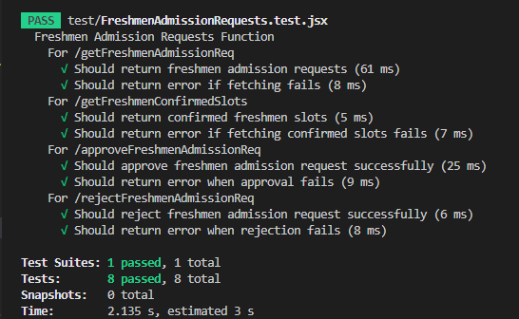

**Transferee Admission Request Page**

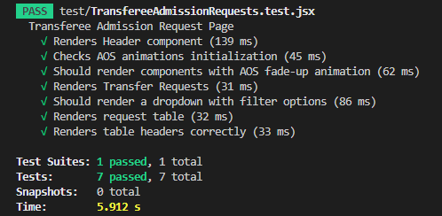

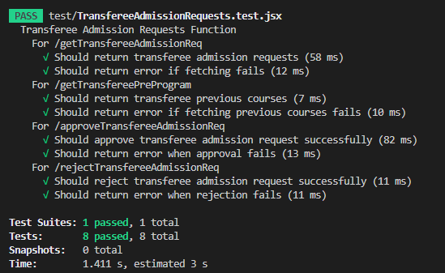

**Adviser Dashboard Page**

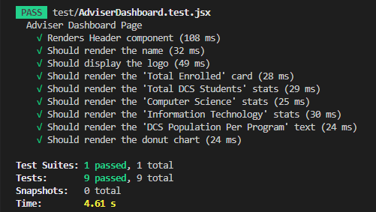

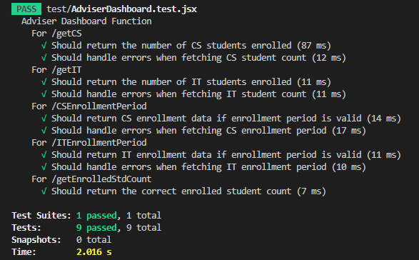

**Enrollment Officer Dashboard Page**

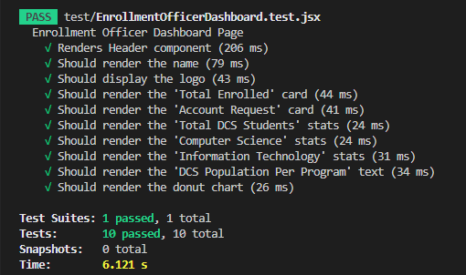

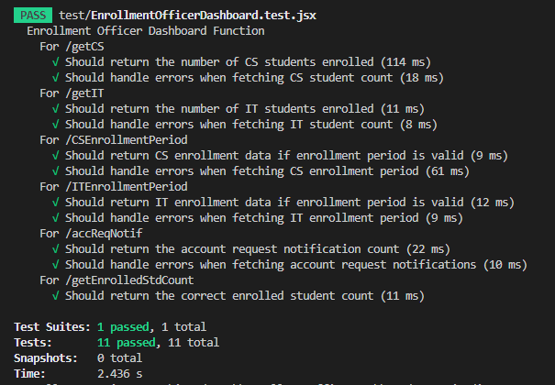

**Society Officer Dashboard Page**

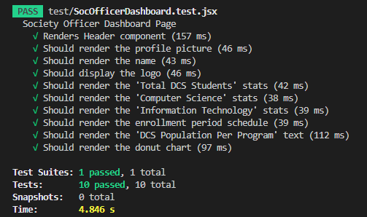

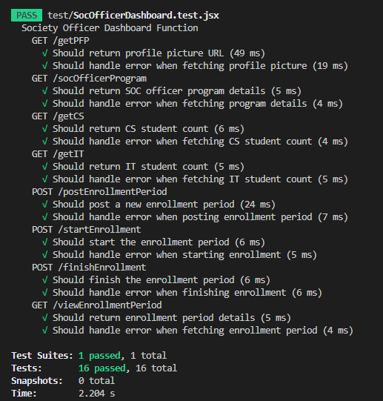

**Account Settings Component**

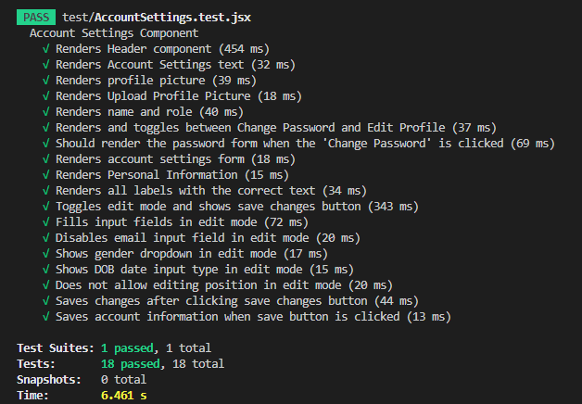

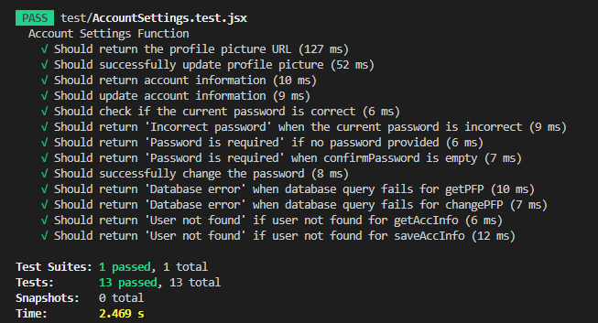

**Regular/Irregular Dashboard Page**

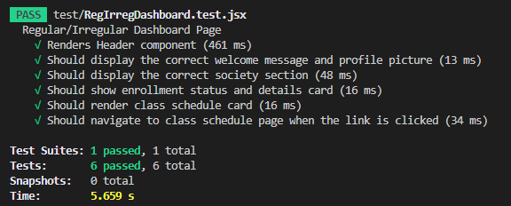

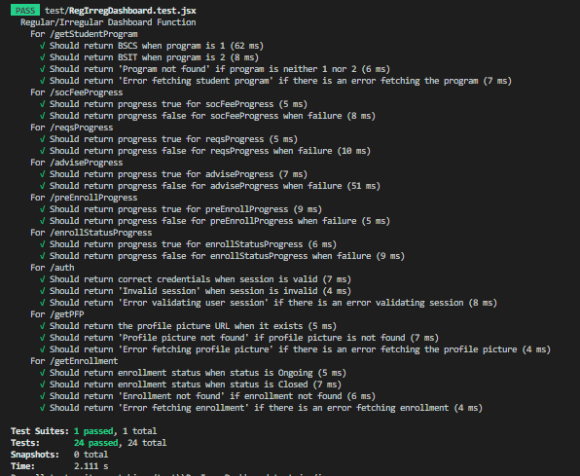

**Student Account Settings Component**

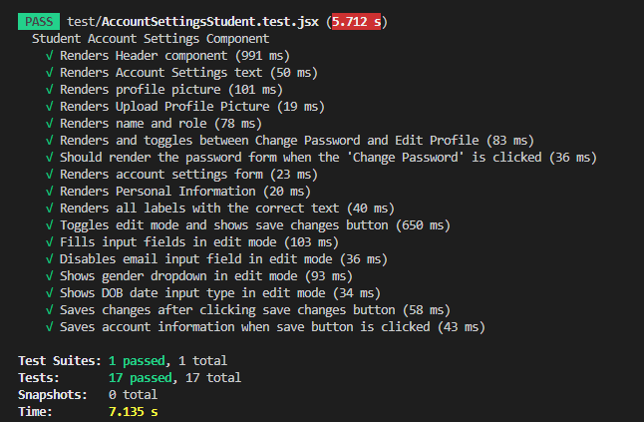

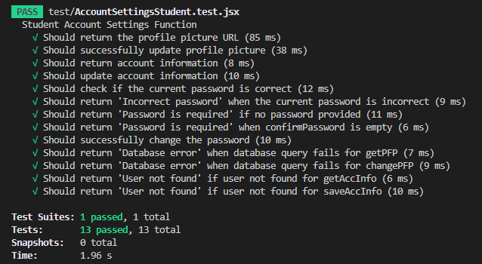

**Log Out**

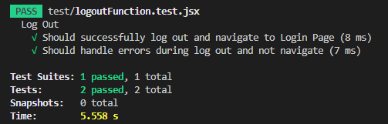

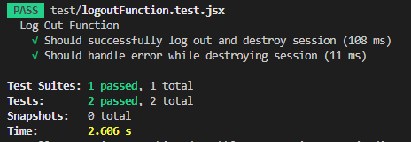

**Test Suites**

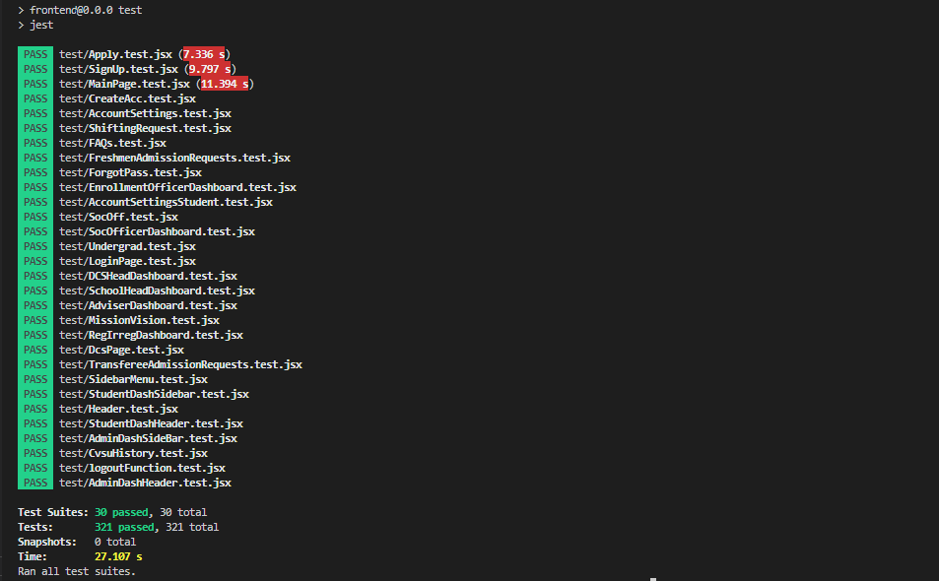

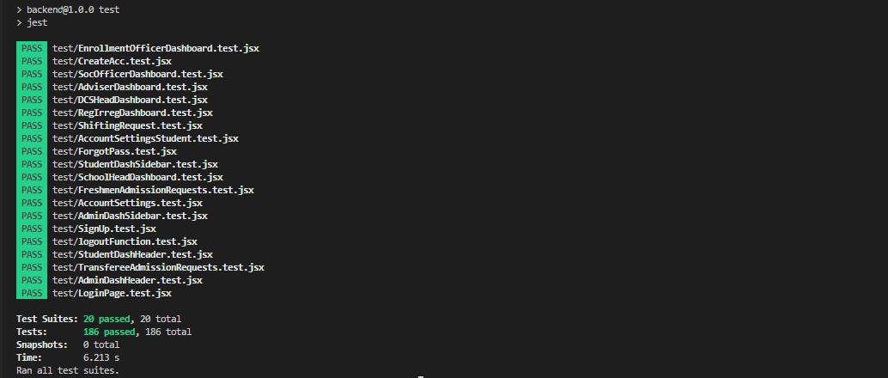

**7.1.7 Test Cases**

|  |  |  |  |  |
| --- | --- | --- | --- | --- |
| **Test Case** | **Test**  **Description** | **Expected Outcome** | **Actual Outcome** | **Status** |
| **Main Page**  Email Us Form Submission | Verify that the form is submitted successfully with valid data. | The form is submitted successfully, and a successful message is shown. | Successful form submission. | Pass |
| **Sign Up Page**  **(For Freshmen, Transferees, and Shiftees)**  Sign-Up with Valid Data | Verify that the user can sign up with valid information. | The user is successfully registered. | Successful registration | Pass |
| **Create Account Page**  **(For Old Students, Society Officers, and Employees)**  Registration for Account Creation with Valid Data | Verify that the user can register with valid information. | The user is successfully registered. | Successful registration | Pass |
| **Login Page**  Login with valid credentials | Verify that the user can log in with correct credentials | The user is successfully logged in and redirected to its respective dashboard. | Successful log in. | Pass |
| **Forgot Password Page**  Forgot Password With Valid Email | Verify that the email provided is valid. | The user is successfully reset the password and can use this for logging in. | Password reset successful. | Pass |
| **DCS Head Dashboard Page**  Real-time Data Monitoring | Verify that real-time data updates correctly on the dashboard. | Real-time data is displayed accurately and updated. | Data updates as expected. | Pass |
| **Shifting Request Page**  Access Shifting Request | Verify the ability of the DCS Head to the shifting request page. | Page loads correctly, all request details are displayed, and the status of the request is updated. | Page loaded correctly, request details are visible, and approve and reject requests are successful. | Pass |
| **School Head Dashboard Page**  Real-time Data Monitoring | Verify that real-time data updates correctly on the dashboard. | Real-time data is displayed accurately and updated. | Data updates as expected. | Pass |
| **Freshmen Admission Request Page**  Access Freshmen Admission Request | Verify the ability of the School Head to the freshmen admission request page. | Page loads correctly, the admission form is displayed, and the status of the request is updated. | Page loaded correctly, form is visible, and approve and reject requests are successful. | Pass |
| **Transferee Admission Request Page**  Access Transferee Admission Request | Verify the ability of the School Head to the transferee admission request page. | Page loads correctly, the admission form is displayed, and the status of the request is updated. | Page loaded correctly, form is visible, and approve and reject requests are successful. | Pass |
| **Adviser Dashboard Page**  Real-time Data Monitoring | Verify that real-time data updates correctly on the dashboard. | Real-time data is displayed accurately and updated. | Data updates as expected. | Pass |
| **Enrollment Officer Dashboard**  Real-time Data Monitoring | Verify that real-time data updates correctly on the dashboard. | Real-time data is displayed accurately and updated. | Data updates as expected. | Pass |
| **Society Officer Dashboard**  Real-time Data Monitoring and Handle Enrollment Period | Verify the ability of the Society Officer to handle enrollment periods and real-time data updates correctly on the dashboard. | Enrollment period is managed properly, and real-time data is displayed accurately and updated. | The handling of the enrollment period functions as intended, and data updates as expected. | Pass |
| **Account Settings Component**  **(For DCS Head, School Head, Adviser, Enrollment Officer, and Society Officer)**  Update Personal Information and Change Password | Verify if the user can update personal information and change password. | Changes are updated successfully. | Personal information and password updated successfully. | Pass |
| **Regular or Irregular Dashboard Page**  Real-time Announcement Monitoring and Enrollment Progress | Verify the correct display of enrollment period based on the program of the user, and the enrollment progress is updated. | The start and end of the enrollment period are displayed, and a percentage of progress during enrollment is shown. | Enrollment period is correctly displayed as well as the enrollment progress. | Pass |
| **Student Account Settings Component**  **(For Regular or Irregular, Freshman, Transferee, and Shiftee)**  Update Personal Information and Change Password | Verify if the user can update personal information and change password. | Changes are updated successfully. | Personal information and password updated successfully. | Pass |
| **Log Out**  Log Out Functionality | Verify log-out functionality with session timeouts when user is logged in. | The user is successfully logged out and redirected to the login page. | Logged out successful. | Pass |

# 8. Maintenance

### **System Reliability and Accuracy**

* **Database Maintenance**: Regularly check and optimize the database to ensure data integrity and performance.
* **Bug Fixes**: Identify and resolve system bugs promptly to maintain smooth operations.
* **Backup Procedures**: Implement automated daily backups of all critical data and files.

### **User Interface (UI) and User Experience (UX) Enhancements**

* **Modern Design**: Adopt a clean, professional, and consistent look across the platform.
* **User-Friendly Navigation**: Simplify navigation for all user roles, minimizing steps required to complete key tasks.
* **Feedback Mechanisms**: Add real-time notifications for success, errors, and warnings.
* **Responsive Design**: Ensure compatibility across various devices and screen sizes (mobile-first approach).
* **Accessibility Compliance**: Follow WCAG standards for users with disabilities.

### **Role-Specific Feature Maintenance**

#### **For Students (New and Returning):**

* Ensure smooth course registration, requirement submission, and profile management.
* Update course catalogs and scheduling functionalities as needed.

#### **For Society Officers:**

* Maintain tools for enrollment period management, class schedule handling, fee monitoring, and requirement validation.

#### **For Advisers:**

* Ensure proper functionality for advising status modifications and pre-enrollment form submissions.

#### **For Enrollment Officers:**

* Maintain verification tools for user registration and enrollment status updates.
* Ensure proper handling of academic information updates and administrative dashboards.

#### **For School and Department Heads:**

* Keep tools for admission/shifting approvals and scheduling communications operational and updated.

# 9. Conclusion

# The development and implementation of the enrollment system have streamlined the process of student registration, making it more efficient, accurate, and user-friendly. This system eliminates manual tasks, reduces human error, and enhances the overall experience for both administrators and students. By implementing core functions such as student data management and course selection, the enrollment system significantly improves operational efficiency and provides a scalable solution for institutional growth.

**Key Recommendations:**

* **Online Payment Integration:** Integrate a secure online payment gateway (e.g. GCash, Maya, etc.) to allow students to pay their society fees directly through the system.
* **Payment Tracking System:** Include a payment tracking system to automatically update society fee status, reducing admin workloads.
* **In-App Messaging:** Add an in-app messaging feature to further enhance the advising phase of the enrollment and minimize the need for in-person interactions.
* **Automated Notifications Enhancement:** Expand the notification system to keep students informed and updated about critical information such as important deadlines, class schedules, payment confirmations, and enrollment status updates.
* **Scalability Testing:** Perform load testing to assess the system’s ability to handle multiple users simultaneously, especially during peak enrollment periods.

# 10. Appendices

**GLOSSARY OF TERMS**

**Academic Calendar.** A schedule provided by the institution that outlines important dates, including enrollment periods, class start dates, and examination schedules.

**Admission.** The initial process of entering a student into the institution’s system. This involves submitting required documents, paying admission fees, and assigning a Student ID.

**Adviser.** An academic staff member who provides guidance to students regarding course selection, monitors their academic progress, and approves or recommends changes to their enrollment based on the student’s program requirements and academic goals.

**Course Load.** The total number of units or credits a student is enrolled in for a specific term or semester.

**Database.** The structured repository where all data related to students, courses, payments, and academic records are stored and managed by the system.

**Data Privacy Compliance.** Measures implemented to ensure the protection of personal and academic information stored within the system, in adherence to relevant laws and regulations.

**Mobile Compatibility.** The system’s ability to function seamlessly on smartphones and tablets, allowing users to access features on the go.

**Notification System.** A communication tool within the platform that sends updates to students and administrators, such as reminders about deadlines or confirmation of actions taken.

**Prerequisite.** A requirement that must be completed before enrolling in a specific subject or course. The system checks for these conditions before allowing registration.

**Registrar.** The office or entity responsible for maintaining student records and overseeing the enrollment process. The system may integrate functions to assist the registrar's operations.

**Student Dashboard.** The user interface where students can view and manage their profile, enrolled courses, grades, and other academic information.

**Student ID.** A unique alphanumeric code assigned to each student in the system. This identifier is used to track enrollment records, payments, and academic progress.

**Student Information.** Data related to students, including personal details, academic history, and enrollment status, stored and processed within the system.

**ADDITIONAL DIAGRAM**

**Data Flow Diagram**

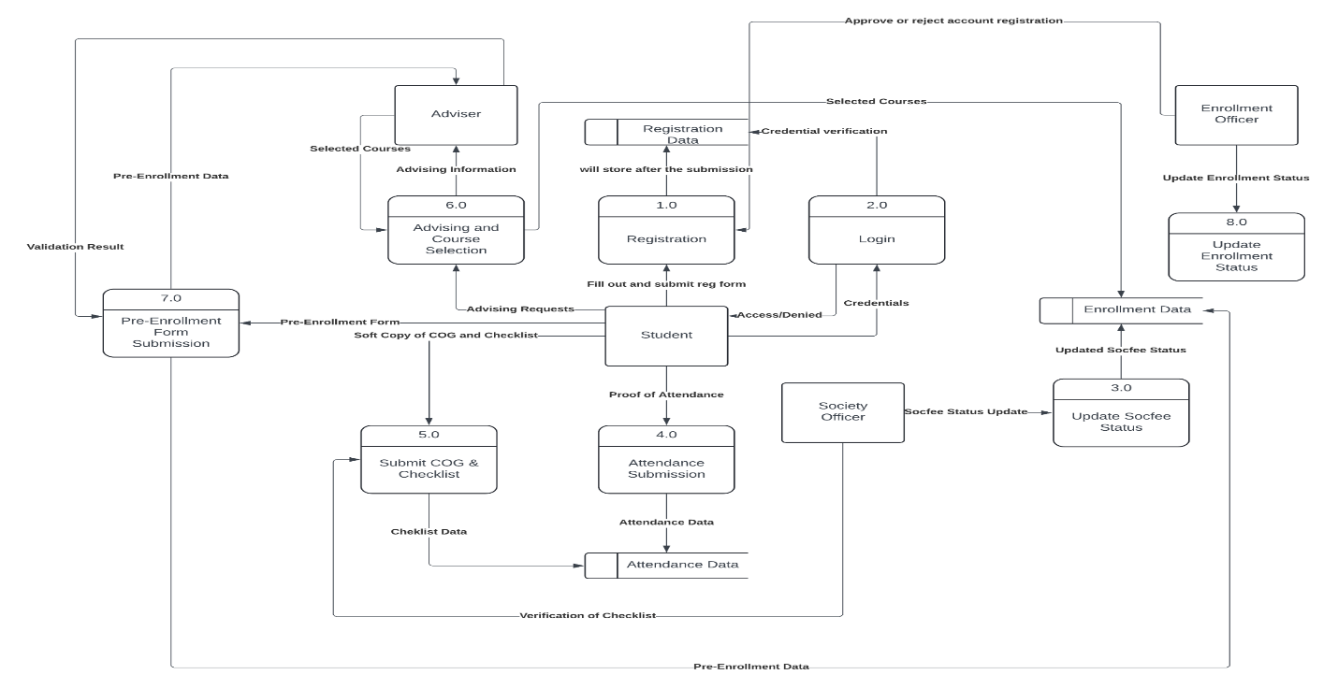

**Gantt Chart**

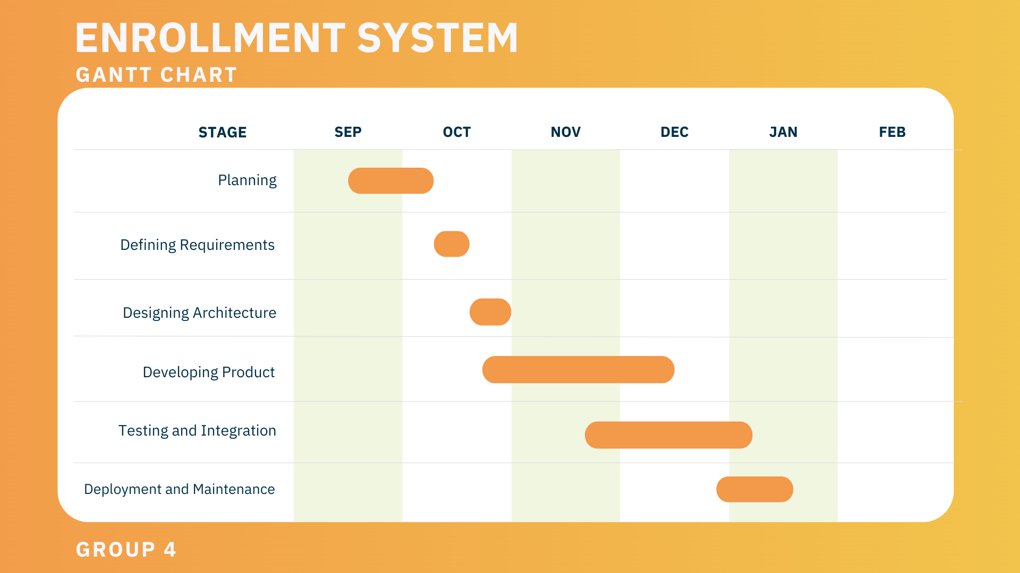

**REFERENCES**

*Visual Paradigm - Online Productivity Suite*. (n.d.). <https://online.visual-paradigm.com/>

*LucidChart | Diagramming powered by Intelligence*. (n.d.-b). [https://www.lucidchart.com/](https://www.lucidchart.com/pages/landing?utm_source=google&utm_medium=cpc&utm_campaign=_chart_en_tier3_mixed_search_brand_exact_&km_CPC_CampaignId=1484560207&km_CPC_AdGroupID=60168114191&km_CPC_Keyword=lucidchart&km_CPC_MatchType=e&km_CPC_ExtensionID=&km_CPC_Network=g&km_CPC_AdPosition=&km_CPC_Creative=442433234360&km_CPC_TargetID=kwd-33511936169&km_CPC_Country=1011185&km_CPC_Device=c&km_CPC_placement=&km_CPC_target=&gad_source=1&gclid=Cj0KCQiAkJO8BhCGARIsAMkswyhc3Vu8gNSj90ke3Cicyo0hYKD0nY-SYq0vmuHFFpUHTPAPhgHpaawaAjmNEALw_wcB)

Far Eastern University. (2024b, December 12). *FEU SPACE • Far Eastern University*. <https://www.feu.edu.ph/feu-space-student-placement-for-admission-to-college-education/>

*A free database designer for developers and analysts*. (n.d.). <https://dbdiagram.io/home>